Team Reports Form for ISWA Member Guide
Please fill out the following information for your Team Report to be published in the ISWA Member Guide.

Team: 2024 Heartland Duals, Girls Team
Team Leaders & ISWA Title: Doug Strayer (Crown Point)
Coaches: John Cantu (Hobart/RWA); Justin Cooper (Whiteland)
Volunteers & Others You'd Like to Thank: Table Worker-Jeremy Neibert (Indian Creek)
Team Results: Team Record & Overall Placement in Which Bracket/Pool
Pool Play, 4-1
Diamond Pool, 1-2 and placed 7th out of 19 Teams
Roster:
52-Briar Parrett, 3-4
58-Brooklyn Stauffer, 3-4
65-Sophia Gatewood, 1-3
73-Grace Nedelsky, 5-2
82-Jessalynn Lopez, 0-7
89-Bridget Martin, 3-4
95-Ella Neibert, 7-0 (All American and Outstanding Wrestler)
101-Kaitlynn Fouty, 7-0 (All American)
107-Marissa “Mimi” Nicolas, 3-4
113-Moriah Morphet, 5-2
120-Mikayla Perkins, 6-1
126-Ava Strayer, 7-0 (All American and Outstanding Wrestler)
138-Julianne Cantu, 5-2
150-Bailey Varella, 4-3
165-Melody Vazquez, 3-4
185-Macey Couch, 3-4
Narrative: Team Indiana wrestled (4) Duals in Pool Play and finished 3-1. Since Team Idaho defeated Team Nebraska Blue, while Team Indiana defeated Team Idaho, Team Indiana won their pool and advanced to the Diamond Pool, placement rounds.
Indiana competed on day two with a hole in our lineup due to an injury the previous day. DIAMOND POOL:
QUARTERFINALS: Team Texas Red narrowly defeated Team Indiana 43-37. This was an exciting dual that came down to the final match.
CONSI SEMI’S: Team Oregon defeated Team Indiana 45-34.
7TH PLACE DUAL: Team Indiana defeated Team Idaho again. This time by a score of 51-28.

Special Awards: Heartland Duals criteria for All-American is a perfect record with at least 6 matches. We were very proud to have three girls qualify for All-American honors:
Ella Neibert, Kaitlynn Fouty, and Ava Strayer. Because we competed in the Diamond Pool, we were allowed two Outstanding Wrestler awards. The coaching staff selected our winners by All-Americans that scored the most team points. Our Outstanding Wrestlers were Ella Neibert (second consecutive year as an All-American and receiving this award) and Ava Strayer

Photo(s) & Captions:
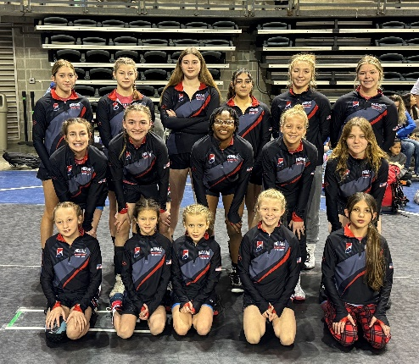
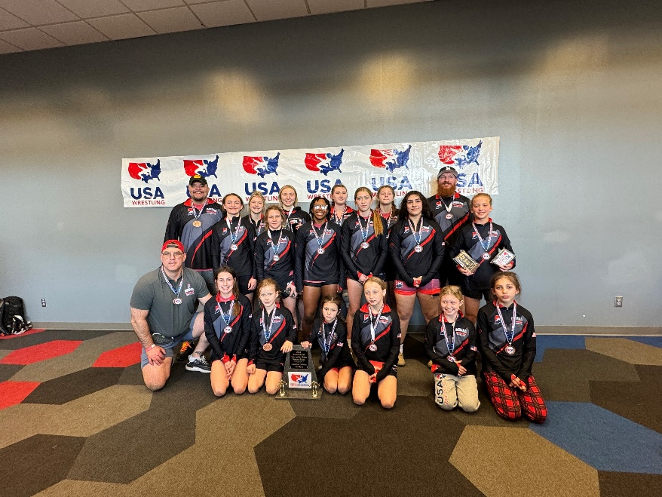

-Back Row: Coach John Cantu, Julianne Cantu, Ava Strayer, Macey Couch, Bailey Varella, Coach Justin Cooper
-Middle Row: Marissa “Mimi” Nicolas, Kaitlynn Fouty, Mikayla Perkins, Moriah Morphet, Melody Vazquez, Ella Neibert
-Front Row: Bridget Martin, Brooklyn Stauffer, Briar Parrett, Grace Nedelsky, Sophia Gatewood, Jessalynn Lopez

