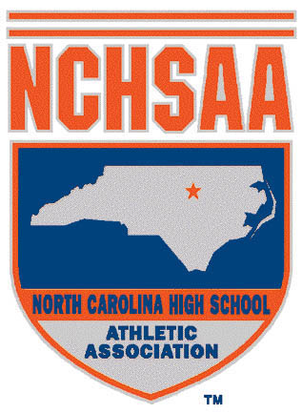
RETURN TO PLAY FORM:
COVID-19 NEGATIVE TEST RESULT MEDICAL CLEARANCE RELEASING THE STUDENT-ATHLETE TO
RESUME FULL PARTICIPATION IN ATHLETICS

This form must be signed by one of the following examining Licensed Health Care Providers (LHCP) before the student-athlete is allowed to resume full participation in athletics: Licensed Physician (MD/DO), Licensed Physician Assistant (PA), Licensed Nurse Practitioner (NP). This form must be signed by the student-athlete’s parent/legal custodian giving their consent before their child resumes full participation in athletics.

Name of Student-Athlete: __________________________ DOB: ____________________ Male/Female

Date COVID-19 Symptom Diagnosed: ___________ Date COVID-19 Symptom Resolved: ___________
This is to certify that the above-named student-athlete had a negative test result after having acknowledged sign(s)/symptom(s) consistent with COVID-19.

As the examining LHCP, I attest that the above-named student-athlete had a negative test result after having acknowledged sign(s)/symptom(s) consistent with COVID-19. By signing below therefore, I give the above-named student-athlete consent to resume full participation in athletics.

_________________________________________________________________ __________________________
Signature of Licensed Physician, Licensed Physician Assistant, Date
Licensed Nurse Practitioner (Please Circle)

_________________________________________________________________
Please Print Name
_________________________________________________________________ ___________________________
Please Print Office Address Phone Number

******************************************************************************

Parent/Legal Custodian Consent for Their Child to Resume Full Participation in Athletics
I am aware that the NCHSAA REQUIRES the consent of a child’s parent or legal custodian prior to them resuming full participation in athletics after having tested negative for acknowledged sign(s)/symptom(s) consistent with COVID-19. I acknowledge that the Licensed Health Care Provider above has overseen my child’s negative COVID-19 test and has given their consent for my child to resume full participation in athletics. By signing below, I hereby give my consent for my child to resume full participation in athletics.

_________________________________________________________________ __________________________
Signature of Parent/Legal Custodian Date
_________________________________________________________________
Please Print Name and Relationship to Student-Athlete

