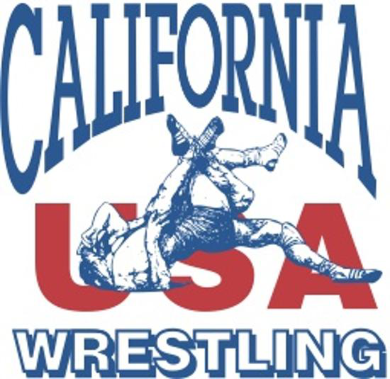
California USA Wrestling Inc.
Association Duals Championships
USA Junior Boys & Girls / 14U Boys & Girls
May 14th, 15th & 16th, 2027
Selland Arena - 700 M Street - Fresno, CA 93721
WEIGH-INS
Day / Time | Style | Age Groups | Site
Friday 6:00pm-9:30pm | Greco-Roman & Freestyle | USA Junior Boys/Girls; 14U Boys/Girls | Selland Arena
Saturday 12:00pm-1:00pm | Freestyle Only | USA Junior Boys/Girls; 14U Boys/Girls | Selland Arena
Important: If an athlete weighs in Friday night, the athlete must wrestle at least one Greco-Roman match. Freestyle-only athletes weigh in Saturday from 12:00pm-1:00pm on site.
2027 TEAM WEIGHT CLASSES
Division | 2027 Weight Classes | Event Allowance
USA Junior Boys | 100, 106, 113, 120, 126, 132, 138, 144, 150, 157, 165, 175, 190, 215, 285 lbs | +2 lbs
USA Junior Girls | 95, 100, 105, 110, 115, 120, 125, 130, 135, 140, 145, 155, 170, 190, 207, 235 lbs | +2 lbs
14U Boys (Schoolboy) | 75, 80, 84, 88, 92, 96, 100, 105, 110, 115, 120, 126, 132, 140, 155, 175, 225 lbs | +2 lbs
14U Girls (Schoolgirl) | 75, 80, 85, 90, 95, 100, 105, 110, 115, 120, 125, 130, 135, 140, 150, 165, 180 lbs | +2 lbs
All line-ups must be entered on USABRACKETING.COM by Thursday, May 13th, 2027.

California USA Wrestling Inc.
Association Duals Championships
USA Junior Boys & Girls / 14U Boys & Girls
May 14th, 15th & 16th, 2027
Selland Arena - 700 M Street - Fresno, CA 93721
EVENT INFORMATION
Seeding Meeting | Mandatory - Saturday, May 15th, 2027 at 7:30am
Seeding Criteria | USA Wrestling PIN System
Team Registration Fee | $400.00 per style
Payment Due | Tuesday, May 11th, 2027 - paid through the USA Wrestling membership system
Saturday Wrestling | Greco-Roman begins at 8:00am. Freestyle begins immediately after Greco-Roman finals and may continue into Sunday.
Sunday Wrestling | Freestyle begins at 8:00am and continues until completion.
Coaches
Association coaches must have a current USA Wrestling Card and a minimum Bronze-Level Coaching Certification. Each coach must present the current USA Wrestling Card and coaching certification to the Mat Chairman before each match or dual meet.
Eligibility
- USA Junior Boys & Girls: must meet USA Wrestling 2027 Junior eligibility requirements, including being born September 1, 2007 or later and enrolled in grades 9-12 during the 2027 spring semester. No 8th-grade athletes are eligible for the Junior division.
- 14U Boys & Girls: Association area is determined by the county in which the athlete lives.

California USA Wrestling Inc.
Association Duals Championships
USA Junior Boys & Girls / 14U Boys & Girls
Policies and Procedures - Association Dual Meet Championships
1. Team Selection: All teams must be certified by the appropriate Association Chairperson and State Office. Teams must be selected by a local documented process within each association.
2. Registration Fees: $400 per style must be paid before weigh-ins.
3. Eligibility: All USA Junior and 14U athletes must satisfy the 2027 eligibility requirements listed in this packet.
4. Officials: Every association shall provide at least three (3) mat officials for each day of competition. If an official cannot be provided, the association will pay a $400 fee per official not provided.
5. Team Limitations: No team may be composed of more than 28 wrestlers. A wrestler may not go more than one weight class above the certified weight. See National High School Federation Rule Book, Rule 4-4-2.

California USA Wrestling Inc.
Association Duals Championships
USA Junior Boys & Girls / 14U Boys & Girls
7. Team Seeding Criteria and Pairing Guidelines
- The top 6 teams may be seeded into pools using the criteria below.
- All remaining teams will be drawn into the tournament.
- Remaining non-seeded teams shall be placed into the four pools by drawing, beginning with Pool A.
8. Team Scoring
The winning team shall be determined by the criteria in the international rulebook. A wrestler receives the classification points earned in the match; team totals determine the dual-meet winner.
- Forfeits and injury defaults are awarded 5 classification points.
- Individual dual-meet ties: most wins; then most falls; then most technical points scored in all individual matches.
- Pool ties: best record; then most classification points from all duals; then most technical points from all duals.
9. Awards
- 1 Championship Team Award
- 28 Individual Bears for each of the top three teams
- 28 Individual Medals for the 4th-place team

California USA Wrestling Inc.
Association Duals Championships
USA Junior Boys & Girls / 14U Boys & Girls
10. Dual Meet Misconduct
Rule 8, Section 1, Article 5 of the High School Federation Rulebook shall apply. Unsportsmanlike conduct by a wrestler before, during, or after wrestling, or against any other individual, will result in a one-classification-point deduction for the first offense. On the second offense, the individual will be removed from the premises and an additional two classification points will be deducted.
Association Duals Tournament Time Frames
- Friday: Greco-Roman/Freestyle weigh-ins - 6:00pm-9:30pm (+2 lbs).
- Saturday: Mandatory meeting - 7:30am.
- Saturday: Greco-Roman begins - 8:00am; rounds follow as mats open.
- Saturday: Freestyle weigh-ins - 12:00pm-1:00pm; limited freestyle rounds may follow Greco-Roman.
- Sunday: Freestyle begins - 8:00am; rounds follow as mats open.
- Awards are presented at the conclusion of wrestling.
*All times are approximate. You are responsible for your team!
**Any deviation from the weigh-in schedule must be approved by the State Chairman.

California USA Wrestling Inc.
Association Duals Championships
USA Junior Boys & Girls / 14U Boys & Girls
Selland Arena - 12 Mat Wrestling Setup
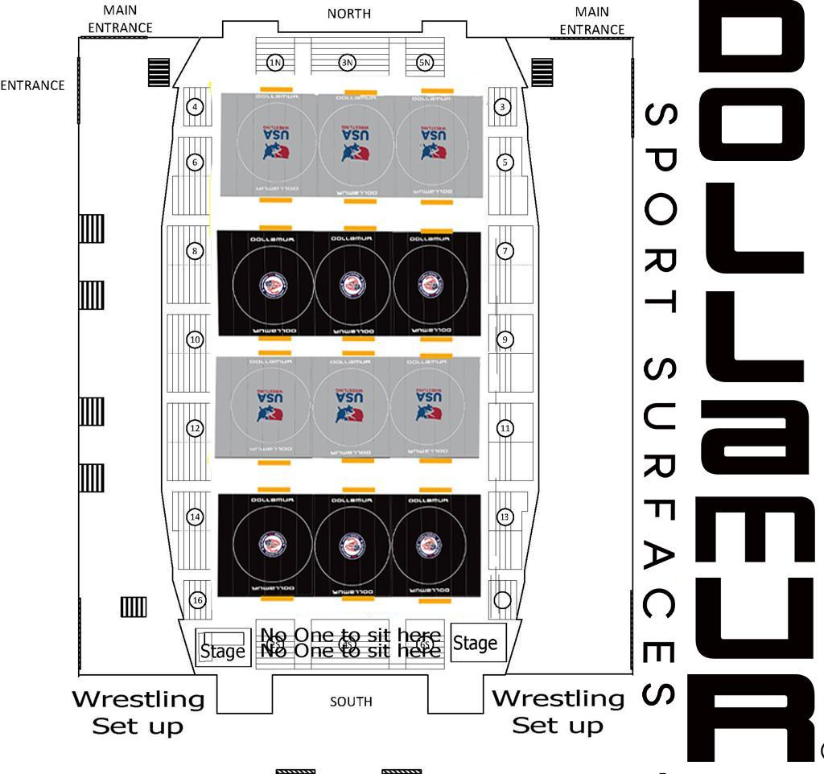
This 12-mat configuration replaces the older 14-mat Selland Arena setup in prior packets.

California USA Wrestling Inc.
Association Duals Championships
USA Junior Boys & Girls / 14U Boys & Girls
2027 Quick Reference
Event Dates | Friday-Sunday, May 14-16, 2027
Location | Selland Arena, 700 M Street, Fresno, CA 93721
Line-up Deadline | Thursday, May 13, 2027
Payment Deadline | Tuesday, May 11, 2027
Friday Weigh-ins | 6:00pm-9:30pm - Greco-Roman & Freestyle
Saturday Weigh-ins | 12:00pm-1:00pm - Freestyle Only
Saturday Meeting | 7:30am
Saturday Wrestling | 8:00am start
Sunday Wrestling | 8:00am start
Mat Setup | 12 mats in Selland Arena
2027 Weight Classes (+2 lbs event allowance)
USA Junior Boys: 100, 106, 113, 120, 126, 132, 138, 144, 150, 157, 165, 175, 190, 215, 285 lbs
USA Junior Girls: 95, 100, 105, 110, 115, 120, 125, 130, 135, 140, 145, 155, 170, 190, 207, 235 lbs
14U Boys: 75, 80, 84, 88, 92, 96, 100, 105, 110, 115, 120, 126, 132, 140, 155, 175, 225 lbs
14U Girls: 75, 80, 85, 90, 95, 100, 105, 110, 115, 120, 125, 130, 135, 140, 150, 165, 180 lbs

