SLPYHA Board Meeting Agenda
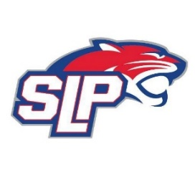
Date: 5/3/22
Bricks
7:00pm

Attendees: Scott Lichter, John Pitzl, Mike Mliner, Corey Piekarski, Adam Kiedrowski, Jon Tranby, Kevin Mitties, Pat Cleary, Nick Peterson
Guests: Jen Grassman, Dan Sandell (The Hockey Lab)

- President Report: Scott Lichter
- Call to order: 7:00pm
- Approve agenda
- Approve minutes from 1/31/2022, 2/28/2022 meetings and annual meeting on 4/5/2022, motion: Lichter move: Mliner
- Jersey update from Jen Grassman
- Latest D10 updates
- Hockey Lab presenting at 8pm
- High School donation
- Vice President Report: John Pitzl
  - Super Rink update
- Treasurer Report/Gambling Report: Mike Mliner
  - Gambling report
  - Volunteer payments
  - All expenses for the month have been approved by the board
- Secretary Report: Corey Piekarski
- Traveling Director Report: Adam Kiedrowski
- Girls Traveling Director Report: Kevin Mitties
- Mite Director Report: Mike Fitzpatrick/Pat Cleary
- Player Development Report: Jon Tranby
- New/ongoing Business:
- Motion to dismiss: 9:35pm, motion: Pitzl move: Tranby

