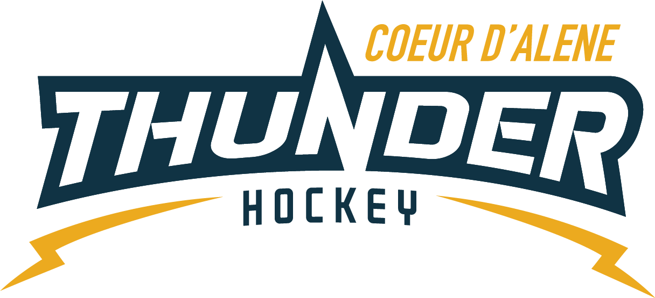

CDAHA

Meeting minutes
Location: Frontier Date: July 20 2021
Attendees: Bob Nelson, Katie Lovitt, Will Higgins, Matt Fisher, Bart Barrett, Megan Smith, Elliot Taub
Absent - Jarrod Hansen, Matt Creighton, Josh Leppert
Guest -
- Call to order
Megan Smith , Vice President called meeting to order 7/20/21 6:33PM
- Roll call
As stated above -
- Approval of minutes from last meeting
Minutes approved motioned by Matt Fisher– Second by Bob Nelson passes unanimous
- New Items
  - TRESURER UPDATE / Finance Committee
    - Current $91,759.75
    - See attachments for update
    - Bob was going to talk to James Costello about Umpqua cost is legit and a thank you letter will get up on web site
    - SAYA will pay ice time
    - July ice time bill
    - Matt Fisher approved treasurer report Megan seconds passes unanimously
    - Raffle tickets updated and ready to hand out on Friday July 23rd
  - Finance committee Update
    - Met and discussed the following –
      - Gear order 8 sets Small – 8 Large sell the helmets so order 16 sets at 500 per set of 4 $2200.00 motion to approve from Matt Fisher – second by Will Higgins all in favor passes unanimously – Katie will order
      - Current CPA is going to bill 500 for set up and 60 dollars per month – Elliot motions to use the new cpa and approve the billing as stated – Megan Seconds – all in favor motion passes
      - May not include taxes and will TBD on 12/31 will let us know if 60 covers it
      - CPA was ok with us not having our own software – the CPA will own the financials and work with the treasurer directly to ensure compliance and accountability – no software is needed for CDAHA at this time – per Katie and the treasurer
  - Coaching Committee Update
      - Leadership for Coaching committee looking to move Joe into the leadership role with coaching committee rolling up to Joe for consensus Coaching committee is gathering the names of those interested in coaching and encouraging them to fill out the application on our website.
      - Nothing else to report at this time.
  - Gear Committee Update
    - 16 sets of gear ordered per meeting tonight
    - Key log no access 10 people responded may look at re keying
    - Katie motions to re key the closet Matt seconds – passes unanimously – Matt Fisher will take point – 10 keys do not copy – set it up same day as board meeting – elliot will email vince and cc Matt
    - Discipline Committee -
      - Jerimiah will be taking over and chair the committee
  - Safesport Committee update – No report
    - Torsten will stay in the role working with Matt C
  - Scheduler update – No report
  - Jerseys – Jackie P will take over and blast to association
  - Kim Ferraro will do power skating classes for 100 per hour currently budgeted for 50 per week but could go every other for Mites and Squirts (LTP votes to be excluded and find a local figure skater) Every other week
  - Every week for Mites / Squirts – Every other week for pee wee, bantam plus bantam rep, midgets, girls, 5 MONTHS 2 times per month 5 - $4000 – let Mike Babcock know it will be every other week
Talk to Matt C and Joe W – Elliot will report next meeting
  - Season start Oct 4 to March 12th – Bantam trave starts sept 20th
  - Registrar meeting September 11th – in person who wants to go – Megan and April
  - Summer Ice spilt pee wees 1st and second 39 v 29
  - Bantam rep try outs 16 sign ups
  - Oversight needed for Kyle Wagner program to ensure compliance – Matt Creighton and anything he wishes to do needs to have board approval 30days in advance of any activities
- Adjournment
Motion to Adjourn Matt Fisher second by Will 7:40
Minutes submitted by: Elliot Taub
Minutes approved by: BOD
- Next Meeting
  - TUE Aug 3 2021 6:30PM
  - Will motions to adjourn -
  - Frontier ICE Arena and potential zoom due to vacations TBD

