

CRYHA Meeting Minutes
Dec 27, 2018
Scheduled Start time
CRIC, Coon Rapids, MN

Meeting called to order by Summer Anderson at 7:05 pm
Board Members; Attendance was taken and the following were present:

Summer Anderson, President | Jenny Moe, Registrar
Mandi DeGrote, Vice President | Stacey Johnson, Equipment Manager
Holly Bachman, Treasurer | Steve Ellenson, Tournament Director
Todd Bushy, Recruiting and Retention | Jim Boden, Player Representative-via telephone
Britney Severson, Secretary | Michelle Lange, Gambling Manager
Kim Spah, Fundraising Coordinator | Sue Erickson, Assistant Gambling Manager
Dan Bieurance, Boys Traveling Director | Chad Alsaker, Safe Sport/ACE Coordinator
Tim Matsche, House/Mite Director | Kelly Sartwell, Volunteer Coordinator
Jeremie Bresnahan, District 10 Representative | Don Ruotsinoja, Referee-In-Chief- via telephone
Jen Shirshov, Girls Traveling Director | Jeff Ammann, Board Member At Large/Ice Scheduler
, Mite/U8 Administrative Director | Steven Moe, Boys High School Coach
Brian Mountin, Website Coordinator | Jim Koltes, Girls High School Coach
, Goaltending Development Director | Darren Marty, PR/Sponsorship Coordinator
Jacob Mars, Hockey Director | Mandy Lilledahl, SKATE Banquet
Jason Rodrigues, Co- Treasurer
Number of Members present: 14

Motion made by C. Alsaker to approve the agenda. Seconded by H. Bachman, no opposed

Gambling Manager M. Lange
- No donation this month
- Motion to approve gambling activity made by C. Alsaker, seconded by B. Mountin; no opposed
- Motion to allow Jan estimated allowable expenses M. DeGrote, seconded by C. Alsaker; no opposed
- $43,000wee paid in taxes in November
- Current owner of Eagle Street Bar and Grill will stay until April and is unwilling to start gambling so will not have gambling there until April

Treasurer H. Bachman
- Accounts are staying strong
- $7,600 in sponsorship- Thanks Darren!
- $78,000 from gambling- Thanks Michelle!
November 2018
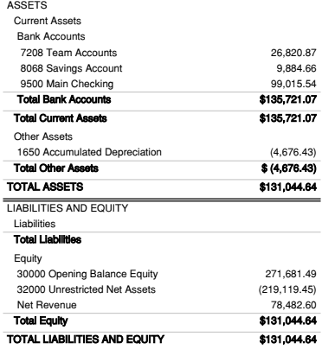

Motion made by C. Alsaker to approve the November financials; seconded by D. Marty. No opposed.

Motion by M. DeGrote to adjourn at 7:30 pm, seconded by S. Anderson. No opposed

Minutes submitted by: Mandi DeGrote, Vice President

These minutes are current, true and accurate:

President: Summer Anderson
Vice President: Mandi DeGrote

Signature: _________________________
Date: ______________, 2018

