SLPYHA Board Meeting Agenda
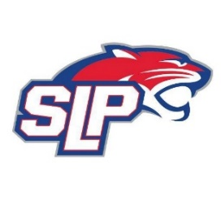
Date: 1/21/21
Zoom
8:00pm

Attendees: Bob Roloff, Scott Lichter, Michelle Rice, Corey Piekarski, Mike Mliner, Jason Shipman, Kevin Mitties, John Pitzl, Jeremy Flaten
Guests: Cindy Tranby

- President Report: Bob Roloff
- Call to order: 8:00pm
- Approve agenda
- Approve minutes from 11/18/20 meeting, motion: Lichter move: Roloff
- Latest D10 updates
- Vice President Report: Michelle Rice/Scott Lichter
  - Golf tournament dates (August 7th or August 20th)
- Treasurer Report/Gambling Report: Mike Mliner
  - Bonuses for pull tab sellers
  - Clothing and apparel for pull tab sellers
  - Donation/Partnership with Friendly Chevrolet
- Secretary Report: Corey Piekarski
- Traveling Director Report: Jason Shipman/Chris Mueller
- Girls Traveling Director Report: Kevin Mitties
- Mite Director Report: John Pitzl
  - Mite goalies
  - Goalies sessions for Mites?
  - Free equipment? (pads, helmet, stick, etc…)
  - Reduce season fees
  - Youth refs for all mite games
  - Rent mini storage?
  - SR 1 Update
- Coaching Director Report: Jeremy Flaten
  - Coaches update and development plan
- New/ongoing Business:
- Motion to dismiss: 10:12pm, motion: Shipman move: Flaten

