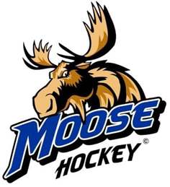
Palmer Hockey Association
Palmer High School
1989, 2019 and 2025 Alaska State Champions
PO Box 1471
Palmer, AK 99645
www.PalmerMooseHockey.com
Pizza Ria Delphi MVP Suite
The Pizza Ria Delphi MVP Suite is a great way to entertain customers, potential customers, employees, family and friends. Treat your group to dinner and a Varsity hockey game at the MTA Events Center for the 2025-2026 regular season. Anyone can reserve the Pizza Ria Delphi MVP Suite during home games and cheer on the Moose with pizza and drinks, all at the same time!
Rental includes:
➢ 15 passes for free admission
➢ Pizza and non-alcoholic drinks for 15
➢ Display your business or organization banner (sponsor provided)
➢ Display business or organization information for your guests
➢ Sponsor name mentioned during the game
➢ Front row to great high school hockey
Great hockey, great food, and great fun for only $400 per Varsity game.
Make your reservation early, as great games will go fast.
Reservations made by October 31, 2025, will be listed as sponsors in the game program.
Date Time Opposing Team Status
Tuesday, 11/18 7:00 pm Colony Imaging Associates
Friday, 12/12 7:00 pm Kodiak Available
Saturday, 12/13 11:00 am Kodiak Available
Thursday, 1/15/26 7:00 pm Homer Available
Friday,1/16/26 7:00 pm Kenai Allen/Valley General
Saturday, 1/17/26 12:30 pm Sohi Stohler & Lonergan, P.C.
Tuesday, 1/20/26 7:00 pm Houston Available
Tuesday, 1/27/26 7:00 pm Wasilla Hometown Realty ~ Harmony Chadwick

All business and organization materials can be displayed starting 30 minutes prior to game and immediately following. Any items left after that time will be disposed of properly.
Thank you for your sponsorship of Palmer Moose Hockey!
For questions and reservations contact: Leslie Swanson (907) 373-8558 or vp@palmermoosehockey.com
LET’S GO MOOSE!!

