
MINUTES TO BE APPROVED AT THE NEXT BOARD MEETING. THESE MINUTES ARE NOT CURRENTLY POSTED AND SHOULD NOT BE DISTRIBUTED UNTIL APPROVED BY USASSCS BOARD.
Board Meeting Minutes November 16, 2023
Location: Santee City Hall
Attendees Shown with Marked Box
President | Jay Strandberg | X | Field Prep | Kevin Hopkins
1st VP/ Field Prep | Erik Ruiz |  | Field Prep | Trevor Henton | x
2nd VP | Kelli Timanus | x | Field Prep | James Timanus
Treasurer | Tiffany Lynch | x | Field Prep | Nate Anderson
Secretary/Safety Coordinator/Head Scorekeeper | Bryan Scholar | x | Field Prep | Brad Allen
Tax Advisor | Lori Britt |  | Field Prep/Equipment | Shane Frary | x
Player Agent | Lance Craw | x
UIC/Parliamentarian | Felicia Leca | x | Head Team Parent Coordinator | Dana Hisaw | x
Field Scheduler/Fall Ball Coordinator | Chris Klima | x | Uniform Coordinator | Jamie DeChant
Webmaster/Social Media/All-Star Coordinator | Alexis Ruiz |  | Picnic Coordinator/Pictures | Kat Vecchione
BOTH Tournament Coordinator | Kayleigh Ponciano-Ahue | x | Snackbar #1 | Amy Ramirez | x
Sponsorships | Kylee Scholar | x | Snackbar #2
Awards | Janis Aiello | x | Social Media Coordinator | Sophia Vigil | x

Guests: N/A
Meeting called to order: 7:04PM
Meeting Minutes
Brad Allen motioned to approve minutes from 10/10/23. Amy Ramirez seconded the motion.
Meeting rule – One Topic at a Time
Financial Update (Tiffany L)
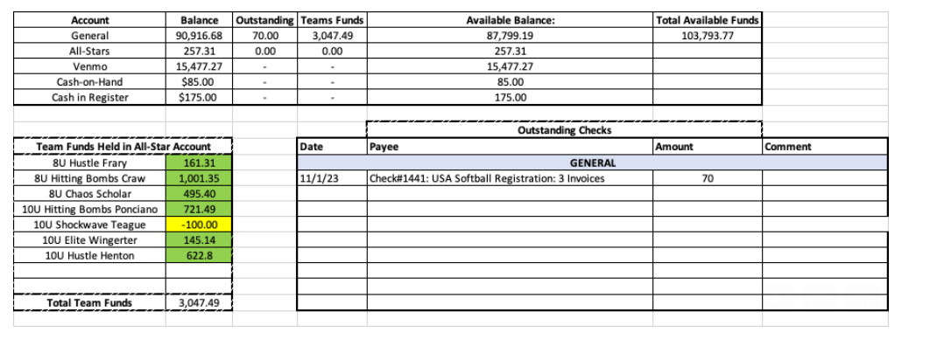

Snack Bar

Spring Rec – Manager Meeting 1/17 – Draft on the 18th – Practices begin 1/22
Easter Break - No softball games March 25 – 30. Games will be played April 1 – 6
TOC: 4/22 – 4/27
Manager Selections – 1/8

Fields/Equipment
Meeting Adjourned: 9:14 pm
Next Meeting: December 11

