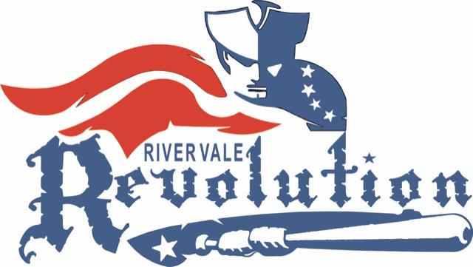

Revolution Travel Baseball/Softball

- Travel Eligibility
- River Vale children in grades 2-8 who were registered for the Spring Recreational program are eligible for travel.
- Players are willing to commit to playing at least 80% of Rec games/practices and also playing 2-3 games and 1-2 practices per week during the travel seasons.
- The age requirements are as follows
  - 14u- Must be 14 or under with no player turning 15 before 9/1/23
  - 13u- Must be 13 or under with no player turning 14 before 9/1/23
  - 12u- Must be 12 or under with no player turning 13 before 9/1/23
  - 11u- Must be 11 or under with no player turning 12 before 9/1/23
  - 10u- Must be 10 or under with no player turning 11 before 9/1/23
  - 9u- Must be 9 or under with no player turning 10 before 9/1/23
  - 8u- Must be 8 or under with no player turning 9 before 9/1/23
*Some age requirements vary by leagues. Make sure you check on league websites.

- Selection Process
  - It has been the long- standing policy of the RVBSA that no child be cut from the program before 9u. Every effort will be made to place kids on a team. If there is sufficient interest and coaching volunteers, a B team will be formed at each level.
  - Players will be separated by their current grade. The travel program is grade based, we do not allow “playing up” or “playing down” unless the player is too old to play for their grade. Such players will be considered to play a grade up but are not guaranteed a spot.
  - The Vice President, League Directors, and coaches will oversee the travel selection process for each grade and select the teams
  - Evaluation will be based on the following categories: (1) Behavior/sportsmanship, (2) fielding/pitching, and (3) hitting. Each category is equally weighted
  - The VP’s and League Directors will keep the results confidential and will integrate this data when finalizing the teams

- Travel Team Guidelines
  - While the travel program is designed to be competitive, the Revolution is not a “win at all costs” program
  - It is recommended but not required to have 12 kids on a roster. In the end it is up to the coaches and League Director to finalize rosters.
  - 10u and below: Where the travel league permits a team to bat its entire lineup with unlimited substitutions (sometimes called the “Optional Rule”), the travel coach must select this option.

- 8u/7u Coach Pitch
  - RVBSA will attempt to place 8u players who are not selected for the kid-pitch travel team on a coach-pitch developmental team.
  - Where there are not enough 8u players to form a team, 7u players will be invited to fill out the roster. 7u eligibility will be determined after 8u travel selection is completed.
  - The 8u/7u coach pitch team is not a competitive team. It is a developmental team that will play in an instructional league where there are no umpires and no standings.

