To quickly add in only the score to be displayed on team pages and used to aggregate stats to widgets.
- Sign in and turn on Edit Mode.
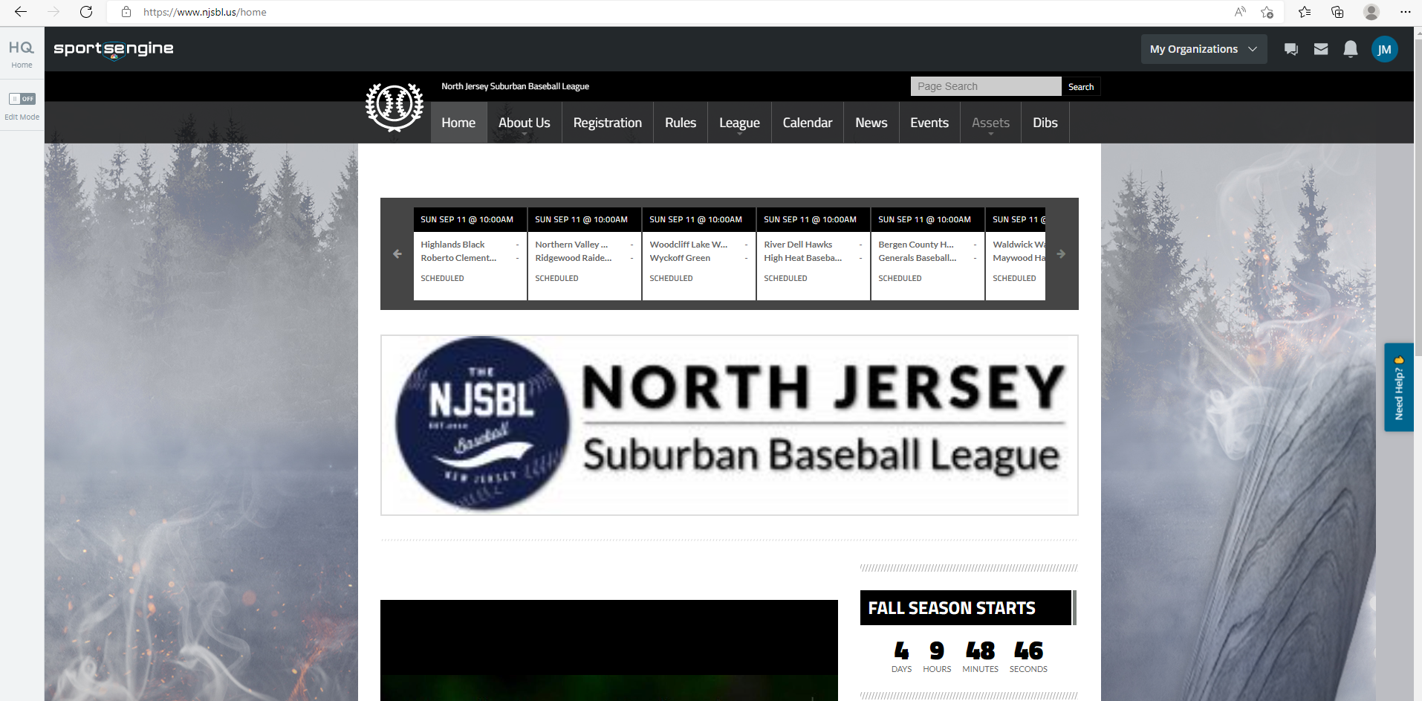
- Find the Team Page you want to score from.
Go To League Menu – Select Your Division – Then Select Your Team (Note you can also search for your team in the Page Search Field)
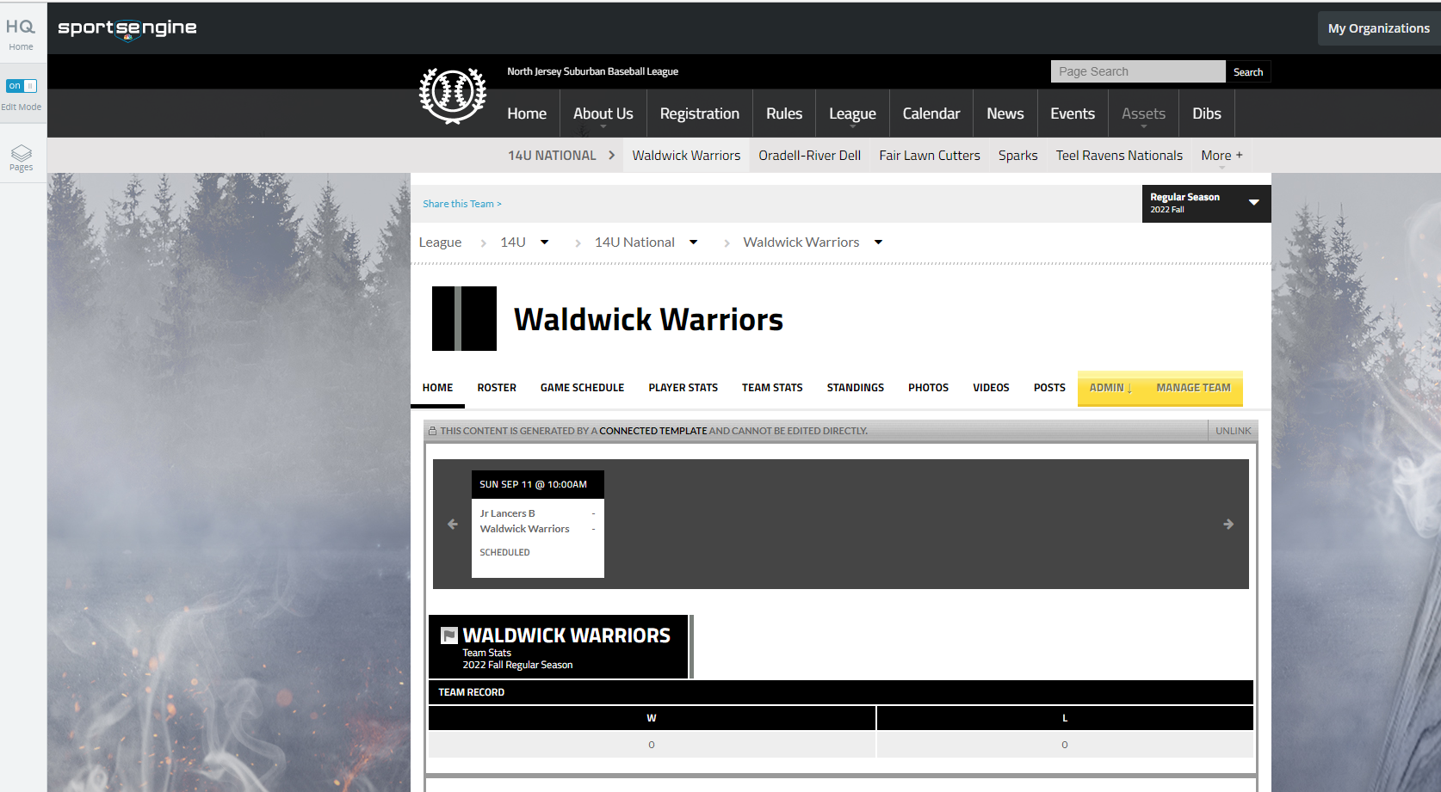
- Select the Game Schedule sub-tab.
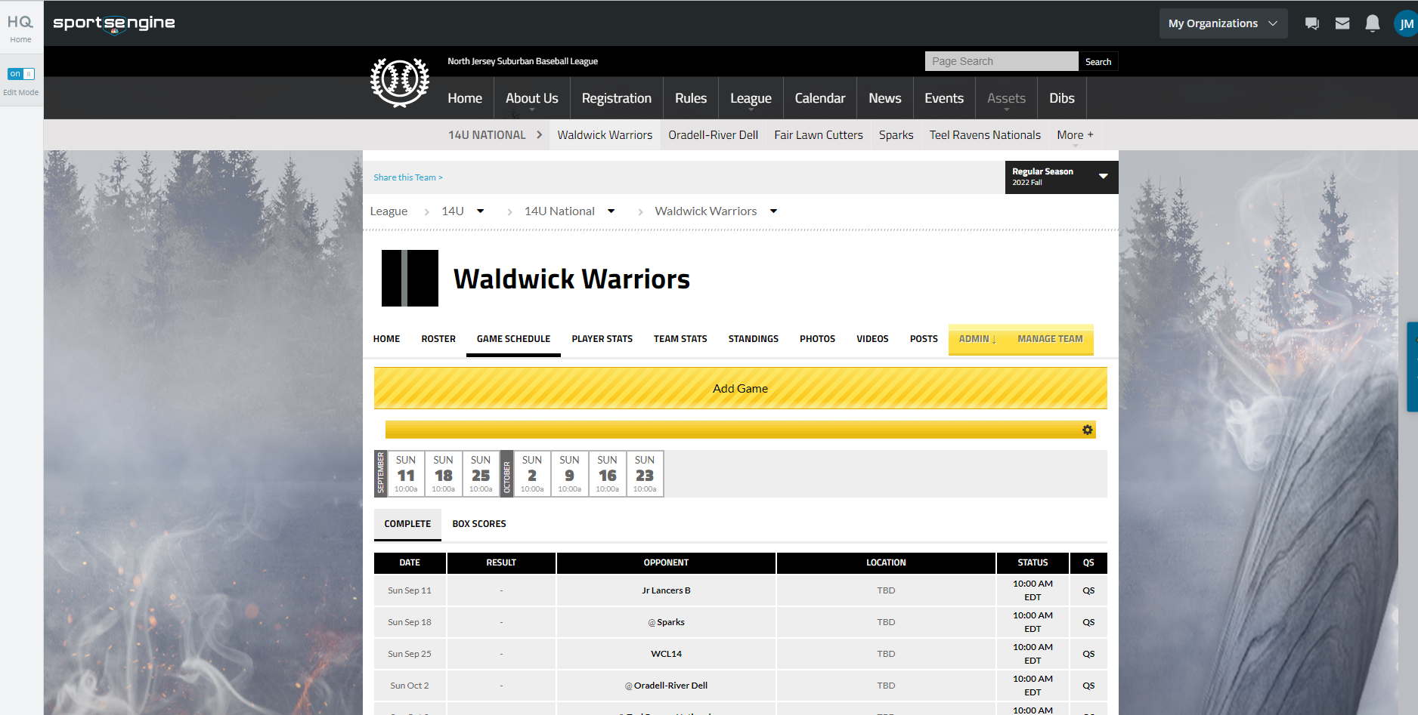
- Under the Status column, click on the "time of the game".
- Scroll down and choose Quick Score.
- Input the score of the game, and change the Game Status to Final.
- Click Save.

Scoring in the APP
- Download the Sports Engine App
- Open Sports Engine APP – Your team should be listed
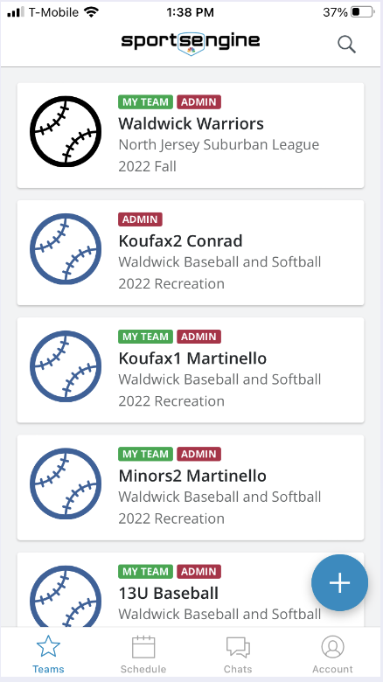
- Once your team is open click on the Schedule Icon
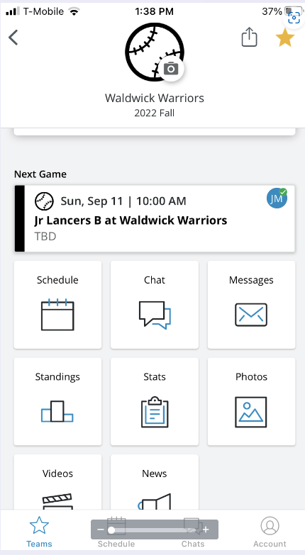
- Your schedule will be displayed. Click on the game to score.
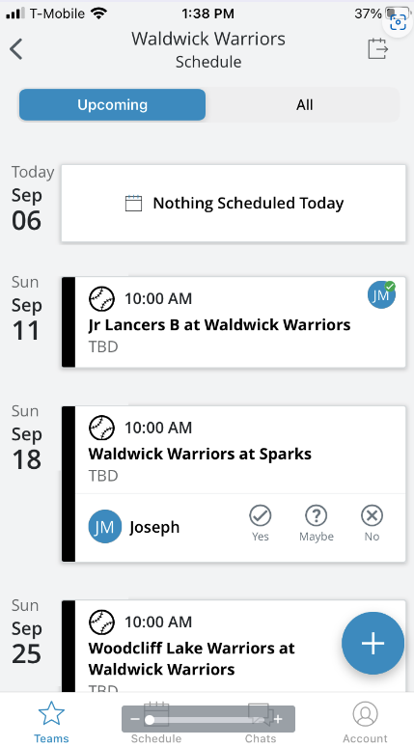

- Game Details will be displayed. Click on the Pencil Icon at the lower right
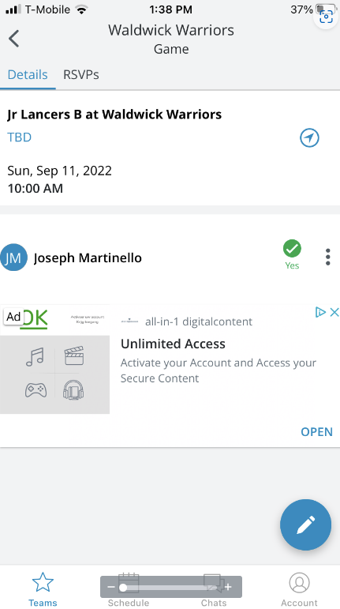
- Click Score Game
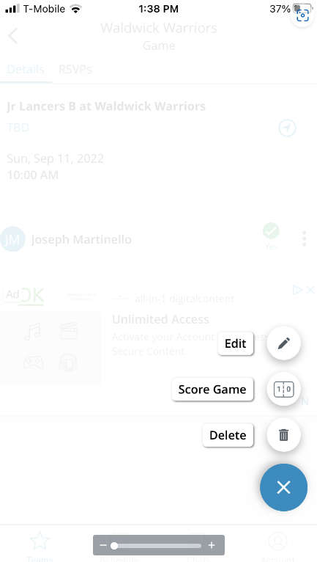

- Update Score and Save
