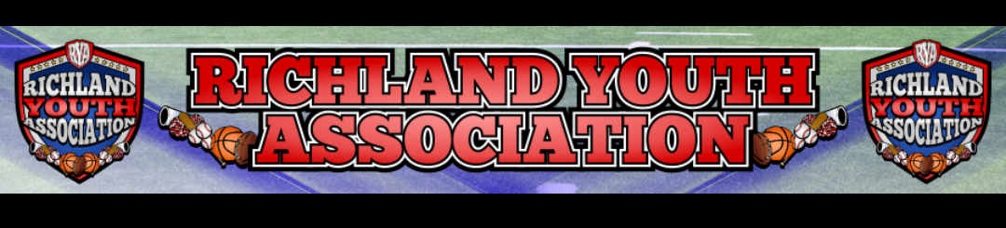
Meeting Date: September 7, 2022 – 6:30pm
Attendees: Mike Cowan, Ben Earley (partial), Blair Armfield, Richard Stutheit, Lisa Willis, Eric Gomez, Marissa Jennings, Emily Standifer (non-Board)
Absent: Kevin Vorpahl

RYA SEPTEMBER BOARD MEETING

General Board Items / Old News
- Did not receive monthly check from Jennifer (not since November)
- Received $125.00 from Pudgy Penguin fundraiser
- Received $250.00 from Las Palapas fundraiser

Rec Baseball: Richard Stutheit
- Jerseys should be in by this Friday, per Zexez
- Field maintenance issues started being addressed by city (CT1 home plate broken, missing locks, RF1 missing 1B)
- Coaches are all background checked and verified through NAYS
- Kevin notified to get umpires background checked - only have 3 qualified umpires as of 9/7
- $40 spent total on FB advertisements
- 224 current players in Fall Rec Baseball (up from 160 last Fall)
- Tournament cancelled for this September - only one team signed up

Football: Eric Gomez
- Football paid except for practice jerseys ($1910)
- Exploring banquet options - 600-700 guests estimated
- Concessions being run by Football volunteers and not using RYA concessions employees / funds

Cheer: Lisa Willis
- Cheerleading bills paid in full
- Etsy refunded the $25 in taxes paid previously
- Refund needed for late registration - K. Carter (registered via SportsEngine website)
- RYA / Richland HS Homecoming Parade (Sept 19th, Monday at 6pm) with 7 RYA floats

Basketball: Blair Armfield
- Registrations open to Oct 31st - cost increased to $200 for registration
- Zexez for uniforms / reversible and shooter shirts ($72.00/player)
- Games used to be at North Richland MS, now over at Haltom MS w/ cost of $10,114 to district (police officers required at all games per Birdville ISD)
- The Link (RH) also used for games, $52/hour (up from $45/hour in past seasons)
- Estimating to profit about $26.00/per kid
  - Estimates based on registering 300 kids
- Website updated with dates to remember
- Games from Jan 7 - March 4

Marketing: Marissa Jennings
- Exploring RYA sponsoring Fall Carnivals at elementary schools (Snow Heights and Holiday Heights)

Premier Baseball: Kevin Vorpahl (ABSENT)
- Received $2,412 check from Kevin for August’s baseball tournament

Meeting adjourned at 8:25pm

