You require that multiple people receive EMAIL and/or Text notifications for the child that you registered for a sport on the St. Anastasia CYO website. CYO introduced a new website this year for the 2018 Fall Season. (We are using a tool called “Sports Engine” to help us manage our website)

This new sitei
I allows you to assign multiple “Guardians” to your child’s profile so that they can receive communications from coaches and administration via the website.

Requirement: In order to be assigned assigned as a guardian, the individual you wish to assign MUST have an account with the www.stanniescyo.org website. If they do not have one, they will be required to create an account before they can confirm your invitation to be a Guardian. Additionally, only the account that registered the child can assign the Guardians.

The steps outlined below assume you are using a computer to complete the Guardian assignment. This currently does not cover the use of the Sports Engine APP.

- Login to the St. Anastasia CYO website and then go to your account settings.

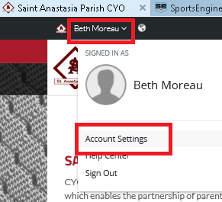

- If your account settings resemble the screen shown below, please click on the “Try the New Experience” button to go to the new Account Dashboard. Guardians can only be assigned in the new Account Dashboard. Note: Skip this step if you do not have this screen below.

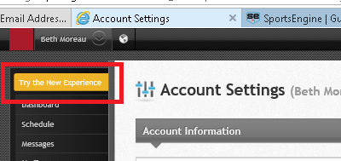

- Once you are in the new Sports Engine account dashboard, click on the Profiles option in the menu on the left.

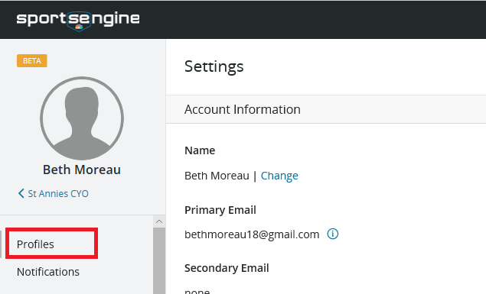

- Now click on the child that you registered to display their profile.

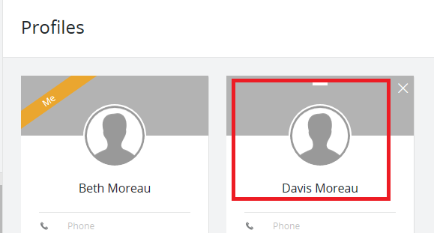

- Now that you have displayed the profile of our child, you can now assign new Guardians. Click on the “Plus” sign in the Guardians section to enter
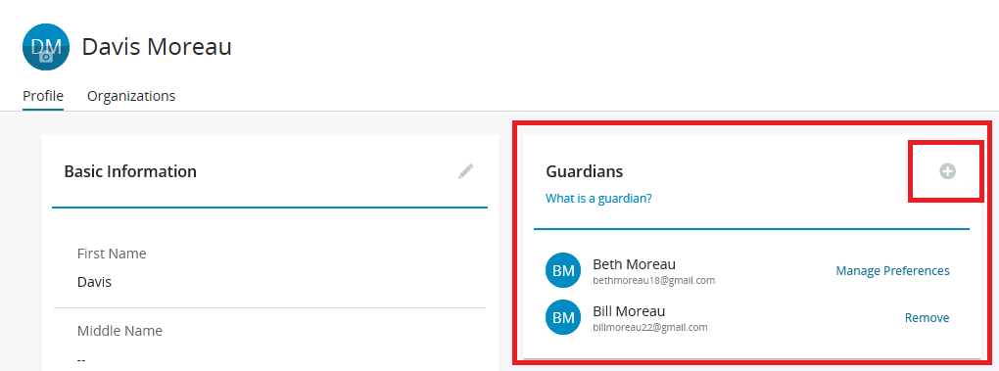

- Enter the email address of the Guardian and then click on Send Invitation. If the person does not already have an account, they will be required to make one before the invitation can be confirmed.

