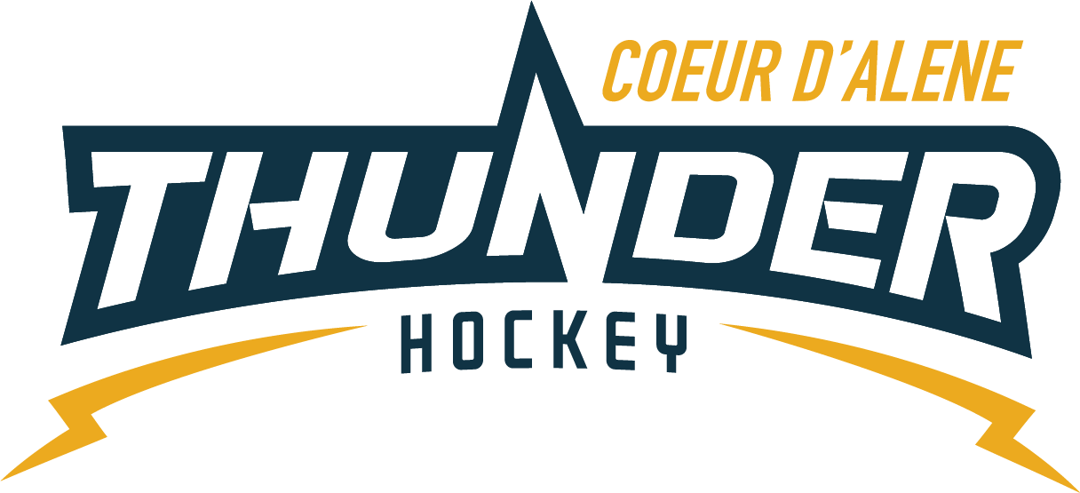

CDAHA

Meeting minutes
Location: Frontier Ice Rink Parking Lot
Date: October 8, 2020
Attendees: Bob Nelson, Elliot Taub, April Hocking, Meghan Smith, Torsten Langley, Matt Creighton, Bart Barrett, Jarrod Hansen, Matt Fisher, Josh Leppert, Jeremy & Jackie Guerrin, Jackie Petterson, Kami Winfrey, Stacy Veach, Steve Skinner and about 20 mite parents
Time: 6:00pm
- Call to order
Bob Nelson, President called meeting to order 10/8/20 @6:04pm
- Roll call
All present
- Approval of minutes from last meeting
Pushed till next meeting or online
- Open issues
  - Treasurer Report pushed to save time
  - Scheduler’s
    - Stacy/Kami said Moscow has reached out and Lewiston is beginning to reach out for games as well
    - Vince has reached out to Spokane and not heard back yet
    - Email sent for open ice with no response
    - All teams will have to read policies of each rink before arriving
    - We have tier 2 teams that need to get 10 games in to be eligible before Jan 1 please keep them on your radar – PW, Bantam, Girls, Midgets
  - PEP proposal
    - Tyson Esivedo is looking for a home affliliate after leaving Spokane, he will be invited to our next available board meeting to discuss
    - Matt C will do research in the meantime, Bob will check the legalities of it
    - Possibility to put out to entire Association for a vote
  - Jersey Conflicts
    - Jackie would like a the backing of the board if we are to draw a hard line in the sand due to late registrations after multiple announcements.
      - Having conflict with returning skaters wanting their numbers but they registered after the drop dead date.
      - Board will back with the policy join late lose your number even if returning to keep the timing of jerseys on time.
  - Car Stickers – Steve Skinner
    - Wants to buy 50 to hand out to our people
    - Asked for permission if he could do this
      - Absolute YES
  - Manager’s Meeting
    - April would like to have all managers carry in their binders a Medical Release
      - Board agreed
  - Refund Policy
    - Wanted to create a policy specific to this season and formalize it.
      - Jan 1 season ending date, injury, prorations
        - Reviewing to make sure all are on the same page.
  - Mite Program
    - Annie Brown read letter to board stating she had spoke a USA Hockey rep pertaining to #s of Mites on the ice at once, wanting to pay for extra ice, coached here for 2yrs, wanting to know how coaching determined, are we delivering a quality program, are we ready to listen to solutions.
    - They were reminded that we were all volunteers serving in CDAHA and assured we have had MANY conversations about this very topic every year, we are held to the standard of the owner of the ice and share with 5 other entities. Meghan let them know if we were to get more ice our prices will have to rise as a whole. Josh reminded them there used to be 108 skaters and very little coaches. We are still growing and adjusting every year.
    - Will and Saraa came up with the suggestion of removing the LTP off 25 minutes into practice and allowing the rest of the time for all the Mites
    - Rhett would like to close the registration
    - Suggested Mites split and go once a week
    - Suggested a survey to get the parent intake

- Adjournment
Bob adjourned the meeting at 7:29pm.
Minutes submitted by: April Hocking
Minutes approved by: CDAHA BOD
- Next Meeting
  - October 29, 2020 LIVE 6 PM changed to a Thurs.

