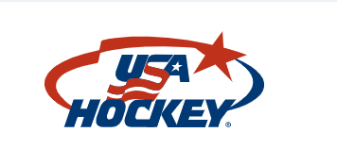

By registering as a member of USA Hockey you are automatically enrolled in the USA Hockey insurance program. The following is a brief description of the insurance policies provided to registered members of USA Hockey.

Tips For Filing a Claim
If you are a registered USA Hockey member and you are injured while participating in a USA Hockey sanctioned activity, follow these procedures:
- At the hospital or doctor’s office, always provide them with your individual, employer health plan, union plan, etc., information as your primary plan.
- The USAH plan requires that treatment following an injury must occur within 30 days from the injury date.
- If you have no other insurance, then your USAH plan will be the primary plan with a $3,500 deductible.
- ONLY CLAIMS ARISING FROM A USAH SANCTIONED ACTIVITY WILL BE HONORED.
- If you need assistance filing an online claim, please contact A-G Administrators customer service team at 484-320-7286.

Step 1: Click this link to file a claim.
Step 2: WHAM Form. Submit to leagueadmin@whamhockey.org

