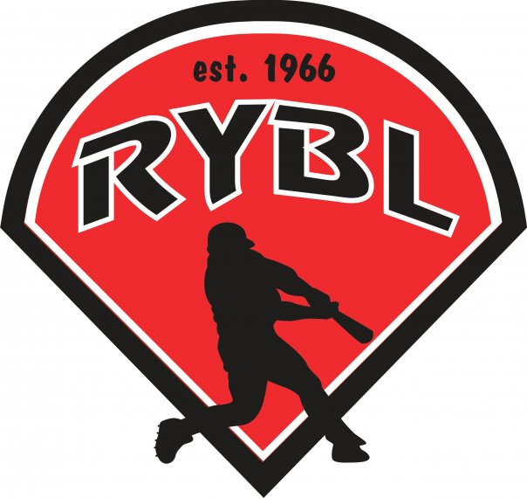
RYBL April 2022
Board Meeting
03/17/2022 7:00 PM
- Call to Order
- Opening Prayer
- Special Guest Adrian Hart and Amy Reed to talk about concessions city tournament dates asap - 5 days a week 5 people to run it 60/40 8k already given to the concessions – 3k to be returned to the boy’s league – shut WIFI off at end of year – $1,500 left in account – 2.6% and 10cents for credit card – $10 minimum - start when the session start?
- Previous Board Minutes Approval – Andy Keogh
  - March 2022 Minutes – Approval
- Treasurer’s Report – Adam Brock
  - Current Bank Balance: 50,000 after 30,000
    - Outstanding Bills: Insurance was paid, need a $500 check for Lions Club on bathroom remodel
    - Accounts Receivable:
- Office and Committee Reports
- Secretary – Andy Keogh – Facebook closed group and YouTube channel
- President – Bryan Altmaier
- 1st Vice President- Chris Pavey signs for opening and closing responsibilities – bylaws change to reflect what Cal Ripken does
- 2nd Vice President – Mickey White – program/rosters with adds $650 talk to the people who do the pictures and get the copies
- Player Agent – Zac Reser
-306 players registered this year so far
- Equipment Manager – Dawn Hyman
-Parade information- Dawn has sent the lineup for the parade to managers, Chris and Mickey make sure everyone knows where to go before Saturday
- Umpire in Chief – Matt Adams lock box for umpire’s week at a time 2 keys – 2nd year ump being chewed on – how do we calm the fans off -
Ground Maintenance- Greg has sprayed for weeds, would like to get some finishing touches done tomorrow before opening day as long as weather permits. Paint lines and get field ready for games. Rebuild the mound
- Unfinished Business
- Need to get with J&J on update for light project cost 5 bulbs no labor costs
- Light bulbs for major league field, five of them need replaced, let’s get someone to replace them
- I will replace more bulbs on scoreboard
- Rookie league scoreboard is back to working
- Need at least a new mic for rookie league press box, vote to order a new one on amazon cost is $70
- New Business
- Concessions is almost ready to take credit card
- Order of parade at opening ceremonies
  - Parade starts at 9am
  - Opening Prayer Ned Sutherland
  - National Anthem
  - Thank everyone for mother son dance participation 2 nights or bigger venue?
  - Discuss our future projects with replacing the poles and lights and wiring
  - Announce each league and let managers announce players on their teams, please let managers know to be prepared for this before ceremony
  - 12-year-old Jacket ceremony (list of all 12s?) I will announce, someone put them on them?
  - Raffle Drawing
  - Thank all our sponsors (anyone have a list of all of them to give me?)
  - First pitch (still need someone to do this?) If we are going with 12-year old, I say we either do Aiden Ring voted for 1st pitch or Nelson Jordan. Both boys have showed great attitudes their whole career at RYBL and Aiden Ring broke his wrist this year, so I think it would be huge for him to be able to throw out first pitch.
- Next board meeting is Thursday May 19th at 7pm Lions Club
- Adjournment

