SLPYHA Board Meeting Agenda
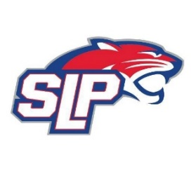
Date: 8/30/21
Brick’s
7:00pm

Attendees: Scott Lichter, Jeremy Flaten, Jason Shipman, Kevin Mitties, Mike Fitzpatrick, Corey Piekarski, Mike Mliner, Bob Roloff, John Pitzl
Guests:

- President Report: Scott Lichter
- Call to order: 7:00pm
- Approve agenda
- Approve minutes from 8/9/2021 meeting, motion: Mliner, move: Flaten
- Latest D10 updates
- Items to include in association email
- The Hockey Lab
- Jersey order
- Goalies – goalies to pay only registration (motion by Roloff and moved by Pitzl), squirts will be supplied with equipment (pads) and peewees and bantams are responsible for their own gear.
- High school donation amount TBD
- Concussion prevention email
- Vice President Report: Michelle Rice/John Pitzl
  - Play up policy
  - Mite 3rd grade play up policy to be revised (motion by Pitzl and moved by Mliner)
- Treasurer Report/Gambling Report: Mike Mliner
  - Motion to transfer $30,000 from gambling account to hockey account by Mliner, moved by Piekarski
  - The board approved expenses as presented by John Pitzl
- Secretary Report: Corey Piekarski
- Traveling Director Report: Jason Shipman/Adam Kiedrowski
  - Tryouts, judges, volunteers, iPads
- Girls Traveling Director Report: Kevin Mitties
- Mite Director Report: Mike Fitzpatrick
  - Mite refs – Kristin Genet
  - Panther Cubs update
  - Try hockey for free
  - Mite update (Mite night at The Hockey Lab for A/B and projected jamborees)
  - A/B Mites will have 3 tournaments (motion by Pitzl and moved by Roloff)
- Coaching Director Report: Jeremy Flaten/Bob Roloff
  - Mandatory coaches meeting
- New/ongoing Business:
- Motion to dismiss: 9:49pm, motion: Fitzpatrick, move: Roloff

