Staff Appreciation Night Checklist
Quick Glance: This is a night to recognize all the school staff members that have shown support for our girls throughout the season. Each player and staff members are announced. Each grouping has their picture taken on the ice. Refreshments maybe served during the game.
PLEASE NOTE: ALL EVENTS SHOULD BE PRESENTED TO BOARD ONE MONTH PRIOR TO EVENT.
Prior to Event
- Plan: Parent volunteer for pictures (2021 volunteer position).

- Plan beverages/treats for the event. Some ideas are: coffee, hot cider or orange drink. (Please check with board for current arena rules).

- Plan: You will need to make sure you napkins, cups, table covers (if applicable).

- Plan: Table or equipment requirements. Speak to volunteer board member to get table request to city prior to event day.

- Plan: Letter player will give to teacher (see example below).

- Plan: Teacher shout out/appreciation:
  - Posters??
  - Video??
  - Gift bags?? (flowers, candy, thankyou note)

- Plan: List of teachers getting invited and why. NOTE: This is easiest to acquire at a pasta feed.

- Plan: Present idea to board one month prior to event.

Day of Event
Set up time – 4:00 PM
- Bring Extension cords if needed
- Hang sign for teacher entrance on main level east side next to the “locker rooms”
- Have a list of teachers that have been invited
Teacher check in and ceremony plan
- Arrive at east entrance and sign in to receive player jersey to wear during the game and photo (Jen will do this for before, during and after the game)
- At 6:20 teachers line up in numerical order
- At the conclusion of the JV game (approx. 6:30) player and teacher will be announced and brought on the ice for picture. Teachers will line up and remain on the ice for final thank you.

Former Ideas:
Treat bags with photo

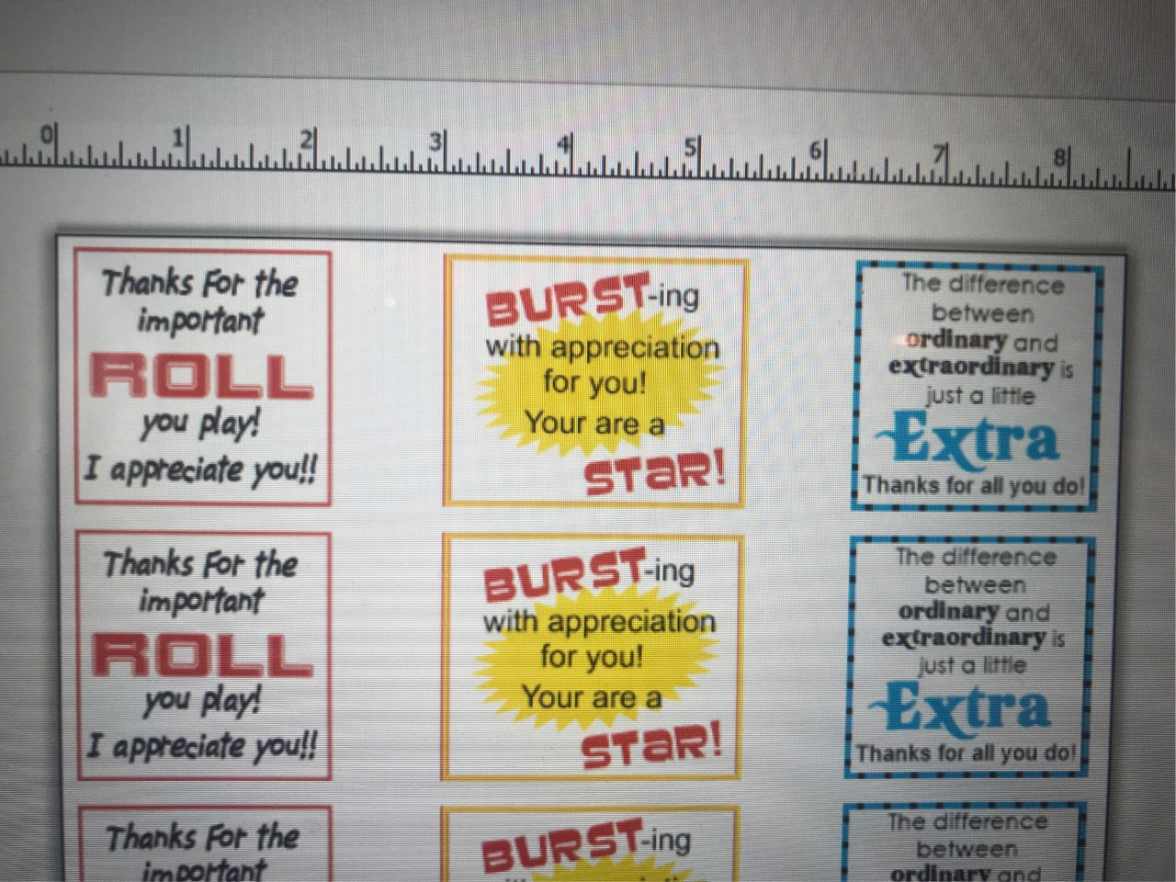

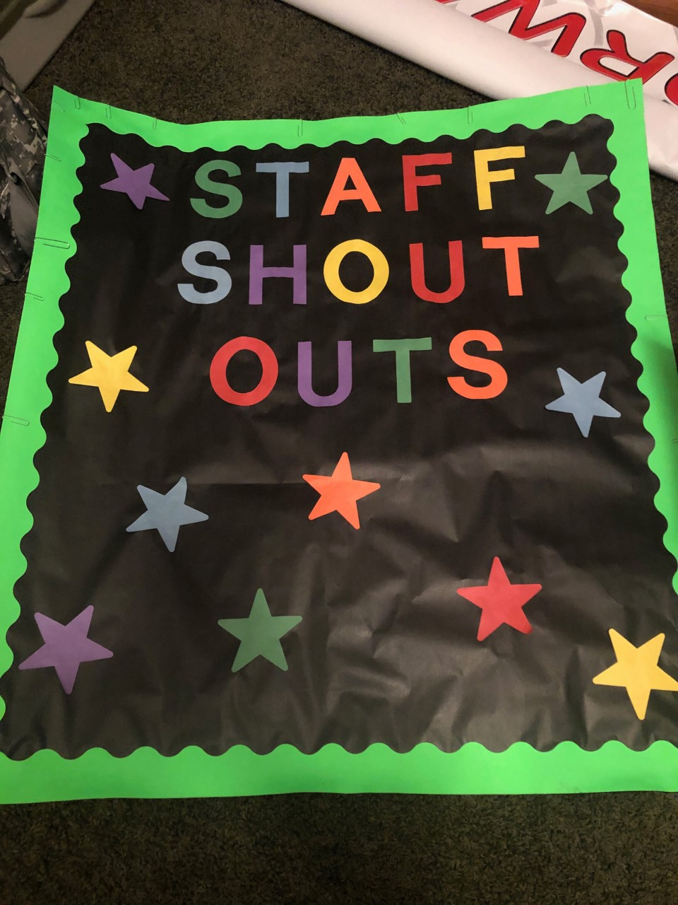

Example of player letter to teachers:
Thank you for coming to my game on Staff Appreciation night – Thursday, November 21st at Elk River Ice Arena
Staff recognition:
6:20 – line up with me along the east side of the rink near the entrance.
6:30 – Join me on the ice for a photo and a team appreciation message
Come watch me play! Teachers get in FREE. I’m playing in the:
JV game at 5:00 Varsity Game at 7:00

