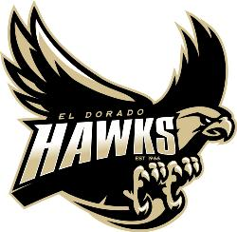

2019 El Dorado Baseball
Casino Night
Player Responsibilities

Poker: Each player will be responsible for signing up (2) or more poker players or casino game players. Cash or checks (payable to: El Dorado Baseball Boosters) RSVP and money due by February 1st to Cynthia Haskell (address below). Casino night is Saturday, February 09, 2018 doors open @ 5:30PM dinner served at 6:00PM.
Donation items for Baskets: We need to make 25 gift baskets to raffle and auction off. Please solicit as many items for our auction. A copy of the donation letter was given with the invitation .Donations due by February 1st please send RSVP for casino night as soon as you get them and mail them to me. I will need a head count for dinner and game tables.
We are working hard to put together a successful Casino Night fundraiser. Any and all help is greatly appreciated and welcomed. We look forward to seeing all of you and thank you for your support in making this program great!
This is a fun evening to build and strengthen friendships from all three baseball levels. Don’t miss out on an evening of making new friends and building team spirit. Let’s kick this season off with a great and successful Casino Night!
If you have any questions, please contact Cynthia Haskell @ cynhaskell@gmail.com or
714-742-9177.
El Dorado Baseball Boosters
C/O Cynthia Haskell
5312 Marynell Dr.
Yorba Linda. CA 92886

