HOW TO ADD A NEW EVENT
**Must be in EDIT mode

Step 1 – Select Manage Team

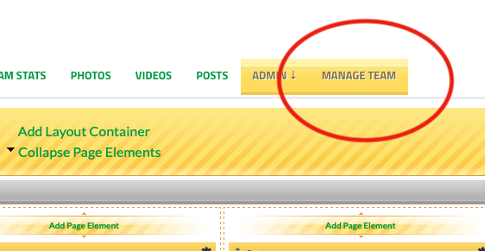

Step 2 – Select “New Event”

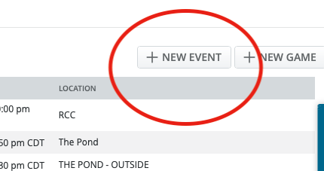

Step 3 – Fill in the necessary Information, Don’t Forget to “ADD EVENT”

