SARTELL SAUK RAPIDS LACROSSE ASSOCIATION
Board of Directors Meeting
Wednesday, March 20, 2023
6:00 PM
Blue Line-Sartell

Meeting Minutes
*Approved*

Call to order: 6:06 pm - Jason Bambenek

Roll Call:

Position | Name | Present
President | Jason Bambenek | x
Vice President | Danielle Granroth | x
Treasurer | Michelle Johnson | x
Secretary | Joan Hooper | x
Boys Coordinator
Girls Coordinator | Beth Atkinson
Coach/Player Development Coordinator | Brandon Urke | x
Registration Manager | Ryan Newman | x
Schedule Coordinator
Volunteer Coordinator | Jessica Rothstein
Equipment Manager | Lewis Solarz | x
Fundraising Sponsorship Coordinator | Beth Atkinson
Media Coordinator | Erika Pool
Apparel Coordinator | Heidi Dankers
Picture Coordinator | Jackie Reese | x
Gambling/Raffle Coordinator | Mollie Newman/Jessica Rothstein | X (MN)
Facilities Coordinator | Mark Giese | x
Outreach, Recruitment and Retention Manager
Game Day Coordinator | Mark Giese | x
Guests
Review Agenda/Additions to Agenda:

Review Minutes: Approved; Motion: Jason B.; Second: Michelle J.
- Joan to post to website

Treasurer’s Report: (Michelle Johnson-present) Approved; Motion: Brandon U, Second: Jason B.
- March report: sent via email prior to meeting for review-see attachment below
- Michelle summarized February report due to absence last meeting;
  - Voted to approve February 2024 report. Motion: Jason B, Second: Brandon U.
- Jason provided Michelle a phone number for individual who owes $100
- Follow-up needed:
  - Michelle will reach out to individual who owes $100 from last season

Regular Business:

President Report - (Jason/Danielle-both present):
Jason:
- Need more volunteers: people aging out next season, need to really make effort to get more parents with younger kids; would like to transition while people are here; would like to have current members be able to train new people; Michelle would like to work with the next Treasurer to transition everything
- Brady O. and one other interested; Jackie may know of someone interested too
- Parent meetings: have individual team ones; inform coaches of board information (i.e. board involvement); Michelle-start as whole group with board information then split into teams; Danielle-can it be combined with picture day? Jason-a lot people to try to coordinate, but not opposed to either way; Mollie has raffle tickets that could go out that day; picture day is end of April-would like to get done earlier
- Board Members/volunteers: make sure you register on SportsEngine: https://www.sartellsaukrapidslax.com/staff
- Jason: wanted to touch base on craziness that it has been happening; usually we have another month with the weather, but this year we started earlier; Jason feeling good about where things are at

Danielle:
- Submitted resignation-denied by board; is feeling she does not have the answers to help with this role, does not want to exit, but does not feel comfortable with VP; Michelle-you are a liaison between parents and board and would be asking questions anyway; Jason and Lewis offered to respond to issues that come up-Danielle can forward them
- If someone wants to direct her with what to do, she’s happy to help.
- Question related to emails: who decides who is going to send out notifications? Jason: board will decide, then communicate to Team Managers to communicate with team
- Ryan: need to be clear on how we communicate; have groups in sports engine but it’s unclear which group to use for communications.
  - Discussion regarding best way to create groups as there have been people missed in recent emails sent out depending on the group.
  - Jason: Spring season should have second parent emails-do we need to do this manually; Ryan: if you build it off of the registrations-will automatically update with changes-unsure if secondary contacts are included
- Follow-up needed:
  - Set coaches as Team Admin
  - Ryan: follow-up with SportsEngine help re: which button includes primary and secondary contacts in Sports Engine; if a list is built in sports engine to include families and coaches
  - Ryan: create group with “All Members (primary and secondary) and Coaches 2024”
  - Jackie: connect with individual who may be interested in volunteering
  - Jason: continue to connect with Brady and other individual regarding volunteering

Boys Coordinator Report - (Open Position)
- Jason: Parent Meetings: try to do one meeting with all ages or just do as teams? Have never actually done but have discussed in previous years
- Danielle: do by team but have a board member or script available for coaches; Ryan: with hockey it’s been nice to have board members present and do it by age group/team as it allows parents to feel more comfortable asking questions
  - Board member talking points: positions open, volunteering, dibs, required gear, recruitment, GNLL registration
- Jackie: will 6u play games with 8u? Jason: not the plan-last year 6u split off, but they practice together still; Include both 6u & 8u parents in same meeting
- 6, 8 & 10: 15 minutes before practice (board member coaches (Jason) will do meetings)
- 12 & 14’s end practice 15 minutes early for Parent meetings on field (Jason and Lewis board members present; several board members with 14u players)
- Ryan: make sure to include GNLL registration in meeting
  - Follow-up needed:
    - Brandon: Email coaches letting know each team will have a parent meeting on April 2nd (see times above) and that board members will be present to answer any questions.
    - Danielle: Send out email to “All Members (primary and secondary) and Coaches 2024” letting them know about parent meetings on April 2nd.
    - Joan: Add meeting to sports engine calendars with locations (practice fields)

Girls Coordinator Report - (Beth Atkinson)
- Not present-no update
- Follow-up needed:

Coach and Player Development Report - (Brandon Urke)
- Doing good with coaches; Jason verified coaches
- Some need to do USA Lacrosse certifications
- Michelle-who are the girls coaching? 6-8-10; Jason: will the girls be okay not coaching together? Michelle said they would go wherever they are needed, but nice to have them together. Jason: one team coach has scheduling conflicts-will pull a couple girls to help those dates-will also need an adult volunteer (USA lacrosse certified and 18+ years).
- Ryan: have you seen the requirements for GNLL; Brandon has information and has shared with coaches
- What is Tron (IV) doing for coaching? Was going to help with 12U, is willing to help wherever he is needed. Jason will follow-up with him to see what he would like to do
- Team Manager update: *All managers must complete volunteer registration on website: https://www.sartellsaukrapidslax.com/staff
  - 6U (combined with 8u)
  - 8U Jackie Reese and Jess Stang (put on different teams)
  - 10u Mark & ____(need one more once team is separated)
  - 12u Brandon Urke
  - 14u Sarah Corrieri
- Ryan: background checks; how are they done? Lewis: Background checks go through USA LAX; Ryan: board not currently getting background checked; Jason: team managers should be if they are interacting with the kids; Jackie-can hockey background check be used-Lewis-no, each league needs different one
  - USA LAX volunteer number is free; background check is not-$60 through USA LAX
- Jason Motion: Everyone (volunteers, coach, managers, board members) does background check and association reimburses for it “reimburse any volunteer who is charged for background check”
  - Approve: Danielle
  - All in favor: yes
- Follow-up needed:
  - Brandon: go to GNLL and review coaching requirements
  - Jason: reach out to Tron (IV) regarding preference now that there is not a need at any level
  - Danielle: reach out to Beckett’s mom re: 10u team manager
  - Joan: send out email to team mangers with role information
  - Jason: find out who receives background check results

Registration Manager - (Ryan Newman)
- Ryan: refunds given out to all who have requested them
- Joan: how are refunds determined? Ryan: sends refund questions to board to ask about; case dependent
- Ryan: when do we shut down registration? Jason: shut down now due to need for jersey (4 week turn-around time) and team numbers. Would still like a few more at some levels if people do register. Ryan: will shut down but add a message they can contact Ryan if they’d still like to register
- Current numbers:
  - 4-6u
  - 17-8u
  - 21-10u
  - 17-12u
  - 21-14u
- Summer fees have been increased now
  - Follow-up needed:
    - Ryan: shut spring down; will add note that they can email Ryan
    - Ryan: look up to see numbers of who signed up for try LAX for free

Schedule Coordinator - (open position)
- Jason: Has spoken with Jing, games will be finalized by Friday (3/22) and can be posted
- Jason: Youth Night on 4/23 @ 6pm @ HS-Jason and Tron working on adding a fun activity for the youth to go along with (this is a HS game vs. Crush-last year youth players made a tunnel before the game, in years before last have played between quarters)
- Jason: Youth kick-off date with HS-still working on (this event if for the youth with HS players helping with activities, pizza was provided last year)
- Follow-up needed:
  - Team Managers: Add games to calendars
  - Joan: email team managers details for role and instructions on adding games
  - Jason: connect with Tron for youth kick-off day & fun activity to go along with HS Youth Night

Volunteer Coordinator - (Jessica Rothstein-not present)
- Jason:
  - Some have outstanding dibs that are paying; Lester’s provided outstanding dibs to Jason, he is working on contacting families
  - Dibs all new this year with no host day; Danielle: could we turn dibs into community service and advertise? Discussion around how this will transfer to future years; Danielle-put out as unique situation this year
  - Mike: could teams use dibs for treats-Jason: larger teams would be difficult;
- Jason motion to suspend dibs for season due to no host day; Michelle second; all in favor: yes
  - Official dibs suspended due to not have a host day this year
- Follow-up needed:
  - Jason: will follow-up on outstanding dibs payments due from last season
  - Jason/Lewis: discuss dib changes this season due to unique situation at parent meeting
  - Danielle: send email with dib changes to “All Members (primary and secondary) and Coaches 2024” as follow-up from parent meeting
Equipment Manager - (Lewis Solarz-present)
- Lewis: all 6 & 8 switched to white pads; ordered 240 balls for year; have about 200 left in storage; 60 indoor balls ordered-currently with 8u’s; meeting with middle school to get full size nets as he did not get back from community ed; need 2 more mid-size; have 4- 8u small ones
- Jason: look into ordering more mid-size nets for future game days
- Jason: re: equipment swap (parent had emailed question about this): would we think about purchasing equipment from players that have grown out of theirs? Do we want to try to set guidelines for times when the association needs them? Jackie: Sartell hockey takes donations-look into providing slip for taxes; discussion regarding prices and if equipment fails-decision that board will not purchase used equipment but if people wanted to donate it, they could
- Danielle: we could organize a swap day; Ryan: organize with try LAX for Free-all agreed this would be a good time to do that
- Required equipment: jock, mouth guard (attached and colored), strict on eye black
- Jason motion to purchase two medium (10u nets); Brandon second, all in favor: yes
- Follow-up needed:
  - Lewis: order another set of 10u nets
  - Danielle: include that equipment will be available before practices next week in Parent meeting email-reminder to bring a check for deposit
  - Jason/Lewis: include equipment needs and specific rules r/t mouth guards, eye black, etc. in board portion of parent meetings

Fundraising Sponsorship Coordinator - (Beth Atkinson-not present)
- Not present; email sent last month regarding host day sponsorships due to no host day (sponsorship includes banners at host day); Danielle: we could put an ad in paper (Newsleader), advertise on Facebook and Website
- Follow-up needed:
  - Beth: reach out to sponsors to let them know there is no host day; let them know we plan to put in papers, post on Facebook, and add to sponsorships t-shirts; and ask if there is anything else we can do to make it right with them
  - Beth: Update 2024 sponsors on website

Media Coordinator - (Erika Pool-not present)
- Not Present-no update
- Danielle: we need to update pictures on Facebook; use practice, games, etc. and make frequent posts
- Jason: at parent meeting and email, inform parents that pictures will be used-if you want to opt out-email board and let them know they will get confirmation email
- Follow-up needed:
  - Jason/Lewis: discuss picture opt-out process at parent meeting

Apparel Coordinator - (Heidi Dankers-not present)
- Not present-no update
- Jason: will still do sponsorship t-shirts

Picture Coordinator - (Jackie Reese-present)
- April 25th start 6u at 5:30 and work through; will take three weeks to get pictures back
- Jackie: who sets up the location? Jackie thinking Oak Ridge to make it easier; Jason-worked well at HS,
- 10 & 8’s will split colors for jerseys; white for all other ages; pads, glove, sticks, jersey’s-no helmet
- Coaches tell them to smile
- Jackie: will everyone have uniforms by the 25th? Jason texted Heidi; Heidi responded they will be available by 4/14
- Follow-up needed:
  - Jackie: call HS to reserve indoor space for pictures-let Joan know once finalized
  - Joan: add details of picture day to SportsEngine

Gambling/Raffle Coordinator - (Mollie Newman/Jessica Rothstein-MN present)
- Mollie: raffle tickets are ready/Jess has raffle tickets for HS players and Tron will hand out; there are 45 HS players, each HS player has to sell 30 tickets; Jason, need to make sure we get all sold and unsold ticket stubs back; Mollie: HS note said “all must be accounted for”
- 60% of HS funds go to them, 40% to youth LAX
- Mollie will bring tickets to parent meeting and hand out; all are organized in separate envelopes with names and ticket numbers
- 2500 tickets printed-have extras
- Return ticket stubs by May 14th
- Drawing date, May 19th; location and time TBD at April meeting
- Follow-up needed:
  - Mollie: bring tickets to parent meeting and hand out
  - Jess: touch base with Tron to ensure we get sold and unsold stubs back

Facilities Coordinator - (Mark Giese-present)
- Mark: needs to discuss summer filed reservations; on hold for now-last year scheduled in June

Outreach,Recruitement and Retention Manager - (open position)
- Joan: Who else can we reach out too; feels like a strong focus on hockey, but many that chose not to play after registering did so due to hockey conflicts; Jason: need to reach out to 6u & 8u players to get them started early; Brandon and Jackie: both kids tried through Kids Stop or Summer Rec and kept playing
- Michelle: Recruiting within schools; go to open houses

Game Day Coordinator - (Mark Giese-present)
- No host day this year
- Follow-up needed:

New Business:
- Joan: There is a new tab on the website labeled “Board Resources” that is current disabled but people with website access should still have access. This tab will hold “working documents” for current and future board members to help with transitions. The SSRLAX Board Positions and Responsibilities link should be accessible and editable to everyone. Ryan created a timeline for responsibilities that need to be done throughout the season and which role completes them, this is also available and editable. The information currently on the form is from the website or previous descriptions provided at meetings. Joan requested each board member go in complete/update the information for their role. https://www.sartellsaukrapidslax.com/boardresources
- Current board positions on website are not accurate-need to update

- Follow-up needed:
  - All board members review and update their role/responsibilities for future review

Old Business:

Open Floor:
- Scholarships available if needed, families can reach out to the board; Ryan will add a note about this with future registrations
- Where do we meet next month? Blue Line has Bingo on Wednesday’s, difficult to hear; Try G-Allen’s next month
- Meeting will be help on the third Wednesday during the season due to Tuesday evening practices and board members coaching

Announcements:

Next Meeting agenda items:

- Submit additional agenda items 7 days prior to meeting via email to SartellSaukRapidsLax@gmail.com
- Next meeting: Wednesday, April 17 – 6 PM, G-Allen’s in Sartell

Adjournment: 8:31 pm – Motion: Michelle
Minutes respectfully submitted by Joan Hooper, Secretary

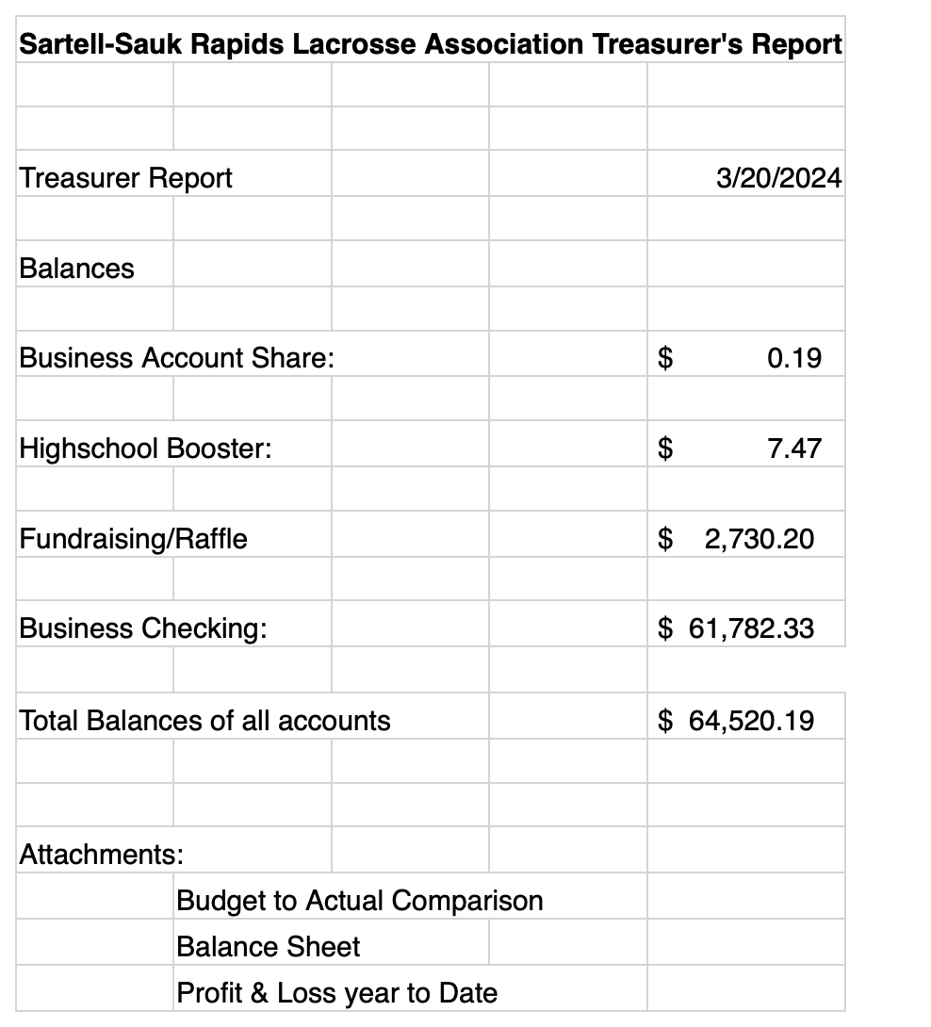
Treasurer’s Report as of 3/20/24:

