When a Niagara Falls Soccer Club Coach, Volunteer Coach, Assistant Coach or
Manager is in a potentially vulnerable situation, or one-on-one situation with any NFSC player,
especially a minor, (ie. - indoor/outdoor training environments, closed door meetings, change
rooms, etc.), there must always be another screened and NCCP trained or certified Coach,
screened volunteer, parent or adult present or within earshot and view with the exception of
medical emergencies. One of the screened coaches, volunteers, parent, or adult must also be
the same gender as the player.
This policy serves to protect minor athletes in a potentially vulnerable situation by
ensuring that more than one adult is present. It also protects the Coaches and Coaching staff.

Coaching Association of Canada Standards
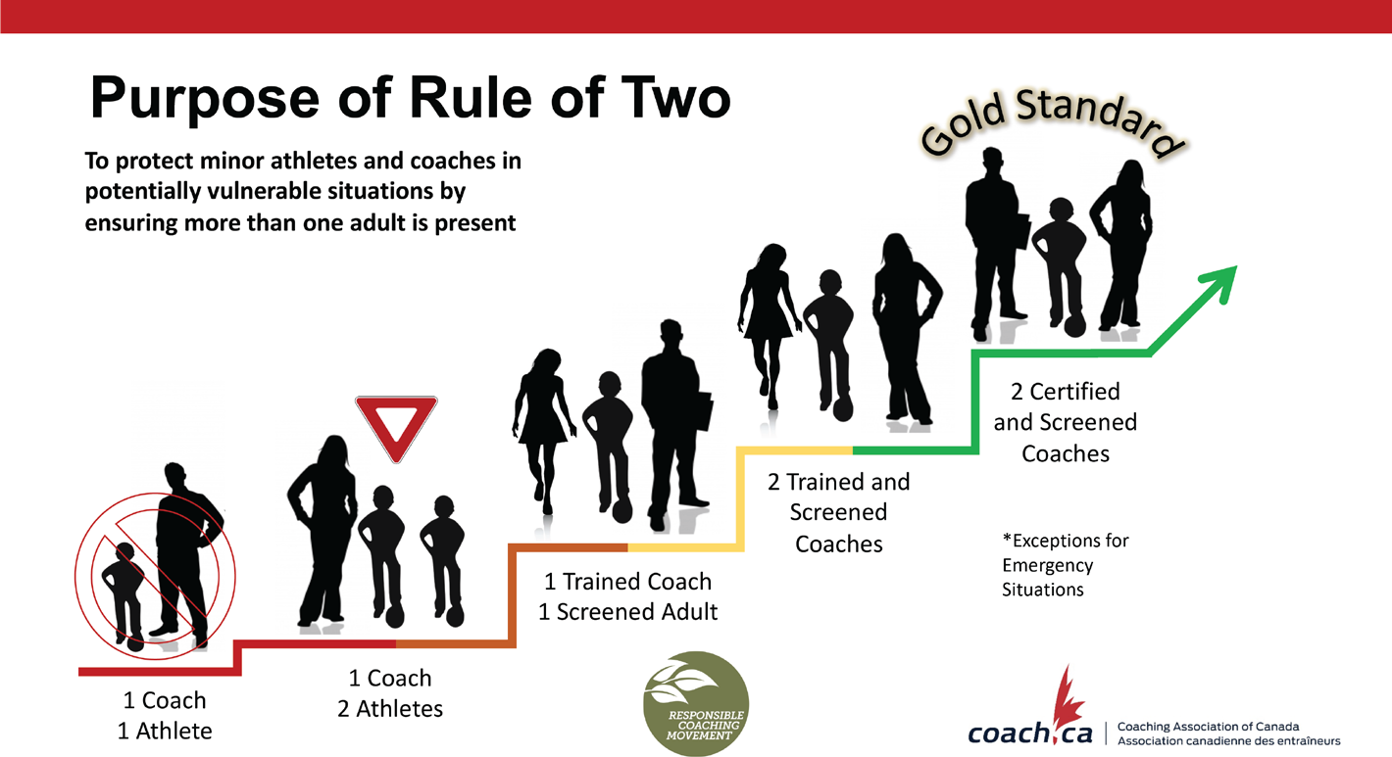
The Coaching Association of Canada has developed standards for the Rule of Two.

This can also be broken down further to more specific scenarios

such as the following;

Travel

The following guidelines are strongly recommended during travel with athletes:

A Person in Authority may not be alone in a car with an athlete unless the Person in Authority is the athlete’s parent or guardian.

A Person in Authority may not share a room or be alone in a hotel room with an athlete unless the Person in Authority is the athlete’s parent or guardian.

Room or bed checks during overnight stays must be done by two Persons in Authority.

Locker Room / Changing Area / Meeting Room

The following guidelines are strongly recommended for locker rooms, changing areas, and meeting rooms:

Interactions between a Person in Authority and an individual athlete should not occur in any room where there is a reasonable expectation of privacy such as the locker room, meeting room, washroom, or changing area. A second Person in Authority should be present for all necessary interactions in any such room.

If Persons in Authority are not present in the locker room or changing area, or if they are not permitted to be present, they should still be available outside the locker room or changing area and be able to enter the room or area if required.

Training / Competition Environment

The following guidelines are strongly recommended for the training and competition environment (including before, during, and after practices and games):

A Person in Authority should never be alone with an athlete prior to or following a game or practice, unless the Person in Authority is the athlete’s parent or guardian. If the athlete is the first athlete to arrive, the athlete’s parent should remain until another athlete or Person in Authority arrives. Similarly, if an athlete would potentially be alone with a Person in Authority following a game or practice, the Person in Authority should ask another Person in Authority (or a parent or guardian of another athlete) to stay until all the athletes have been picked up. If an adult is not available then another athlete should be present in order to avoid the Person in Authority being alone with a single athlete.

Persons in Authority giving instructions, demonstrating skills, or facilitating drills or lessons to an individual athlete should always be doing so within earshot and eyesight of another Person in Authority.

Gender Identity

A Person in Authority who is interacting with athletes should be of the same gender identity as the athletes. The following guidelines are strongly recommended:

For teams consisting of athletes of just one gender identity, a Person in Authority of the same gender identity should be available to participate or attend every interaction.

For teams consisting of athletes of more than one gender identity (e.g., co-ed teams), a Person in Authority of each gender identity should be available to participate or attend every interaction.

Electronic Communications
A Person in Authority who is communicating with athletes via electronic communications shall do so in a group and / or include parents and other Persons of Authority within that team. There shall be no one-to-one electronic messaging.

I (insert printed name) ____________________________________ as a Person of Authority acting as (circle one); Head Coach/Assistant Coach/Manager/Parent Liaison have read and understand the Niagara Falls Soccer Club policy of "Rule of Two". I will adhere to this policy for the safety of all NFSC players. I understand the procedures that have been put in place and the consequences that may occur from breaching this policy as per NFSC Coaches Code of Conduct.

Signature: ____________________________________
Date: ____________________________________

Policy dated: January 2nd, 2019
Amended: April 1st, 2020

