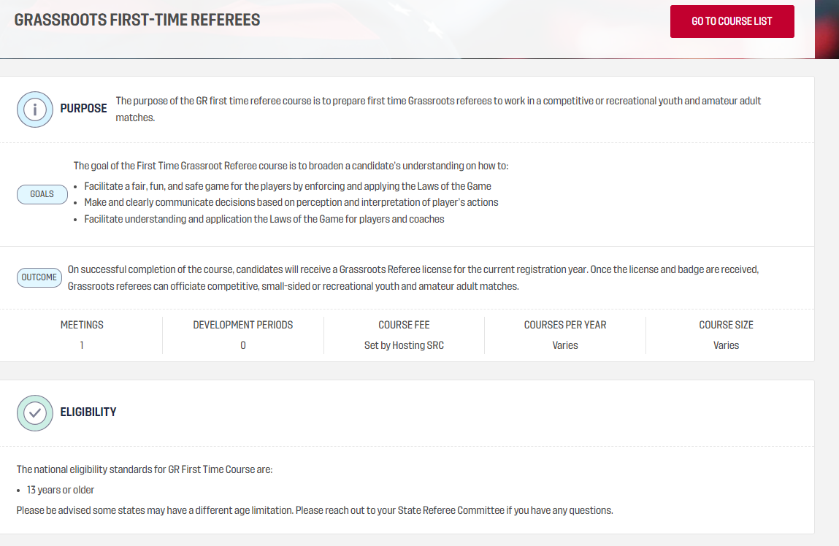
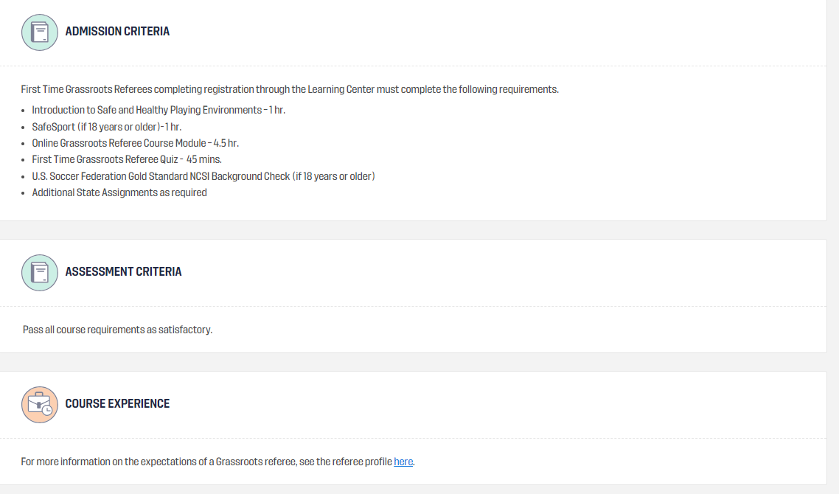
FAQ
HOW DO I FIND THE RIGHT COURSE?
https://ussoccerfederation.force.com/lcsupport/s/article/How-to-find-and-sign-up-for-a-course-in-the-Learning-Center
WHAT IF I HAVE ALREADY DONE SAFESPORT?
https://ussoccerfederation.force.com/lcsupport/s/article/Do-I-need-to-complete-SafeSport-again
WHAT DOES MY BACKGROUND CHECK STATUS MEAN?
https://ussoccerfederation.force.com/lcsupport/s/article/What-does-my-background-check-status-mean
HOW DO I CONTACT MY STATE REFEREE COMMITTEE (SRC)?
https://ussoccerfederation.force.com/lcsupport/s/article/Find-my-State-Referee-Committee-SRC
WHEN WILL I RECEIVE MY BADGE?
https://ussoccerfederation.force.com/lcsupport/s/article/When-will-I-receive-my-license-and-badge
HOW DO I GET GAME ASSIGNMENTS?
https://ussoccerfederation.force.com/lcsupport/s/article/Game-Assignments
HOW DO I FIND MY ASSIGNMENTS?
https://ussoccerfederation.force.com/lcsupport/s/article/How-do-I-find-my-assignments

