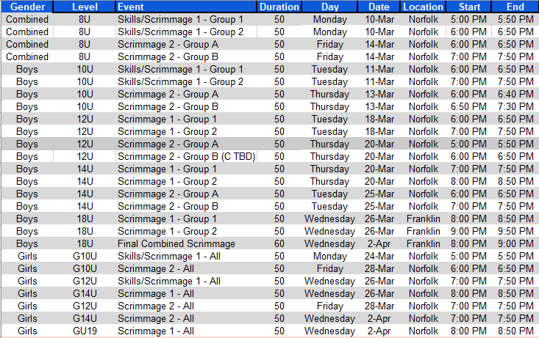
KPW Youth Hockey is excited to get ready for the next season!!!
Please register for the Tryouts for evaluation on the Travel Teams offered by KPW.
Important notes: 1. Tryout registration DOES NOT secure a spot next season. 2. You must be in “good standing” and complete season registration separately. 3. We cannot guarantee proper placement or inclusion if you miss the signup deadlines 4. Our Mite Development and Learn to Play programs do not require Tryouts and you don’t not need to attend these dates.

