How to find Available fields

From the main page of the website, click on BASEBALL or SOFTBALL
From the drop down menu click on TEAMS
Click on AVAILABLE FIELDS

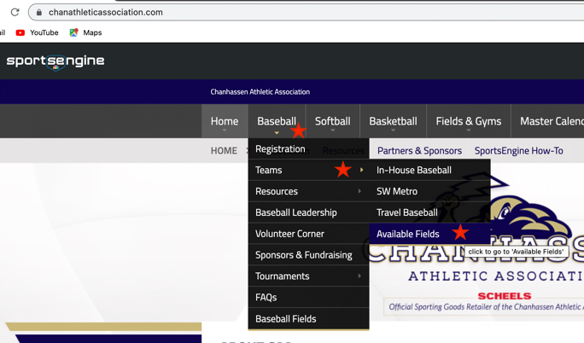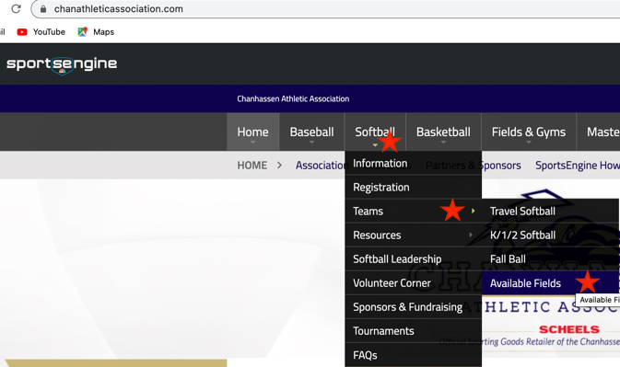

Click on:
SMALL (all Softball, and Baseball 5-11 yrs)
MEDIUM (12-13 Baseball only)
LARGE (14+ Baseball only)

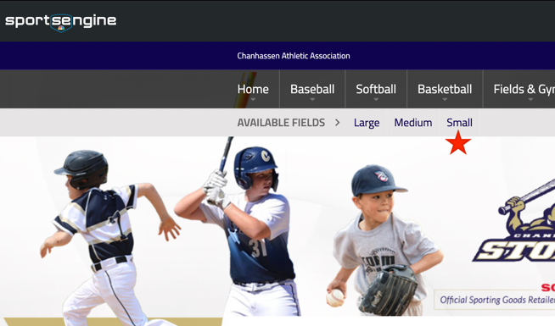

Calendar will show up, scroll down to show all dates. Any field listed is available for you to request for a game or practice.

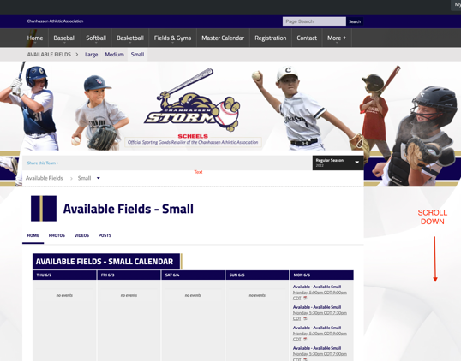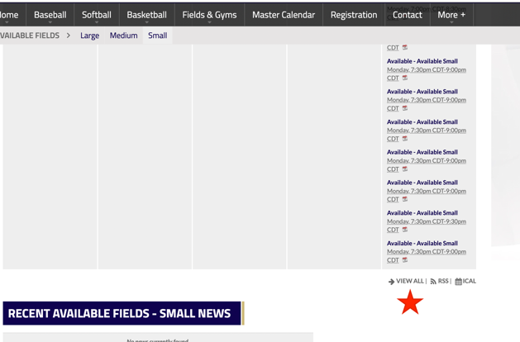

Be sure to click on View More Events to see the ALL of the available fields on any given date.

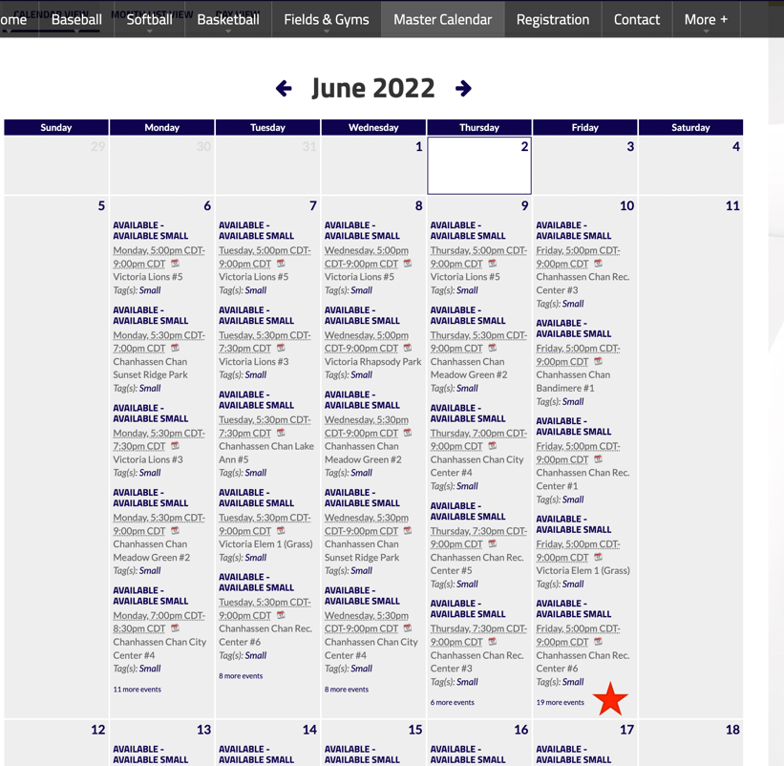

Once you have found an available field, please send an email to:

caadiamondscheduler@gmail.com to make requests

