Location: Shopper forum MALL, 1255 Airport Way, Fairbanks AK. 99701
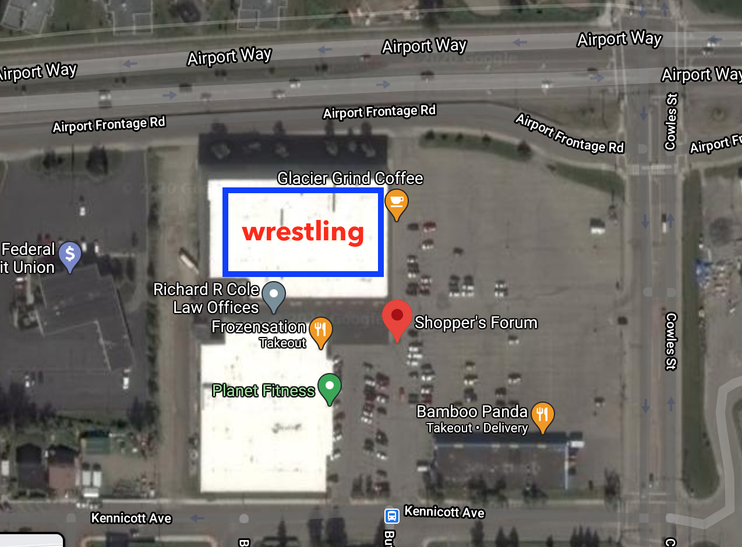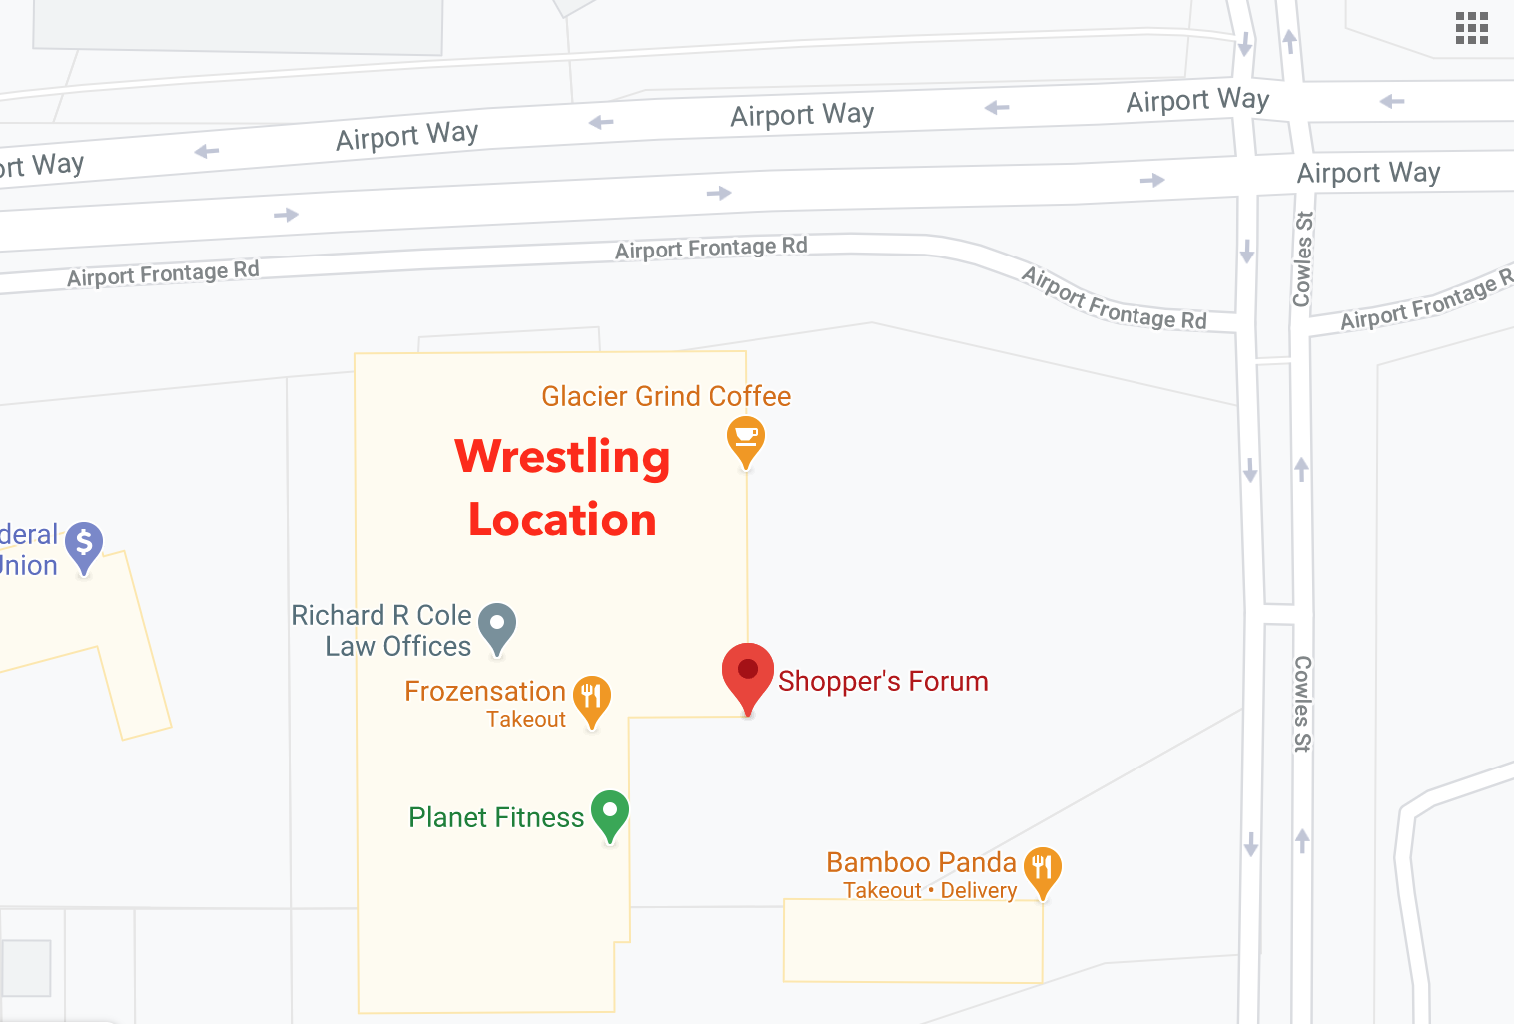

Cost: $40- one style, $20 for every other style or double bracketing
Individual tournament styles: Greco Roman, Freestyle, Folstyle, GI BBJJ, NO GI BJJ
This is for all ages and separate from the team event

Duals (SAT 4pm, after Individual wrestling and NO GI tournament) 4 team max
$75 per team:
Middle School Freestyle
High School Freestyle
White Belt GI
Online registration can be found at alaskafairbankswrestling.com, click on Conflict in the Coliseum box. People registered for wrestling will receive an email to register for free on track wrestling. You will be emailed the directions

Online Registration closes 19 April, $20 late registration fee and must call in after 19th of APR

Weigh-Ins: Satellite weigh-ins will be $10 dollars per grappler
Weigh-ins will be done in Singlet/ compression shorts and shirt. GI competitors will not weigh-in in a GI. GI checks will take place Saturday the Apr 23rd, 1hr before competition.
At event Weigh-ins: there is no morning weigh-in for that day of events
Thursday, 22nd April, 6-8pm at Venue (Shopper forums). This weigh in will
count for Friday and Sat events if in two events.
Friday, 23rd of APR, 3-6pm at actual event will count for SAT events.

Satellite weigh-ins: Weds 21 APR 2021, this weigh-ins will count for SAT event if you are competing on Fri. You must have a minimum of two matches on Friday the 23rd for Satellite weigh-ins to count. Clubs must contact Coach Bockert to make theirs a Satellite Location.
ALL groups and weights will be separated by male and female.
We also reserve the right to combine weights or groups if there is only one grappler.
NOGI NOVICE (0-2 years’ experience) Advance (3yrs and up Exp.)
Group 1 (K-4th) | 45lbs, 55lbs, 65lbs, 75lbs, 75lbs+ | 45lbs, 55lbs, 65lbs, 75lbs, 75lbs+
Group 2 (5th-8^{th)} | 55lbs, 65lbs, 75lbs, 85lbs, 95lbs, 105lbs, 115lbs, 130lbs, 150lbs, 170lbs, 170lbs+ | 55lbs, 65lbs, 75lbs, 85lbs, 95lbs, 105lbs, 115lbs, 130lbs, 150lbs, 170lbs, 170lbs+
Group 3 (9th-12th) | 75lbs, 85lbs, 95lbs, 105lbs, 115lbs, 130lbs, 150lbs, 170lbs, 195lbs, 220lbs, 220lbs+ | 75lbs, 85lbs, 95lbs, 105lbs, 115lbs, 130lbs, 150lbs, 170lbs, 195lbs, 220lbs, 220lbs+
Group 4 (Adult) | 125lbs, 140lbs, 160lbs, 180lbs, 200lbs, 220lbs, 220lbs+ | 125lbs, 140lbs, 160lbs, 180lbs, 200lbs, 220lbs, 220lbs+
BJJ GI White-grey belt yellow belt & up
Group 1 (K-4th) | 45lbs, 55lbs, 65lbs, 75lbs, 75lbs+ | 45lbs, 55lbs, 65lbs, 75lbs, 75lbs+
Group 2 (5th-8^{th)} | 55lbs, 65lbs, 75lbs, 85lbs, 95lbs, 105lbs, 115lbs, 130lbs, 150lbs, 170lbs, 170lbs+ | 55lbs, 65lbs, 75lbs, 85lbs, 95lbs, 105lbs, 115lbs, 130lbs, 150lbs, 170lbs, 170lbs+
 | White Belt | Blue Belt | Purple belt and up
Group 3 (9th-12th) | 75lbs, 85lbs, 95lbs, 105lbs, 115lbs, 130lbs, 150lbs, 170lbs, 195lbs, 220lbs, 220lbs+ | 75lbs, 85lbs, 95lbs, 105lbs, 115lbs, 130lbs, 150lbs, 170lbs, 195lbs, 220lbs, 220lbs+ | 75lbs, 85lbs, 95lbs, 105lbs, 115lbs, 130lbs, 150lbs, 170lbs, 195lbs, 220lbs, 220lbs+
Group 4 (Adult) | 125lbs, 140lbs, 160lbs, 180lbs, 200lbs, 220lbs, 220lbs+ | 125lbs, 140lbs, 160lbs, 180lbs, 200lbs, 220lbs, 220lbs+ | 125lbs, 140lbs, 160lbs, 180lbs, 200lbs, 220lbs, 220lbs+

Greco Roman we reserve the right to Madison Bracket
Group 1 (K-1st) | 45lbs, 55lbs, 65lbs, 75lbs, 75lbs+
Group 2 (2nd-3rd) | 45lbs, 55lbs, 65lbs, 75lbs, 85lbs, 85+
Group 3 (4th-5th) | 65lbs, 75lbs, 85lbs, 95lbs, 105lbs, 115lbs, 115lbs+
Group 4 (6th-8th) | 75lbs, 85lbs, 95lbs, 105lbs, 110lbs, 115lbs, 120lbs, 132lbs, 140lbs, 165lbs, 190lbs, 190lbs+
Group 5(9th-12th) | 106lbs, 113lbs, 120lbs, 126lbs, 132lbs 138lbs, 145lbs, 152lbs, 160lbs, 171lbs, 182lbs, 195lbs, 220lbs, 285lbs
Freestyle we reserve the right to Madison Bracket
Group 1 (K-1st) | 45lbs, 55lbs, 65lbs, 75lbs, 75lbs+
Group 2 (2nd-3rd) | 45lbs, 55lbs, 65lbs, 75lbs, 85lbs, 85lbs +
Group 3 (4th-5th) | 65lbs, 75lbs, 85lbs, 95lbs, 105lbs, 115lbs, 115lbs+
Group 4 (6th-8th) | 75lbs, 85lbs, 95lbs, 105lbs, 110lbs, 115lbs, 120lbs, 132lbs, 140lbs, 165lbs, 190lbs, 190lbs+
Group 5(9th-12th) | 106lbs, 113lbs, 120lbs, 126lbs, 132lbs 138lbs, 145lbs, 152lbs, 160lbs, 171lbs, 182lbs, 195lbs, 220lbs, 285lbs
Group 6 (Open) | Madison bracketing
Event Schedule: 23 APR (FRI)
8am doors open 9:00am bracket changes close
9:00am rules clinic (GI BJJ and Wrestling style separate clinics)
9:30am-3pm grappling starts
Group 1-3 Freestyle----MAT 1-4, Group 3-4 GI BJJ---MAT 4-6
3pm-7:30pm
Group 4-6 Freestyle---MAT 1-4, Group 1-3 GI BJJ ----MAT 4-6
24 APR (SAT)
8am doors open 9:00am bracket changes close
9:00am rules clinic (NO GI BJJ and Wrestling style separate clinics)
9:30am- 3pm Grappling Starts –
Group 1&2 Folkstyle, Group 3-6 Greco Roman MAT 1-3
Group 2-4 NO GI (some overlap with Middle school age)
4pm TEAM DUALS (MAX 4 teams including IGA)
HS Freestyle MAT 1(weights, 110,120,130, 135, 140, 145, 152, 160, 170, 182, 195, 220 285)
MS Freestyle MAT2 (weight, 75, 85, 95, 105, 110, 115, 120, 135, 145, 160, 175, 190, 190+)
Adult WHITE BELT GI MAT 3 (weights, 120, 140, 160, 170, 180, 200, 200+)
GI DUALS: Each team will fill their weight classes and compete in a 4-team round robin. Each Match up from the teams scores you total team points. 1st place team will get a 1st place team trophy for their gym.
Match score for the team as follows: any winning match scoring 9 points or less gives their team 3 points.
Any Match ending in 10 or more points is a major decision score their team 4 team points. Any match ending in a submission scores their Team 5 points.

Awards: 1st- 6th will receive medals
Any grappler who wins all 4 styles (GI, No GI, Fokstyle, Freestyle) in any weight will receive a wood Gladiator RUDIS sword Trophy
Rules and Matches
NO GI and GI: We will use the common NO GI and GI rules with the right to modify. This will be briefed at the rules clinic. Time limits for matches will be 4Min for Groups 1 and 2, 5Min for Group 3 and 4. Uniforms will be checked and hour before start of competition.

Wrestling Freestyle& GRECO: We will use the USA wrestling rules for matches. Groups 1 and 3 will be 2-1:30 periods. Group 4 will be 2-2:00 periods. Group 5 will be 2-3:00 periods. Must be in Singlets or shorts and shirt

Facility Setup: Mats and Table set up
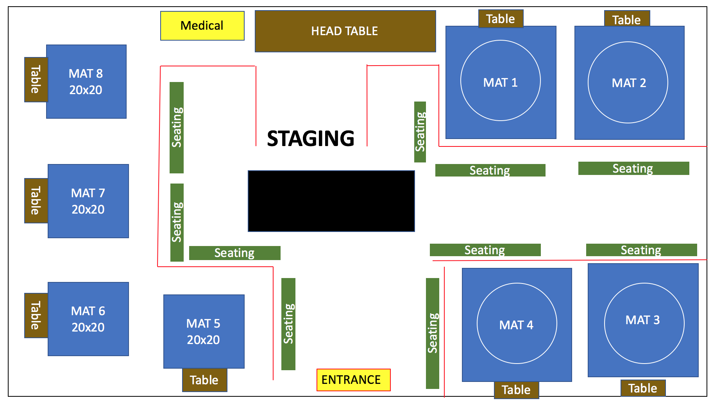
Rules with in the facility:
No outside food or drink in Facility. There will be concessions stands with-in the facility.

Spectator passes are $10 Adults and $5 kids for a day. 2 day passes $15, 6 years and younger are free

Only 2 coaches are allowed in a corner, no gathering please. Coaches can get their passes for $20.
POC: Westley Bockert@ 803-873-8101 interiorgrapplingacademy@gmail.com

