2024.2025 Kids Nationals
Team Leaders & ISWA Title: Jonah M. Odum
Coaches: Sean Schmaltz, Chad Harper, Ben Dolly, Matt Kelly, Andy Oberlin, Juwan Bolden, Eric Aue, Chris Payton, Britt Brown, and Chad Red

The following wrestlers achieved All American status by placing top 8 in the country:

Narrative: 2025 Kids Nationals was held in Cedar Rapids, Iowa and it was a record setting tournament for entries with over 1,600 kids registered (+400 more than last year). Indiana was represented by 65 wrestlers from across the state of Indiana and came home with 1 National Champions, 2 Runner-up finishes, 9 third place finishes, and 43 All-Americans overall (22 in Freestyle and 21 in Greco-Roman). While not everyone came home with All-American status, we are proud of how each wrestler competed and how our wresters represented our state. Our kids had fun on the mat and off the mat by competing through the day, swimming at the hotel, and playing games at night with their newly made friends from all over the state. These kids made memories that will last a lifetime and will be better prepared for national events in the future.

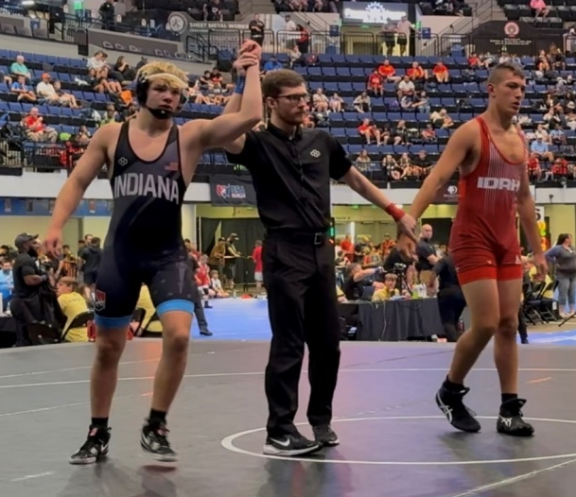
Noah Fitzgerald after winning a Greco-Roman national championship at 175lbs (14U).

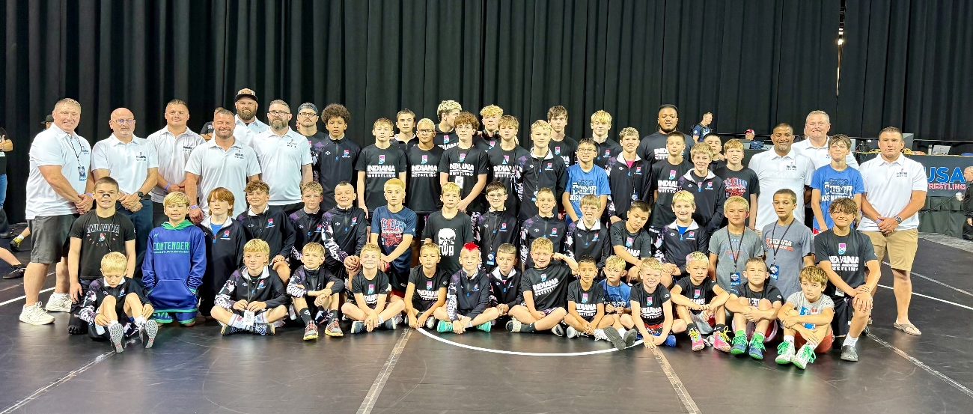
Back Row: Coach Chad Harper, Coach Andy Oberlin, Coach Matt Kelly, Coach Britt Brown, Coach Ben Dolly, River Lilly, Gavin Brown, Noah Fitzgerald, Mack Harrison, Gabrial Bousman, Coach Juwan Bolden, Team Lead-Coach Jonah Odum, Coach Chris Payton
-Middle Back Row: Coach Sean Schmaltz, Coach Eric Aue, Zach Hunt, Owen Pennington, Bryson Whaley, Gavin Meranda, Landon Haub, Eli VanBruaene, Bennito Delgado, Eli Bailey, Kam Fuller, Sam Ward, Ezra Cappa, Coach Chad Red, Josh Sanders
-Middle Front Row: Haedyn Cochran, Bennett Silence, Arlo Pratt, Eli Burke, Sean Schmidt, Carson Banks, Lucas Pipito, Jon Luke Austin, Gage Guillaume, James Windholtz, Zander Smith, Anthony Quiroz, Tysen Robertson, Wyatt Melchi, Goose Gibbs, Brian Wesley
-Front Row: Toby Janusek, Harrison Parker, Case Hoehn, Cayden Kelly, Wyatt Schoettle, William Kelly, Jordan Kiger, Sebastian Valle, Camden Rocha, Jeremiah Sanders, Laken Warren, Roman Howe, Gavin Hooper, Tucker Jackson.

