
MINUTES TO BE APPROVED AT THE NEXT BOARD MEETING. THESE MINUTES ARE NOT CURRENTLY POSTED AND SHOULD NOT BE DISTRIBUTED UNTIL APPROVED BY USASSCS BOARD.
Board Meeting Minutes February 12, 2024
Location: Santee City Hall
Attendees Shown with Marked Box
President | Jay Strandberg | x | Field Prep | Kevin Hopkins | x
1st VP/ Field Prep | Erik Ruiz | x | Field Prep | Trevor Henton | x
2nd VP | Kelli Timanus | x | Field Prep | James Timanus
Treasurer | Tiffany Lynch | x | Field Prep | Nate Anderson | x
Secretary/Safety Coordinator/Head Scorekeeper | Bryan Scholar | x | Field Prep | Brad Allen | x
Tax Advisor | Lori Britt |  | Field Prep/Equipment | Shane Frary | x
Player Agent | Lance Craw
UIC/Parliamentarian | Felicia Leca | x | Head Team Parent Coordinator | Dana Hisaw
Field Scheduler/Fall Ball Coordinator | Chris Klima | x | Uniform Coordinator
Webmaster/Social Media/All-Star Coordinator | Alexis Ruiz |  | Picnic Coordinator/Pictures | Kat Vecchione
BOTH Tournament Coordinator | Kayleigh Ponciano-Ahue | x | Snackbar #1 | Amy Ramirez
Sponsorships | Kylee Scholar |  | Snackbar #2
Awards | Janis Aiello |  | Social Media Coordinator | Sophia Vigil | x

Guests: N/A
Meeting called to order: 7:06PM
Meeting Minutes
Tiffany Lynch motioned to approve minutes from 1/9/23. Brad Allen seconded the motion
Meeting rule – One Topic at a Time
Financial Update (Tiffany L)
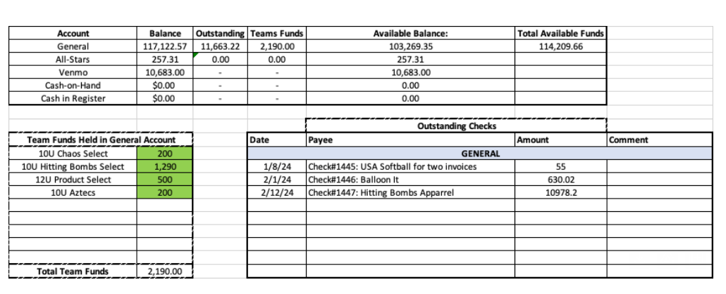

September: Kayleigh will email Emily with final numbers

January: We will wait until March tourney occurs and then collect this

Snack Bar:
- We will purchase a new big freezer this week.
- Deep clean was completed end of January.

All-Star Jersey Recommendation:
- BellaLete: Fancy softball pants & nice jerseys

Santee Swag:
- Start with booth and go from there regarding snack bar
  - See what sells & get feedback

The managers have game balls already.

Raffle:
- Klima & Nate will be the point of contacts.
- Team sales are being collected during week – prior to day of sales.
- Day of sales will occur with booth.
- Raffle should be held around 11amish.

Sponsors:
- Banner sizes have to be 4x6.
- Feb 1 – Jul 31 are the timeframes.

Rule Change: Board member shifts for spring season will be altered from one week to “five shifts”.

Meeting Adjourned: 8:28 pm
Next Meeting: March 11

