UVHA Annual Meeting Minutes
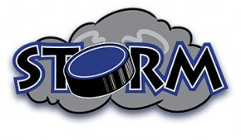
March 28, 2019 ~ 6:30 PM
Kinney Pike Insurance, White River Junction, Vermont

- Attendance: Kylie Young, Sherry Dube, Jacki Smith, Beth Mann, Sarah Morlock, Brock Barton, Jason Spaulding, Justin Barwood, Roger Gillies, Bill Mann, Alex DeFelice, Josh Obar, Jay Zanleoni, Ethan McNaughton, Jason Gramling, Eric Smith

- Meeting called to order: 6:30 PM

- Order of Business:

  - Welcome and Thank You-President Spaulding welcomed the membership and thanked the current Board for their service, highlighting specific duties and accomplishments.

  - Election of officers-President Spaulding read the candidates for each position and made a last call for additional candidates and nominations. Ballots were distributed and the membership received instruction for casting their votes. The votes were counted and President Spaulding announced the election results (see below). Each position will be held for a term of two years.
    - President: Jason Spaulding
    - Secretary: Sarah Morlock
    - Directors-at-Large: Kylie Young, Ethan McNaughton, Jay Zanleoni

  - Open Floor-President Spaulding opened the floor to the membership for further questions or comments. No further business was conducted.

- Meeting Adjourned: 7:16 PM

