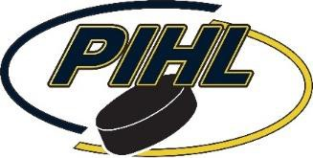
RISK ACKNOWLEDGEMENT & LIABILITY
WAIVER 2011 Birth Year Players

To be completed for each 2011 birth year player participating on a PIHL Middle School team.

Association Name: _

Name of Participant (print): _ Birthdate:

I hereby acknowledge that I permit my child to participate at an age level that is one year in age above the USA Hockey recommended guidelines.

I understand and appreciate that the risk of injury may be greater at this level and that the risk of injury from hockey may be significant, including the potential for permanent paralysis or death. I understand that while particular rules and personal discipline may reduce this risk, the potential for serious injury still exists.

By my child’s participation, I knowingly assume all such risks, both known and unknown. Further, I agree to indemnify and hold harmless the association listed above; any PIHL officers and staff members; and USA Hockey, Incorporated from any and all liability, loss, expense, attorney’s fees, or claims for injury or damages caused as a result of my request.

I understand that the agreement by my association to allow my child to participate on the PIHL Middle School team is probationary and my association reserves the right to reverse its decision if it is felt that my child is not capable of participating at this level. I acknowledge that this might not occur until after his/her performance has been observed in actual game situations by the coaches and/or the association coaching director.

I understand and agree to respect all of the conditions listed above for participation with this USA Hockey team.

Participant Signature: Date:

Parent/Guardian Name (print):

Parent/Guardian Signature: Date:

