Log into KV Site with your user id and turn on Edit mode on the Ice/Trade for Sale Web Page
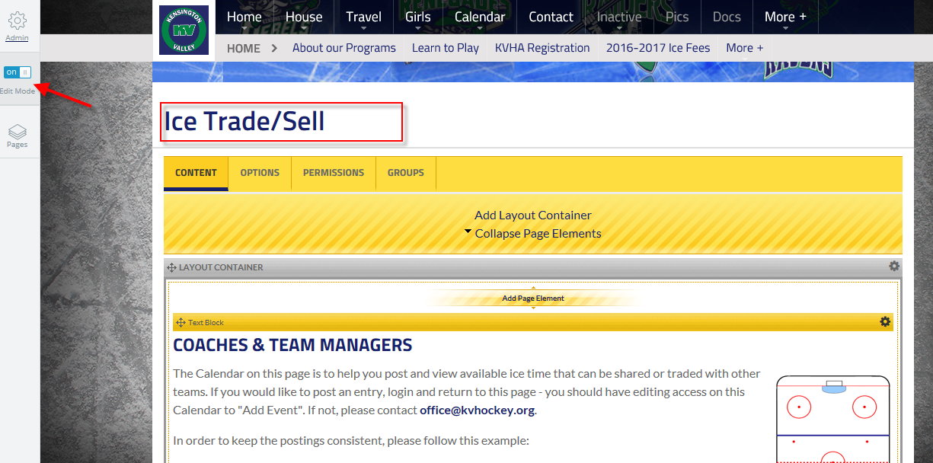
Next scroll down to the calendar section and click on the edit wheel in right hand corner of layout section. It should give you a menu and next select add event
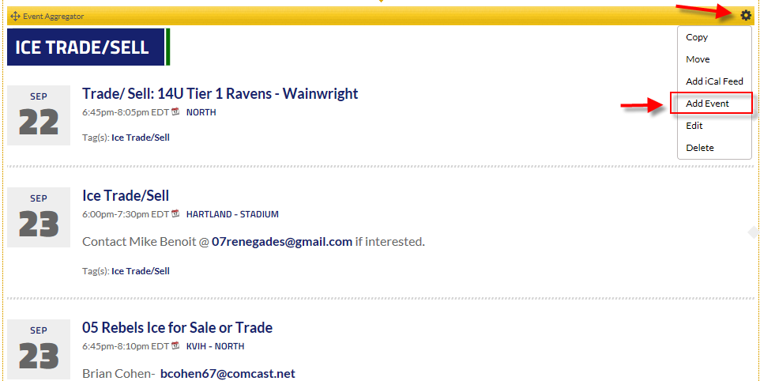

The add event creation box should open up. Enter all key fields describing the sale of the ICE and Click the Create This event button at bottom of box when done..
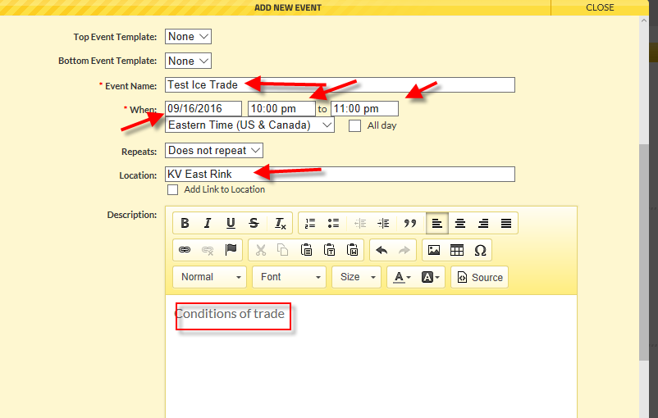
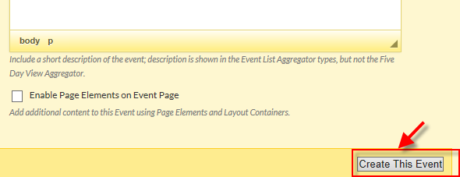

Confirmation page shows entry and navigate back to page to see the item in the listing…
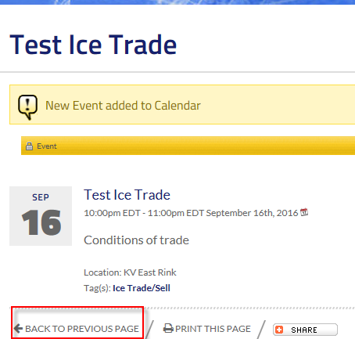

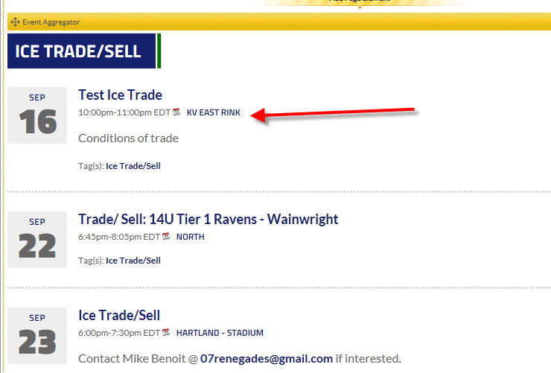

Note: Please remember to take off calendar entry when trade/sale is complete.

