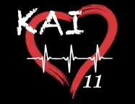

The Max Schewitz Foundation will be partnering with WCCF Kai11 Save-A-Heart Mission to provide HeartSmart EKG to young adults, ages 13-21, at the Northview Building (corner of Northview and Grandview), 1721 Northview Road, in Waukesha, WI.

Tuesday, August 9, 2022 – 10:00 – 3:00
Registration required. NO walk-ins will be accepted.

There is a lot to know about Sudden Cardiac Death in Young Adults

Kai, Max and Josh were healthy, young adults with NO symptoms –
AN EKG MAY HAVE PREVENTED THEIR DEATHS

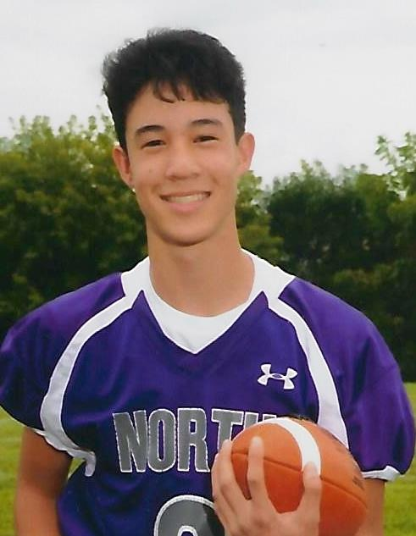  Kai Lermer of Waukesha, WI, was playing basketball with friends when he went into sudden cardiac arrest. He died from WPW, an undiagnosed heart condition, on April 3, 2019 at age 16. | 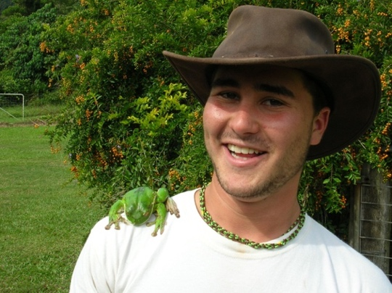  Max Schewitz of Lake Bluff, IL, left for work one morning, hugged his mom good bye and was dead by noon. He died of hidden cardiac disease on September 29, 2005 at age 20. | 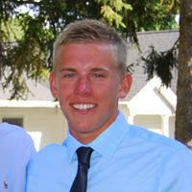  Josh Church of Wadsworth, IL, wasn’t feeling well at swim practice. He suddenly collapsed and died of a hidden heart condition on November 16, 2016 at age 17.
- EKG's are not routinely done on seemingly healthy young adults in our communities. A painless, simple and non-invasive EKG detects 94% of high-risk individuals compared to 9% by physical examination and 20% detected by a physician discussing family history. We think it’s worth looking for these kids!
- The Max Schewitz Foundation has provided almost 100,000 EKG tests to high school and college students.
- 952 students have been referred for further medical evaluation. They may have failed their test but what they learned may have saved their lives.
- Testing costs are $20 per student IF registered by 8/2/22. Students registered 8/3 – 8/8/22 will be charged $25. Registration closes on Monday, August 8th at NOON. No exceptions. A copy of your student’s EKG is included in this price. Registration fee must be paid at time of registration and is non-refundable. Fifteen minute appointments will be scheduled online starting 7/1/22.

Please visit www.HeartSmartEKG.org for additional information and/or to register your student(s) under 2022 WCCF Kai Lermer Memorial Fund 8/9/22 Screening

