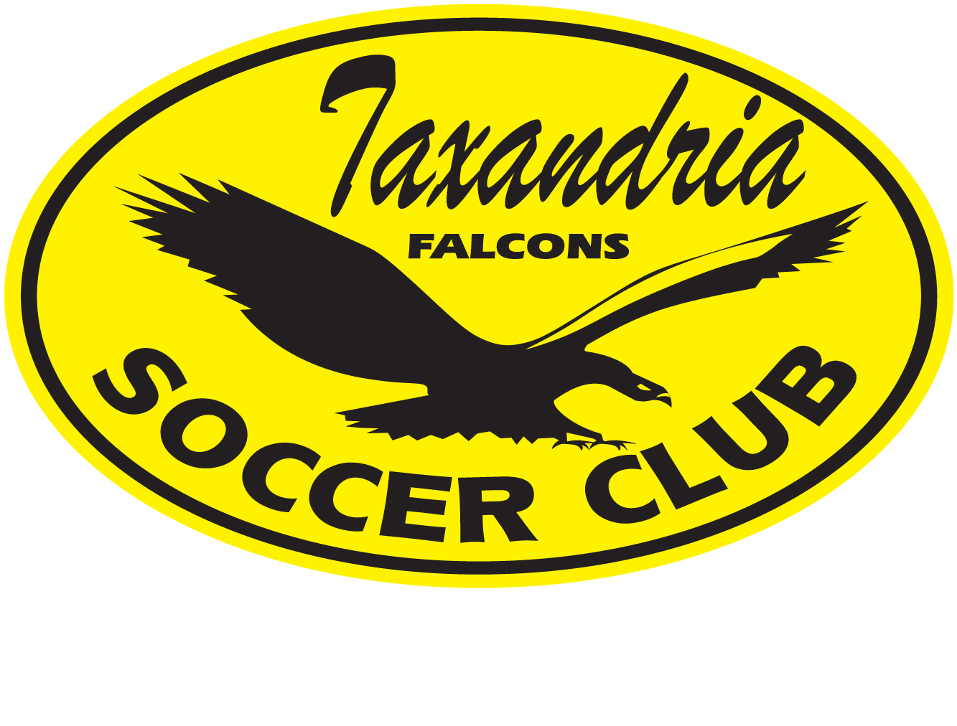
TAXANDRIA FALCONS SOCCER CLUB

CODE OF CONDUCT

Effective: May, 2024

Taxandria Falcons Soccer Club (hereinafter “Taxandria” and/or “The Club”) Codes of Conduct outline the expected behavior for coaches, players, and parents involved in the club. These codes of conduct are in place to ensure a safe and respectful environment for all members of the club, and violations may result in penalties ranging from a written warning to dismissal from the club. The main points of each code of conduct are as follows:
Coach's Code of Conduct:
- Treat players, parents, referees, and team and club officials with fairness, politeness, and respect, without discrimination based on religion, race, ethnicity, or gender.
- Develop all players on the team or in a player pool.
- Avoid using vulgar or profane language at games or practices.
- Arrive on time and be fully prepared for all games and practices.
- Teach players to play fairly and respect the rules, referees, opponents, and spectators.
- Ensure that equipment and facilities are safe and appropriate for the players' ages and abilities.
- Refrain from participating in practice, game, or team events while under the influence of drugs or alcohol.
- Not smoke at games or practices.
- Dress appropriately in approved club wear for all games and practices.
- Be responsible for the payment of any fines imposed on the club as a consequence of their behavior.
- Adhere to the Ontario Soccer Association Code of Conduct.
Player's Code of Conduct:
- Treat other players, parents, referees, and team and club officials with fairness, politeness, and respect, without discrimination based on religion, race, ethnicity, or gender.
- Avoid using vulgar or profane language at games or practices.
- Arrive on time and be fully prepared for all games and practices.
- Refrain from participating in practice, game, or team events while under the influence of drugs or alcohol.
- Not smoke at games or practices.
- Dress appropriately in approved club wear for all games and practices.
- Be responsible for the payment of any fines imposed on the club as a consequence of their behavior.
- Adhere to the OSA Code of Conduct.
Parent's Code of Conduct:
- Be responsible for their child at every practice and game, as Taxandria is not responsible for unsupervised players.
- Understand that their child plays soccer for their own benefit, not for the parent's benefit.
- Not give instructions to players, as that is the coach's role.
- Never question the referee's judgment, integrity, or honesty.
- Support efforts to eliminate verbal and physical abuse from the game of soccer.
- Wait 24 hours before discussing any issues with the team coach, and do so in a private and constructive manner.
- Not approach the team coach prior to or during a session.
- Show respect for all players, coaches, officials, and spectators at all times.
- Encourage their child to play by the rules and resolve conflicts without hostility or violence.
- Applaud good plays by both their child's team and their opponents.
- Ensure that their child arrives for practices and games on time as designated by the coach.
- Not engage in any form of bullying, whether in person or electronically (via social media).
- Obey requests from referees or the team coach to leave the vicinity of the field.
- Contribute their child's payment on time.
- Understand that failure to abide by the Code of Conduct may result in removal from the vicinity of the playing field and potential further sanctions by the club.
The Codes of Conduct also outline disciplinary procedures for infractions that occur during games, including penalties imposed by the referee and potential discipline hearings convened by the Ontario Soccer or their delegate, which could result in suspension from soccer and fines. Members of the club are responsible for reimbursing the club for any fines payable due to their actions or inactions.
Consequences for violating the Codes of Conduct may vary.

If you have any questions or concerns regarding this policy, please contact our board at taxandriasoccer@gmail.com.

