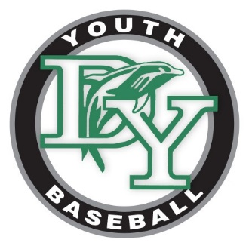
Dennis Yarmouth Youth Baseball
2017 All-Star Tournament Application

Please mail this form with check for $450.00 for each team entered to:
Age Group Dates Amount Enclosed
9 Year Olds July 7/28-7/30 $________________
10 Year Olds July 7/21-7/23 $________________
11 Year Olds $________________
Contact Information:
Program/Town: ______________________________________________________________________
Coaches/Contacts: ______________________________________________________________________
______________________________________________________________________
______________________________________________________________________
______________________________________________________________________
Contact Address: ______________________________________________________________________
______________________________________________________________________
Phone Number: ______________________________________________________________________
E-mail: ______________________________________________________________________
All slots are filled on a first-come first-serve basis. Payment is required ahead of time.
Upon receipt of your check, the coach will be contacted to confirm your team’s placement.
No AAU teams will be admitted to Dennis Yarmouth Youth Baseball tournaments.
Dennis Yarmouth Youth Baseball
P.O. Box 898
South Dennis, MA 02660

To confirm availability, contact info@dyyba.com

