Instructions on How to Sign Up for Volunteer Opportunities

- Go to http://www.masonsoccer.com
- In the left navigation menu, click on “Volunteering”
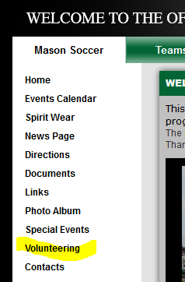

- This will present you with all available “event/opportunities“. Click “Sign Up” next to the opportunity you are interested in. As the “event/opportunity” fills up then it will disappear from this available list.
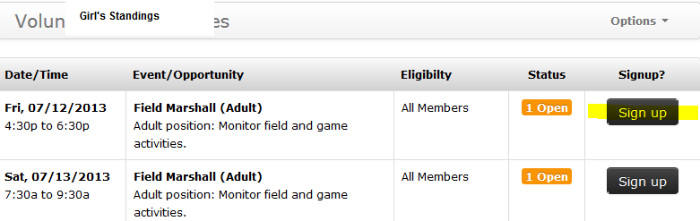

- Enter the parent’s email address into the “Email” field.
Note: If this is your first time logging in then DO NOT enter a password and then click “Continue”. You will be prompted to create a password on the next screen.
Note: The volunteer function within the website uses the parent’s email address. It does not use the player’s email address. The only exception to this rule is if the parent and player use the same email address.
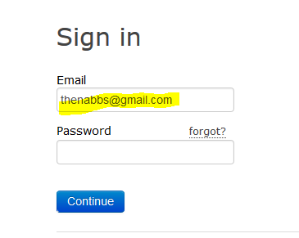

- An email was sent to the email address listed in the “Email” field.
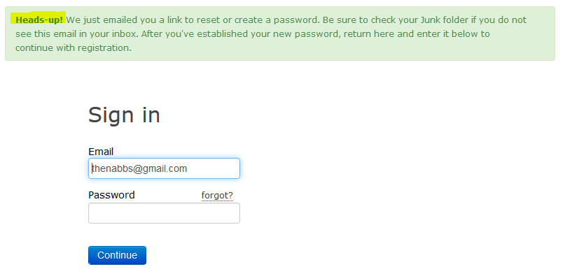

- Follow the instructions in the email, click the link to create/reset your password.
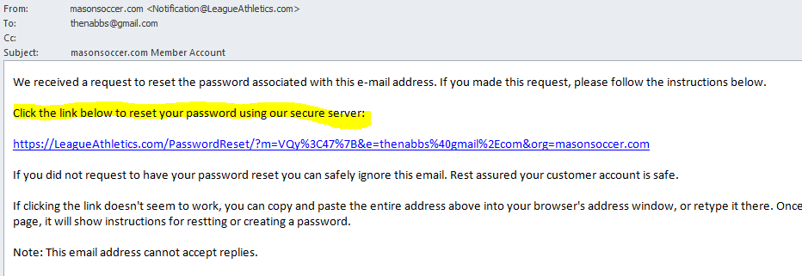

- Enter your new password, click “Submit” and thanks for Volunteering
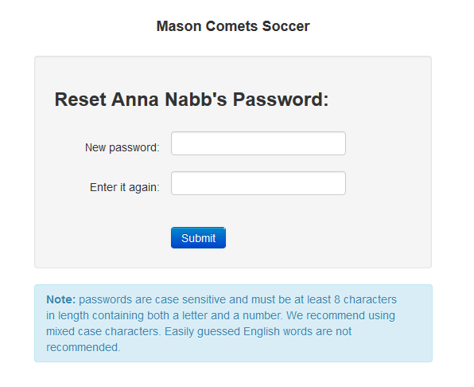
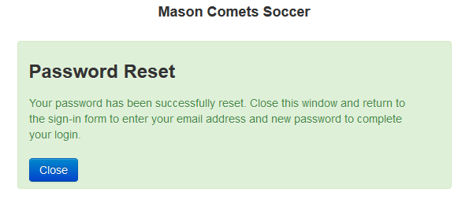

- If you have any questions then please send an email to masoncometsoccer@gmail.com

