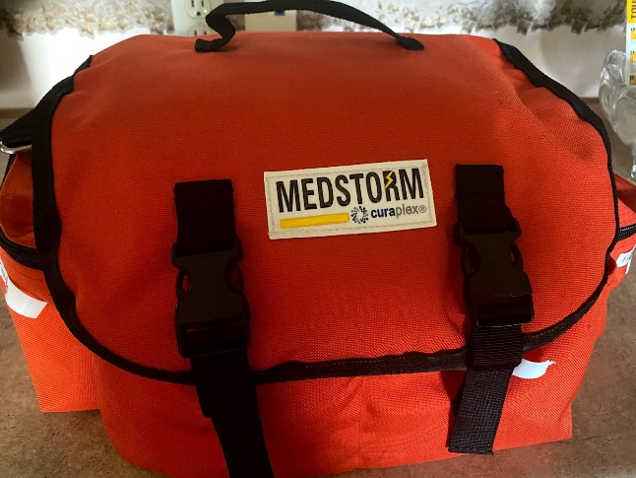 | Hello hockey friends! You probably saw this orange bag at the ice arena. Specifically, it is located it the clock booth. This is our DCYH first aid kit. The other one (black with the red cross on it) is located at the concession stand, right under the counter.
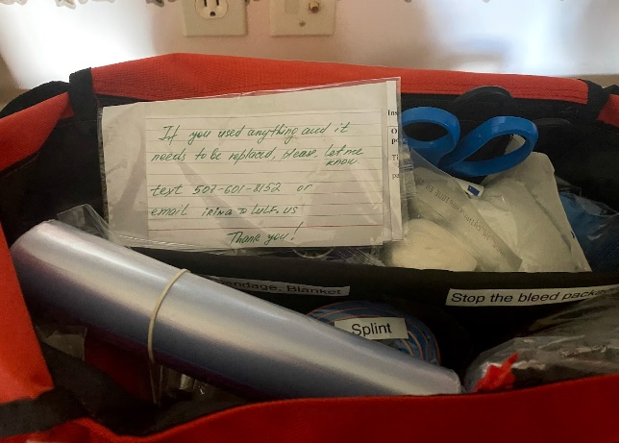 | This is how our first aid kit looks when you open it. Notice on top there is a note, saying to contact me if you used any items and they need to be replaced. I check the kit from time to time, but would appreciate the heads up.
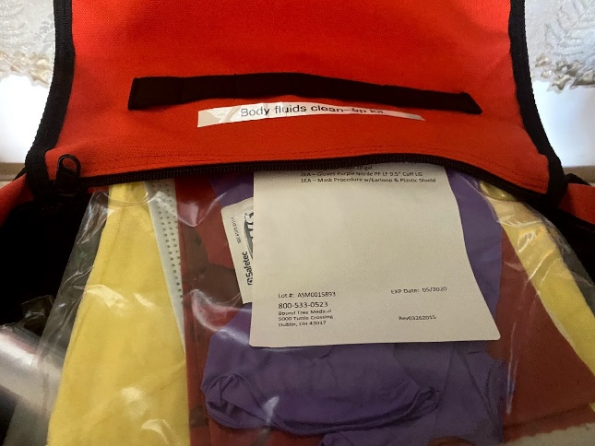 | Now let’s go through the various pockets. We start with the boring one – body fluid spill kit. It is required, we have another one in the concession stand kit as well. It is in the lid pocket .
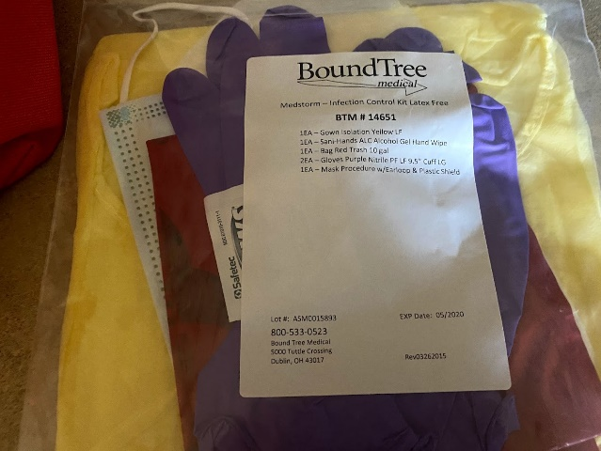 | This is how it looks like. It has gown, mask, gloves and a body hazard bag. Hopefully, we will never need it.
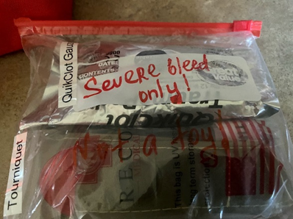 | Another set of items that I hope we will never use is in the Right front inside pocket. Those are items FOR SEVERE BLEED ONLY.  Please, do not use it for minor cuts.  It is better if used by medical professionals, or by people who went through “stop the bleed class” or it’s alternative.  Here what is in there:
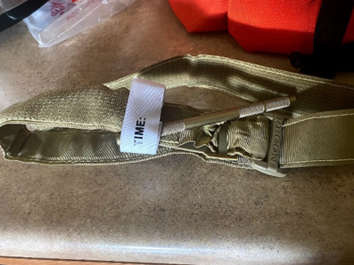 | Tourniquet.
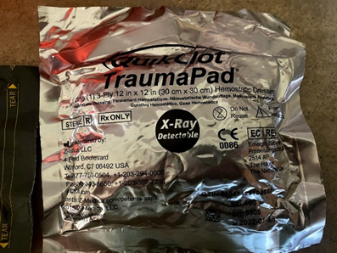 | QuickClot trauma pad.
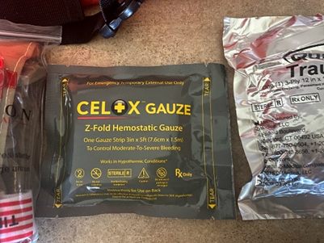 | Z-fold hemostatic gauze.  If you use either QuickClot or GelX gauze, place the wrapper under the bandage loops so ED personnel will know what was used right away.
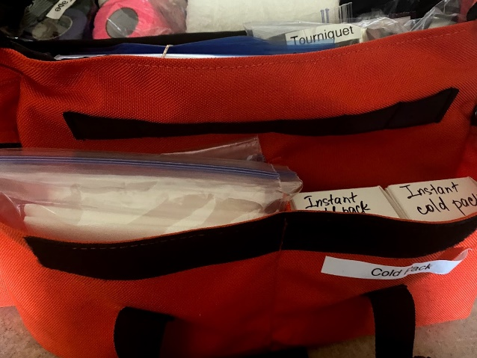 | Front pocket – a couple of instant cold packs and individually packed heavy duty paper towels. I also put a bunch of ziplox bags in the bag – in case you just want to grab some ice and use it as a cold pack.
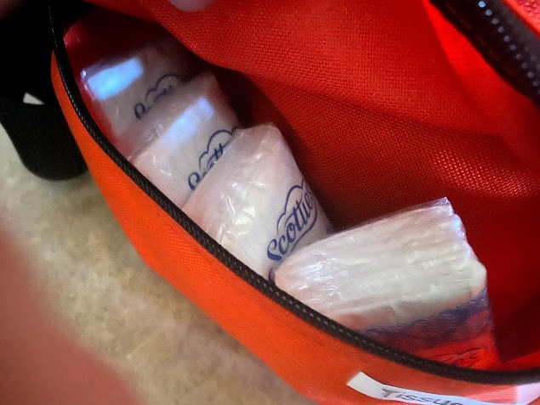 | Tissues in the left outside pocket.
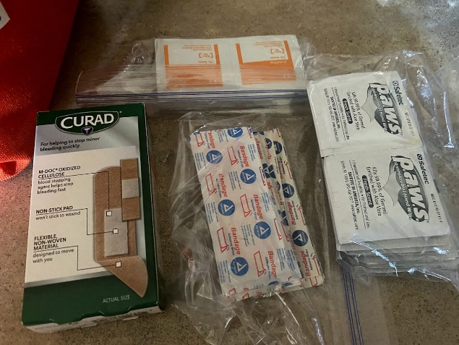 | The right outside pocket contains a bunch of band-aids, hand sanitising wipes, and some alcohol wipes.  More bandaids are in the consession stand first aid kit.
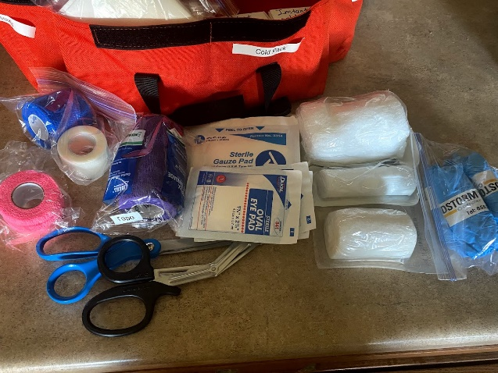 | The biggest pocket inside, on the back, has a pair of scissors, various gauze, gloves (size L), bunch of tape.  Please, if you do the book and need to use scissors, remember to put it back
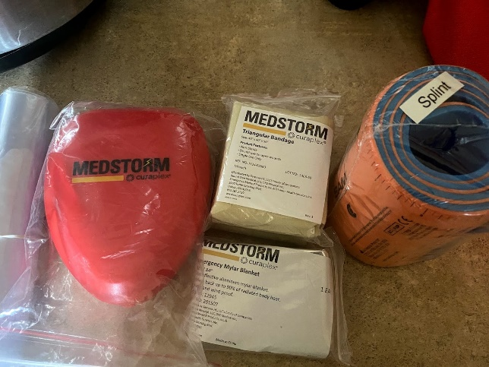 | Left front inside poket – CPR mask, Emergency Mylar blanket, triangular bandage, and SAM splint.  SAM splint can be cut and folded according to the need.  Here are some links on how to use it:  https://youtu.be/ukTe5Gn_aRI - how to make a wrist splint  https://youtu.be/YRJzZ95Ddoc - arm splint  https://youtu.be/8oQr805Z1UA - ankle stirrup

Thank you for reading!

Irina Lulf, Max’s mom

