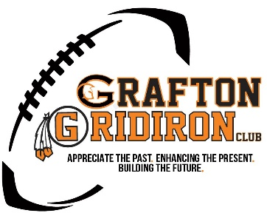
2021 Giving Campaign Form – Football Stadium Project
To be properly recognized, please complete this form with your payment. If you choose Venmo or Paypal for payment, please print and email this completed form to graftongridiron@yahoo.com. You may mail this form with check payments.
Name: ___________________________
Street: ____________________________
City: _____________________ State: ____________ Zip Code: ____________________
Telephone #: _____________________________
Email Address: _____________________________

Name to Appear on Giving Boards and/or Website: _______________________________
Total Contribution Amount: $_______________

Payment Options:
One Time Payment
Financed Amount over 12 Months (2 Equal Payments if donation is over $1,000.00 Total). You will be sent a contract document to complete with payment dates and commitments that you will need to sign and return to us for further processing.

Payment Method Used:
Check
Venmo (@graftongridiron)
Paypal (graftongridiron@yahoo.com)
Stock Transfer (Please contact GGC for details and routing)

Please make checks payable to and mail in address below:
Grafton Gridiron Club
PO Box 393
Grafton, WI 53024

For more information or questions, please contact Cary Van Sluys at 414-378-5112 or graftongridiron@yahoo.com. Completed forms may also be sent to email address as well.

