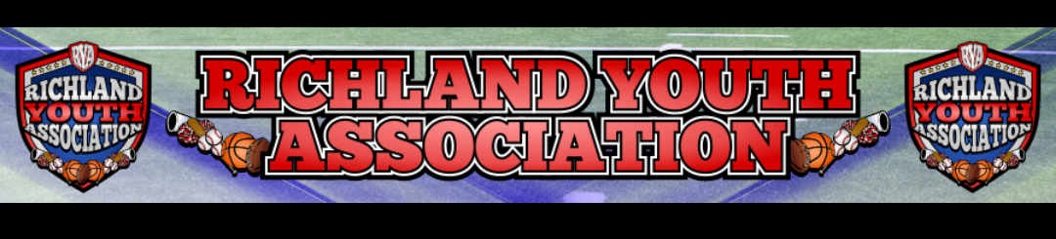RYA MARCH BOARD MEETING
Meeting Date: March 9, 2022
Attendees: Mike Cowan, Blair Armfield, Richard Stutheit, Marissa Jennings, Lisa Willis, Kevin Vorphal
Absent: Ben Earley

General Board Items
- All in favor of Kenneth West’s removal from the Board; Mike Cowan made attempt to notify Kenneth by phone & will continue to contact him until he gets through
- No incoming monthly check from Jennifer
- Received $2700 check from Kevin for RYA Let’s Get Started Season Opener

Basketball: Blair Armfield
- Championship results; very busy, went well, a few broken trophies but being resolved
- Parent feedback; skill level of teams not proportionate

Rec Baseball: Richard Stutheit
- Several new Baseball Directors in the surrounding areas
- Kevin signed off on umpire game schedules
- Haslet 12u will play all their Saturday games at Richfield Park
- Coordinating RYA Night with RHS for April 8th
- Consider paying for Head Coach’s jersey in the fall
- Preparing/editing Officiating Agreement for Kevin to sign next board meeting

Premier Baseball: Kevin Vorphal
- 18-20 teams already signed up for tournament April 1-2
- Cross Timbers big field is $800 for the weekend April 1-2

Marketing: Marissa Jennings
- Working on opening day activities & vendors

Cheer: Lisa Willis
- Cheerfest: Candise Villarruel, Waxahachie Cheer President will be hosting
- Individual towns will open a separate registration near end of the season
- Registration fee to cover associated costs as determined by Cheer Director:
  - Expenses regarding insurance, practice space, etc
  - Additional gear for competition; uniform, poms, bows, etc
  - Possible fee to Waxahachie for hosting (will get details)
- Ages 6-12 years & would most likely need to have participated in recent cheer season
- Practices would start after registration & continue until competition day
- Entrance fee for spectators covers cost of the facility rental

