Hanover Youth Ball Board Meeting Minutes
September 9th, 2025 6:30pm
Hanover Historical Society

Executive Board Board Members
Joe Peterson—Chair X- Jay Sogn X - Anne Clarke
Missy Thompson – Vice-Chair Brian Thompson X - Shelly Schoeberl
Katie Dawson – Secretary X- Angela Henry Krista Billman
X -Lisa Flatten – Treasurer Chris Larson Robyn Pouliot
Kyle Bruns Christine Dauterive
X = Absent Chad Ganglehoff Karin Brinkhoff

- Call to Order at 6:32pm.

- Open Forum/Visitors – Andrew Bethke joined the meeting and has helped with Machine/Coach Pitch. Welcome Andrew!

- Treasure Report/Budget Update— Report approved by Missy & Robyn
Items Over Budget-Equipment higher due to new mounds, Umpires – paid directly, Trusted Coaches – Made more people sign up & it is charged per person
Under Budget -League Fees, Field Maintenance, Tournament Hosted

- Parade/Dunk Tank Harvest Festival Review - Made $1005 profit
The parade was fun! Thanks to Karin, Nick, and Chris for help around the truck making sure no one was in the way of driving. The turnout with players was awesome, older kids carried banner the whole way. Blew a fuse in the truck and lost music for a bit. Candy distribution needs to be more sporadic.
Dunk Tank – Kids had to push button due to machine malfunction. Koltes & Olivia had a ton of kids. Mayor had a lot too and said he would do it next year. Contact Diana Law @ City Hall for mayor contact.
Need $150 for change

- St. Paul Saints Day review - Sold 38 tickets $190
Very hot, humid day in August. Maybe 10 kids on the field before the game.

- Picnic recap – spent $1381
Cool, kind of rainy day. Same as Historical Society ice cream social
Next year Maybe What’s the Scoop?
No grapes due to prep work needed – clementines instead
Hotdog warmer needed? Trash bags – City Hall?

- Season recap by league
Softball –
8u #’s down – 3 teams 23 players – Possibly Anne take next year
Open skills to younger players
10U 2 teams 23 players, fast Pitch Wright Co, Chris coached
Would like Clinics earlier and getting enough pitchers
Softball Continued…
12 & 14U Team each in Crow River – better than Maple Grove
2 players went to the All-Star Team for 14U – 2
Clinics/Skills/Evals – Contact Buffalo Varsity Coach
Rec/Travel/Club Terminology for team placement would help
MN Softball Association is the main league

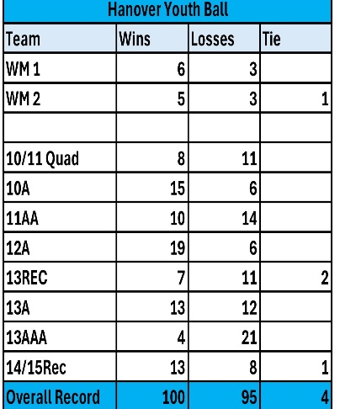
Baseball –
Travel 112 boys / 10 teams Record 100/95/4
2 developmental leagues – Quad City and Willy Mays
7 Gopher = 2 Rec/ 5 A, AA, AAA
Surveys received – next year to all
9/10 Teams in the right league

Machine Pitch 28 kids / 3 Teams
Coach Pitch 20 kids / 3 Teams
Jamboree – Concessions $575
Hanover Elementary – good

T-Ball –
130 Players / 16 Teams / 32 Coaches
Feedback: All Positive
Next year play last game on a field
14U girls & Olivia helped coach – Older kids to teach basic skills
Bag & Equipment - need another bag and bats

Great year overall – HAA was happy!

Coaches Banquet at Big Bore in the shed – Capped at $500 for night. Lots of leftover food. Continue or not?

- DIB’s talk –
Went through list of unclaimed dibs
Learning experience – Need sign in and out sheets at each Dib event for tracking
No cashing of checks this year due to technical difficulties and tracking
Next year $400 check from all for 4 hours of dibs

- Timeline review- Clinic Timeline/availability – Next month- See Attached
Updated and moved a few things – August to September

- BBA and Hanover Baseball meeting review and possible merger discussion-
Looking ahead on possibly combining 10U and up Travel teams with Buffalo due to making full teams and planning for kids going into High School. A lot of questions are still unanswered but we as a Board would like to meet with the Buffalo Board and go over what they expect and what 50/50 would look like if we do combine associations. Name change for togetherness, Gopher state recommended for a symbolic division.
Entry fee $300, $150 deposit flowers sale. Use of both fields
11 Board Members voted to try to merge this next coming season 10 Yes, 1 No
More to Come!
Brian gave a motion to proceed with possible merging with Buffalo. Chad second.

- Fall Ball-
- Teams
- Field Schedule
- Monday night Lights – Kyle – 15 players Machine Pitch and 15 Coach Pitch

- Fall Cleanup/Equipment Storage/Batting Cages—All
- Date: 9/13
- Ask for volunteers for assistance- Dibs – send out emails for confirmation

- Gator Maintenance – Jay – Next meeting

- Equipment-Joe – Would like someone else to do it

- Board resignations/retirements –
Robyn – Transitioned her duties, Thanks for your service!
Shelly until October – Clinics – discuss at next meeting
Lisa and Katie in their last year - Treasurer and Secretary

- Board Recruitment – All – Next Meeting- If you want to get involved and help, please come to one of our monthly meetings! We can use more help in a lot of areas to grow the program! We recommend anyone to come and check us out!
All agreed to bring Andrew Bethke to the Board – Not sure on duties yet

- Board duties review – All – October Meeting

- Social media posts/emails with next meeting date
Post about recruitment of board members
Post next meeting date

- Off season goals – Next meeting

- Next Meeting Date (Board appointment/Office elections)
2nd Monday of the month Oct 13 6:30pm

- Adjournment Missy and Christy at 9:25pm

