Go to SportsEngine Hq

- Open the “Competition” menu
- Select “Rostering”
- “Filter” teams to the current season and year
- For Players
  - Open “Assign players” tab
  - Open drop down menu for list of year and seasons; select the current year and season
  - All currently registered players will be listed
  - To add multiple players, select boxes next to names and drag to the appropriate team
  - To do individual players, highlight name and drag over to the appropriate team
- For Coaches and Team Managers
  - Open “Assign Staff” tab
  - Open drop down menu for list of year and seasons; select the current year and season
  - All currently registered coaches and volunteers will be listed
  - Highlight the individual and drag over to appropriate team. Once added you will need to designate them as a Coach, Team Manager, or General Staff
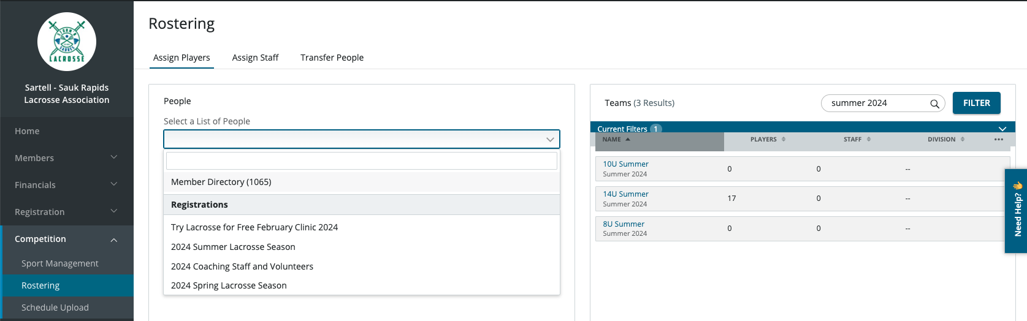
4d/e
5d
4b
4a
3
2
1

