HBBC Coaches Clinic
Saturday, November 23, 2024

Intro and Overview
Brief description of who I am and what I've done.
Brief discussion of what my goals for the Clinic are:
- Share my experiences, specifically some of the "short-cuts" I've learned along the way
- Give new volunteers a starting place that is hopefully relevant to what the players will need in the future
- Selfishly, try to get as many kids learning the same things as possible to help feed to the HS

Coaching Philosophy
- Find ways to teach, help them know what they should try 'next time', instead of only identifying the mistakes.
  - Every callout/criticism can be inverted.
  - Don't ask questions to players in the game. They can't answer. You don't WANT them to answer.
    - "What are you doing?" - If they knew the right thing to do, they'd do it.
- Try to have as many drills as possible be able to translate to the game
  - Minimize N v 0
  - Use constraints to control what is being learned [Repetition without Repetition]
  - 5v5, 4v5, 4v4, 3v3… It doesn't matter about the format, but constraints can focus what is being learned.

Man Defense (Demo)
- 4 Positions
  - Ball
  - Gap
  - Skip (X Switch on Skip Pass; Always takes the ball)
  - Hole
- Push the ball towards the baseline and keep it out of the paint

Zone Offense Concepts (Demo)
- Odd vs Even and Even vs Odd
- Attack the Gaps
  - Help them learn where the gaps will usually be.
  - Eventually emphasize how to create them
- If the ball is passed to the player in the middle, 'strong-side' baseline player should cut
- If the ball is passed to a player on the baseline, player in the middle should 'dive' to the MID-Post

RnR Breakdown Drills (Demo)
3 Player groups to focus on developing reads in the offensive players.

Learn by Playing (Demo)
Even with Small Sided Games, constraints can be used to focus development
Examples of constraints:
- Must hit 2 cutters before shooting
- Can only score off a ball screen

HBHS General Gameplan
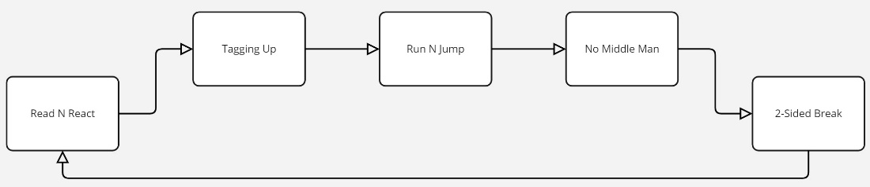

Man Offense Concepts (Read and React)
- Give an overview of the reason this system works and the benefits of using it.
- Discuss who can make decisions and when
- Use the PDF to go through the initial sets of "Rules" (PDF located on Docs page on hbbasketball.org)
- Begin walking through the Drills
  - Pass Cut Fill and the flow it can create
    - Keep immediate screens out; they have to earn it
  - Threats with the ball
    - Circle Dribble
    - Draft Drive
    - Real Estate
  - Threats from 1 spot away
    - Dribble At
    - Read Cut
  - Threats as the Filler
    - Read
    - Curl
    - Shoot

Tagging Up
- This is the start of the Transition Defense, and takes the guesswork out of "matching up" on the run
- When an outside shot goes up, all players on offense "Tag Up" on their defender
- Tag Up:
  - Run in to get to the Top Side of your defender. If the D gets the rebound, you guard your Tag on D
- Bonus: Being in this position creates a ton more 50/50 chances at offense rebounds

Run and Jump
- A Man to Man based pressure defense that can be used in the Full or Half court
- Discourages the ball hander from attacking their defender
- Creates traps from the back side if the ball dribbles away from you.

No Middle Man Defense
- A variation of Man to Man defense that looks to prevent the ball from getting to the most dangerous location
- This can also help make Help Rotations more predictable, and thus more successful

2-Sided Break
- Push and run at all times
- Fill the Corners (to create space) and the 45s (Wings); Rebounder/Inbounder fills the top as Trailer
- Pass the back ahead: Early and Opposite
- Look to create advantages - Pass to opposite to create 2-on-1
  - Attack while the defense is still scrambling

