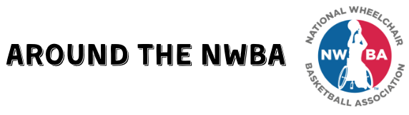
Fill out this form to the best of your ability and where applicable.

Name (of person submitting form):
Phone number:
Email:

Name of event/activity:
Date of the event/activity:
Location:

Event/activity/story description:

Teams/athletes that participated in the event/activity:

Outstanding team performances:

Outstanding athlete performances:

Team placements (1st, 2nd, 3rd, etc.):

Highlights of the event/activity/story:

Please send this form, along with a picture or video of the event/activity to Rebekah Markovitz at Communications@nwba.org.

