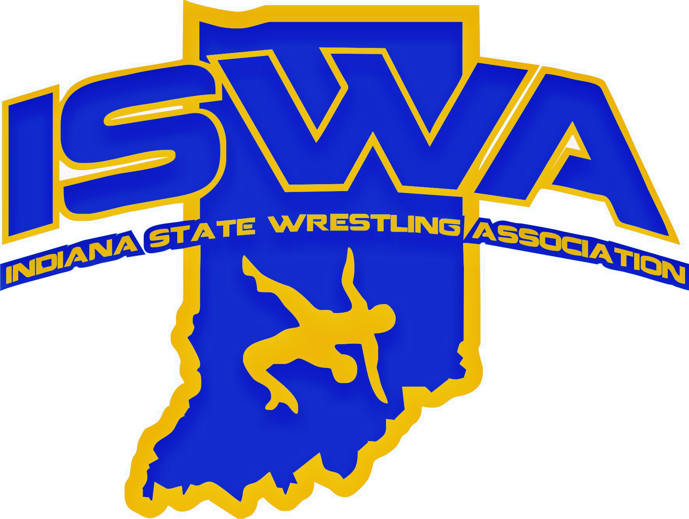
INDIANA STATE WRESTLING ASSOCIATION, INC.
P.O. Box 157, Beech Grove, IN 46107 Phone: 317-780-1885

This year marked my first as the ISWA Folkstyle Officials Developmental Director, and it has been both a rewarding and eye-opening experience. We made meaningful progress by increasing the participation of newer officials at ISWA events, which is a positive step toward building a stronger officiating community. However, it is clear that we must continue to focus on recruiting new officials and developing the skills of all current officials to ensure long-term sustainability.

One of the most pressing concerns is the rising average age of officials in Indiana. To maintain a healthy pipeline, we must prioritize bringing in younger officials who can grow with the sport. Additionally, with the rapid expansion of women’s wrestling, we have a unique opportunity to recruit and support female officials. This is not just a matter of representation—it’s a necessity. Without this growth, we will continue to rely on out-of-state officials to support major events. This year, we were fortunate to receive help from eight officials from Ohio and three from Kentucky during our State Tournament, and their contributions were greatly appreciated.

Despite these challenges, Indiana officials continue to represent our state with distinction at national tournaments. Their performance has earned them repeated invitations to high-profile events, and this year was no exception. Seven officials represented Indiana at the 2024 Brian Keck Memorial Preseason Nationals & Boys National Recruiting Showcase. Another seven participated in the 2025 USAW Kids Folkstyle Nationals. Four officials officiated at the 2025 Air Force Special Warfare USA Wrestling 16U & Junior Folkstyle Nationals, and seven more were present at the Heartland Duals. These appearances are a testament to the skill and professionalism of our officials and reflect positively on the ISWA as a whole.

I would also like to extend a heartfelt congratulations to Gary Fox, who was named this year’s ISWA Folkstyle Official of the Year. Gary transitioned into officiating after 25 years of coaching and, in just six years, has built a strong reputation through his dedication and performance. He began by working numerous local and state tournaments and has since earned consistent invitations to the Heartland Duals and USAW National Events. His journey is a shining example of what is possible with commitment and passion.

As we reflect on the year, it’s clear that we have both challenges and opportunities ahead. I am proud of the progress we’ve made and optimistic about what we can achieve together. Thank you to everyone who has supported our mission and contributed to a successful season.

Respectfully Submitted,
Jared Curcio
Folkstyle Officials Developmental Director

