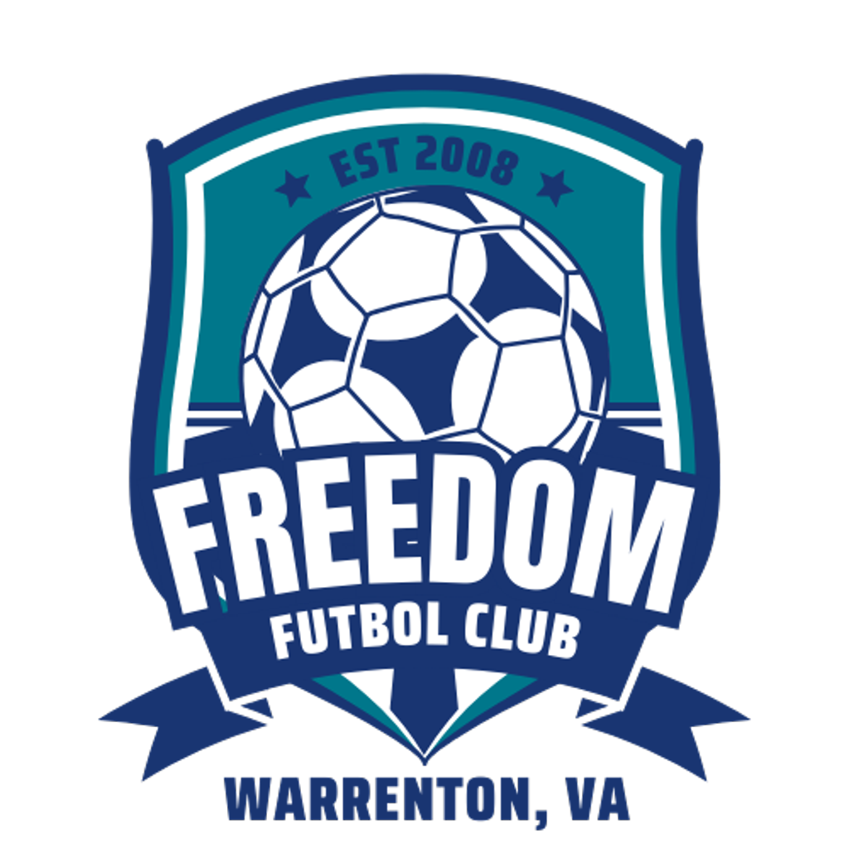
Freedom Futbol Club
2026 Sponsorship Package
Warrenton, Virginia

About Freedom Futbol Club
Freedom Futbol Club (FFC) is an independent, nonprofit travel soccer club based in Warrenton, Virginia, competing in the National Capital Soccer League (NCSL). Our mission is to develop confident, adaptable soccer players while building strong character, leadership, and accountability in every athlete.
Freedom Futbol Club is a 501(c)(3) tax-exempt nonprofit organization. All donations are tax deductible to the fullest extent allowed by law.
Why Sponsor Freedom Futbol Club?
Your sponsorship directly supports:
- Youth athlete development and quality coaching
- League and tournament play in the DC–Metro area
- Speed, agility, strength, and conditioning training
- Equipment, facilities, and operational expenses
- Financial assistance to ensure access for all athletes

A partnership with Freedom FC is an investment in local youth, families, and community impact.
Sponsorship Opportunities
- Platinum Sponsor — $10,000+
Premier Club Partner
Benefits include:
- Exclusive Platinum Sponsor designation
- Logo placement on all Freedom FC team jerseys
- Prominent logo placement on club website homepage
- Dedicated Platinum Sponsor social media spotlight
- Banner placement at home events (where permitted)
- Recognition in club-wide communications
- Opportunity for customized partnership activations
- Tax-deductible donation acknowledgment letter

- Gold Sponsor — $5,000–$9,999
Benefits include:
- Logo placement on club website sponsor page
- Banner placement at home events (where permitted)
- Social media sponsor recognition
- Club communication recognition
- Tax-deductible donation acknowledgment letter

- Silver Sponsor — $2,500–$4,999
Benefits include:
- Logo placement on club website
- Social media recognition
- Sponsor listing in club communications
- Tax-deductible donation acknowledgment letter

- Bronze Sponsor — $1,000–$2,499
Benefits include:
- Business name listed on club website
- Group social media thank-you
- Tax-deductible donation acknowledgment letter

- Team Sponsor — $750
Benefits include:
- Business name or logo associated with one team
- Recognition on team social media posts
- Team-level appreciation acknowledgment
- Tax-deductible donation acknowledgment letter

- Friend of Freedom FC — Up to $749
Benefits include:
- Name listed as a supporter on the club website
- Tax-deductible donation acknowledgment letter

Use of Sponsorship Funds
Sponsorship contributions directly support:
- Player development programs
- League and tournament fees
- Strength, speed, agility, and conditioning programming
- Equipment, uniforms, and field usage
- Financial assistance for families in need

Freedom Futbol Club is committed to transparency and publishes required IRS filings and compliance documentation.
Chelsea Logue
Director of Marketing and Social Media
Freedom Futbol Club
703-909-3019
Chelsea.Logue89@gmail.com
https://www.freedomfcvirginia.com/

