AGM Report
July 2019
GBYSL remains busy and we can start to give details as to potential park openings.

Cyan Park-South Reno
Approved, funded and ready to break ground, practice fields only.
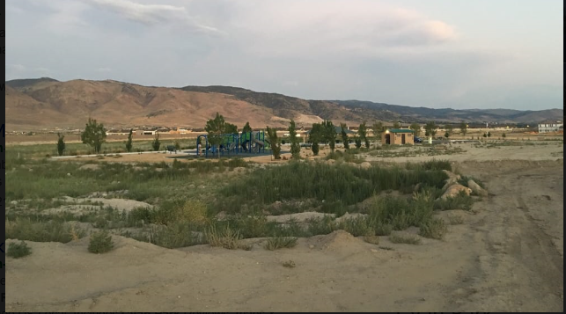

Mill Street-
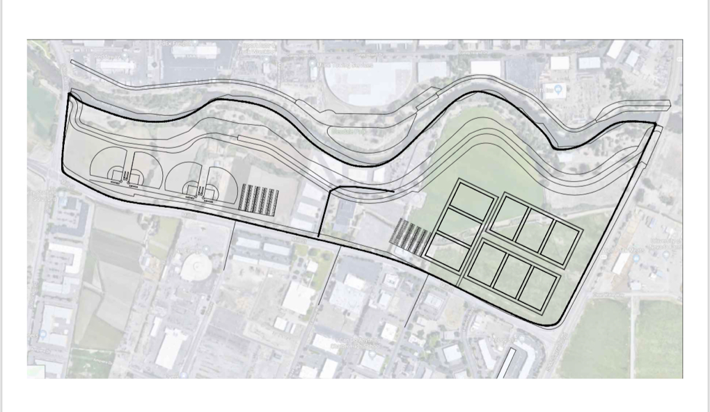
Conversation with Truckee River Flood Management continues to move forward and we have a tentaive set of plans. Unfortunately City of Reno nor Washoe County has money to build them, we will have to fundraise.

Lazy 5
I have received tentative approval to plan for 200-300,000 square feet of new sod. Vaughn Hartung County Commissioner has been very supportative of this project. We will have to fundraise for the expansion.
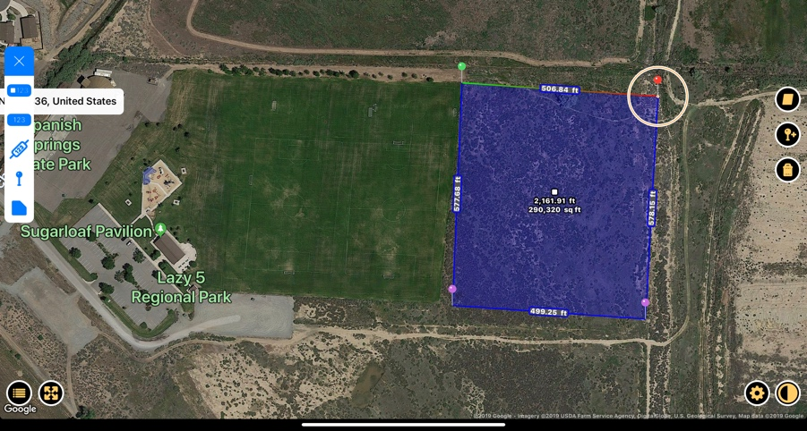
Pembroke
This continues to move forward with the development group. This will be a joint venture with the group and City of Reno, this will have fees associated to use the facility. GBYSL nor RYSA nor City of Reno will be involved in the permitting process

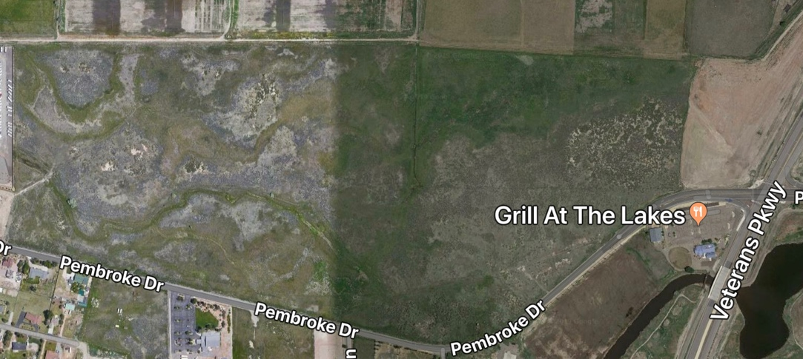
W Moana Lane
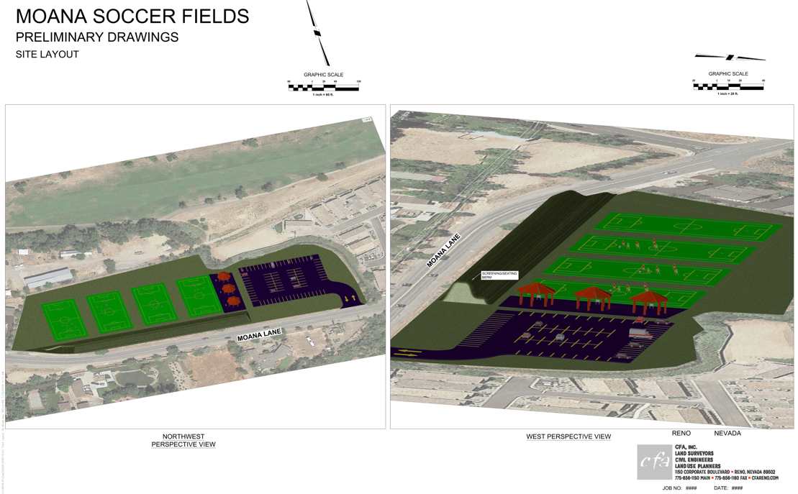
This 100,000 square foot section would be used to move U9 games from Gojack. Gojack could then be used on Saturday for older games or practices. Washoe County is willing to do a land swap with the city. City of Reno has money in park district for build new fields, only for new fields. Practice field during the week.
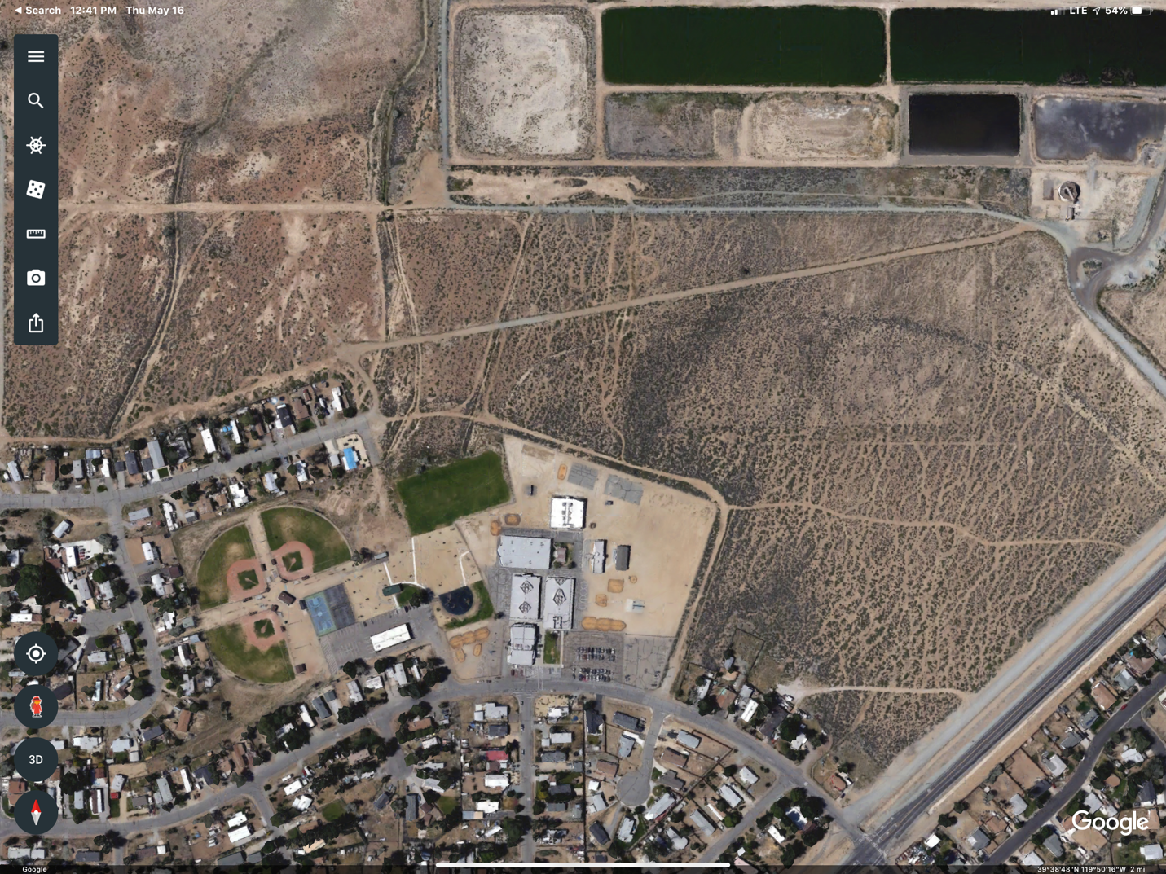
Lemon Valley
This could be an interesting field project. We have all heard the problems with Swan Lake and possible solutions. One could be expand the fields and use the water from the treatment plant and Swan Lake for irrigation. Commissioner Vaugh Hartung and I have been talking, I will keep you posted.

-Registration numbers remain strong both on recreational and competitive side.

-TOPSoccer has a record number of players this season. Thank you Sandy Castillo for coming out for opening day and TOPSoccer opening day. Thank you Marjorie and Teresa and Jeremy for your leadership with this program. City of Reno will be recognizing TOPSoccer in the form of a procolomation.

-ODP, our northern teams faired well at our first ever regional tournament in Arizona in January. We are planning for continued success. We had almost 550 players tryout, biggest number ever by far, previously roughly 130 tryouts. We had 60 players invited to the regional camp, our best showing ever.

-Reno1868FC, our partnership contines strong with our kids being used for walk ceremonies and game ball kids. No comment on the “Lights”, nor basketball this season…Guy…

Guy Hobbs was re-elected President of Nevada Youth Soccer Association.

WPSL-There is new WPSL in the northern region that we are supporting.

Richard L. Jay
GBYSL Commissioner

