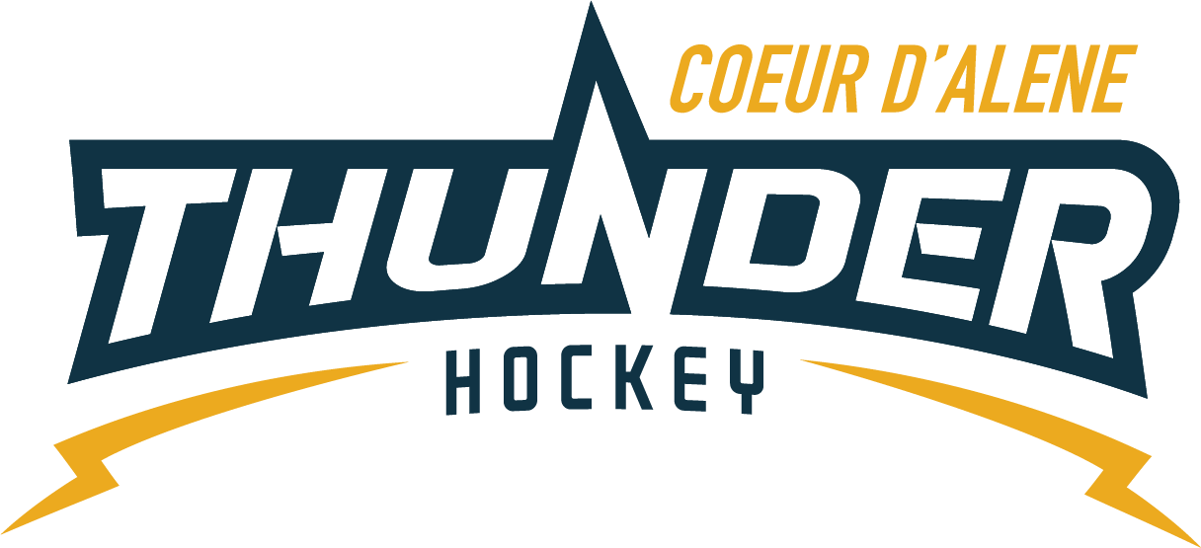

CDAHA

Meeting minutes
Location: ZOOM
Date: July 2, 2020
Attendees: Bob Nelson, Elliot Taub z, April Hocking, Meghan Smith, Torsten Langley z, Matt Creighton, Bart Barrett z, Jarrod Hansen z, Jackie Guerrin, Jackie Petterson, Rhet Neilson
Time: 6:00pm
- Call to order
Bob Nelson, President called meeting to order 6/18/20 @ 6:14pm
- Roll call
As stated above, Matt Fisher absent
- Approval of minutes from last meeting
Motioned by Matt C to approve minutes Meghan 2nd – passed
- Open issues
  - Financial Update
Fiscal year end June 30
2 cks still going out
$43, 301 in bank
  - Mites Budget
    - Jackie P sent out very thorough breakdown
    - $250 for all Mites only Mite Jamboree
    - $99 program will only have a practice jersey
    - $250 program will have sublimated jerseys
    - Using left over sponsorship for this year specifically
    - All needs to be handed over to financial committee from here out
    - Side note to check into if we can have separated accounts for each division for fundraising going forth, that rolls over to only that division each year – to be taken to financial committee
  - Bart motioned to approve Mite Budget Matt 2nd
  - Rhett wants to know how we are combining roster for 6u/8u
    - Coaches decision is final decision, not the parents – will be discretion of skill base separation
    - Board backs the coaches 100%
  - Jersey Lease Program
    - Needs to be defined only with Mites
    - Numbers will come from the Jackies
    - Again to Financial Committee for further approval
  - Summer Clinics
    - A lot of coaches stepping forward for this and the times for the clinics
      - Mon – 5-6 MITES
      - Tues 6:15-7:15 Ban/Mid
      - Wed 6:15-7:15 Sq/PW
    - Covid surge issues
      - Need to look at the safety issues
      - Have them get ready at home
      - No locker rooms
      - Use USA Hockey back to the rink guidelines
    - Josh will not be sending his kids or be coaching due to new spike and his working environment/knowledge
    - Josh motions to suspend it for now
    - Voted with one nay, Torsten, to reevaluate in a month for our fall session take week by week
  - Coaching Committee
    - Matt C will be director
    - Jarrod, Matt F, Josh, Krystal
      - Bob and Bart liasons
    - Potential PWTravel Coaches
      - Cody Chongaway
      - Terry
      - Agnew
      - Marcus
  - Fundrasier Update
    - Jackie G has secured 3 sponsors so far
    - Could have kids ask businesses they know personally not to be burdening anyone during pandemic
- Adjournment
Elliot motioned Bart 2nd adjourned the meeting at 7:25pm.
Minutes submitted by: April Hocking
Minutes approved by: CDAHA BOD
- Next Meeting
  - August 6, 2020 LIVE

