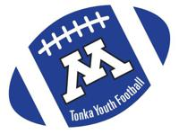
Tonka Football Injury Report
Submit one injury report by player only if they will miss their next game due to the injury sustained. Do not include the players name.
Fill in shaded area only

Submitted By:
Date:
Grade:
Football Related Injuries: (sustained in practice or game play)
Nature of the injury: | Categorize as:  - Joint Muscle (sprain, bruise, etc.)  - Upper Body/Lower Body/Hands/Feet (bone injury)  - Neck/Head (strained neck)  - Physician Diagnosed Concussion  - Concussion-like Symptoms, but Physician did not diagnose as concussion
Non-Football Related Injuries:
(sustained outside of football. Example: broke arm on trampoline)
Nature of the injury: | Categorize as:  - Joint Muscle (sprain, bruise, etc.)  - Upper Body/Lower Body/Hands/Feet (bone injury)  - Neck/Head (strained neck)  - Physician Diagnosed Concussion  - Concussion-like Symptoms, but Physician did not diagnose as concussion

Submit report to Chad Dill & Tony Wixo.

