Payment Links - https://www.invasionvbc.com/page/show/5072380-2021-2022-player-fees
Recurring Payments –
- You will fill out the amount, total player fees divided by # of payments
- Check the “Make this recurring” box
- The box will only default to 5 cycles, this is our normal payment plan
  - If you have a different payment arrangement, please reach out to Travis Dalton at travis.invasionvbc@gmail.com
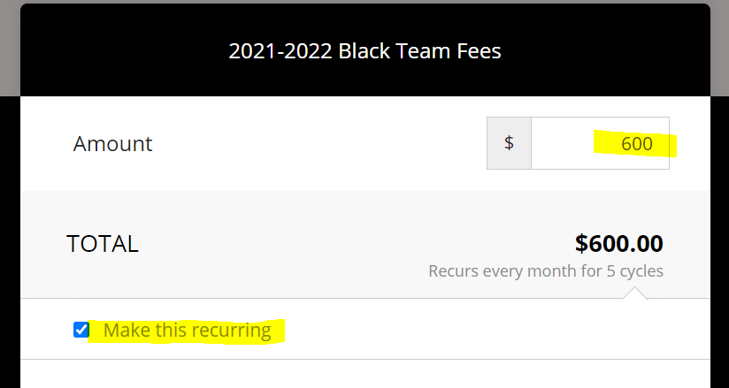
- Fill out contact details and payment information. Please be sure to put the players full name and team in the required fields
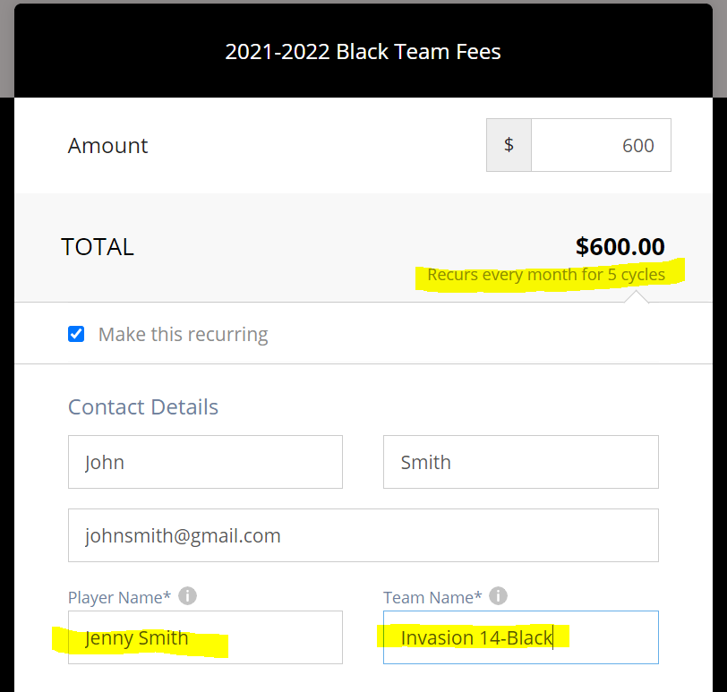
Monthly Payments, Not on Autopay –
- You will fill out the amount of the payment you would like to pay
- The form defaults to not on autopay, so just be sure the “Make this recurring” button is unchecked
- Fill out contact details and payment information. Please be sure to put the players full name and team in the required fields
