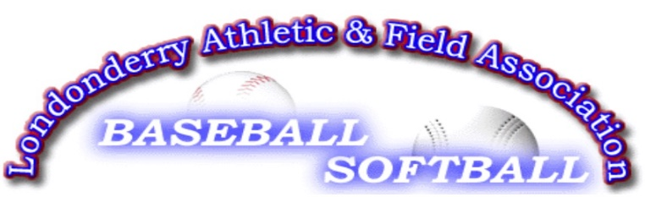

Londonderry Athletic Field Association
Post Office Box 78
Londonderry, NH 03053-00783
February 2, 2017

Dear Prospective Sponsor:
We are requesting your support for this year’s LAFA season. This year we have expanded the opportunities to sponsor as described below:
- Single ($175): your company’s name will be added to the ball team’s name. For example, ABC Company’s Pirates.
- Double ($350): Team Sponsor plus your company’s banner on one of our outfield fences of your choice
- Triple ($500): 1 & 2 plus your logo scrolling on your team’s page on website
Additional Options:
- Home Run ($500): Set up a display (vehicle, boat, RV, etc.) with your sales person hosting it for the day near the Pavilion.
- Grand Slam ($700): Your logo will appear at the top the LAFA homepage
LAFA supports games and practices for over 700 children in baseball, softball, and most recently kickball. Activities occur every day of the week with all-day schedules on Saturdays. In addition to our recreational programs, we have all-star teams for baseball and Lightning (softball) who play teams from other towns. This flow of traffic from both inside and outside the town of Londonderry will give your business terrific access to potential customers.

If you are interested in contributing, please complete the attached selection form and mail to the address on the form. LAFA is a 501(c)3 not for profit organization and donations are tax-deductible.

We appreciate your support and feel free to contact me with any questions at the email or phone number below.

With appreciation,

Rob Galan (603-438-8880 & rgalan56@hotmail.com)
Head of Sponsorships, LAFA

Cc: Tim Dodge, President of LAFA

