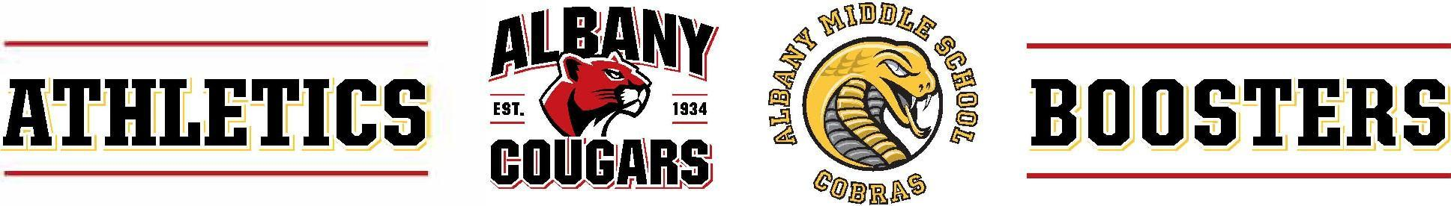
Athletics Boosters Board Meeting Agenda
603 KEY ROUTE BLVD · ALBANY · CA · 94706
November 18, 2025: Board: 6:30 – 7:15, General: 7:15 - 8
In-Person
- Welcome, Intros, & Agenda Review
In attendance:
  - Garth Schultz, President, Communications, AMS Liaison
  - Yvonne Gallegos, AUSD Athletic Department, Captain’s Council, Website, AMS Track & Field, AHS XC
  - Sarah Roberts, Treasurer, AMS Liaison
  - Diandra Sam, Secretary
  - Marie Hopper-Member at Large and Schoolfundr Liaison

- Fundraising Update
  - Fall crowdfunding outcomes – every team ended with a positive balance
  - Boys’ basketball, girls’ basketball, boys’ soccer are using Schoolfundr, girls’ soccer TBD
  - Board to revisit AMS expectations for fundraising with attention to how individual teams are performing and spending
  - Banner fundraising: banners are in the gym and on the track; corporate sponsors currently pay a one-time fee for having their banners displayed for one year
  - Board to follow up with existing corporate sponsors to renew sponsorship and to attract new sponsors

- Financial Update
  - Fewer student athletes projected to participate in upcoming sports seasons which is expected to reduce family contributions and crowdfunding efforts

- Winter Sports
  - Tryouts for spring sports will be in December

General

  - Student commissioner’s update: ceremony done for seniors after football game was forfeited by opposing team, mascot is present for ending ceremonies

